Database 3: Assignment 1

By Ryan Haskins 16442673

# Video link: <https://northampton.mediaspace.kaltura.com/media/Database3+Demo/0_1l2pcusd>

Contents

Introduction 3

Database design 3

Draft model 3

Database properties 4

Database Schema 5

Database Build 5

Database queries 9

Query 1: Display the total number of matches played 9

Query 2: Display details of all matches involved “Manchester United FC” 10

Query 3: Display all the teams that played the EPL matches in the season 10

Query 4: Display the team with the most “win” in January 11

Query 5: Display the top five teams that have the best scoring power 12

Query 6: Display the top five teams that have the worst defending 12

Query 7: Display top five teams that have the best winning records. 13

Query 8: Display top five teams with best half time result 14

Query 9: Which teams had the most “loss” 15

Query 10: Display the team with the most consecutive “wins 15

Database Evaluation 17

Learning Diary Evaluation 17

Appendix 19

Learning Diary 19

Week 2: 19

Week 3 23

Week 4 28

Week 5 31

Week 6 33

Week 7: 37

Week 8 40

Week 9: 40

Week 10 50

# Introduction

This report is about the creation of a NOSQL database. The program that will be used is Neo4j. This database will store information that has been supplied. The database is on the English Premier League (EPL), it will store all the teams, matches, and results from the 17/18 season. There are a few assumptions we have taken from the data supplied these assumptions are listed below:

* Team 1 is the home team for the match.
* Team 2 is the away team for the match.
* All data stored in the xml file is accurate and correct.

# Database design

In this section of the report it will explain the draft design of the database the developer will be looking to build.

## Draft model

Below is a draft to show how the database will link up. It works by having all the clubs as nodes and creating a relationship to each node. The relationship will represent a match. Every team play each other twice so every node will have two relationships with every other node. The data is stored inside the relationship so when querying the database, the queries will just be focusing on pulling information from the relationship and using the nodes as a condition to check they are pulling through the data from the correct source. This is designed to make it easier and more efficient to query as the information is stored in one style and in one place in the database. This also makes it easy to see who the home team is as the database was will read “Chelsea Featured Manchester City.” For example. This shows that Chelsea is at home and it is hosting or features Manchester City who would be the away team.

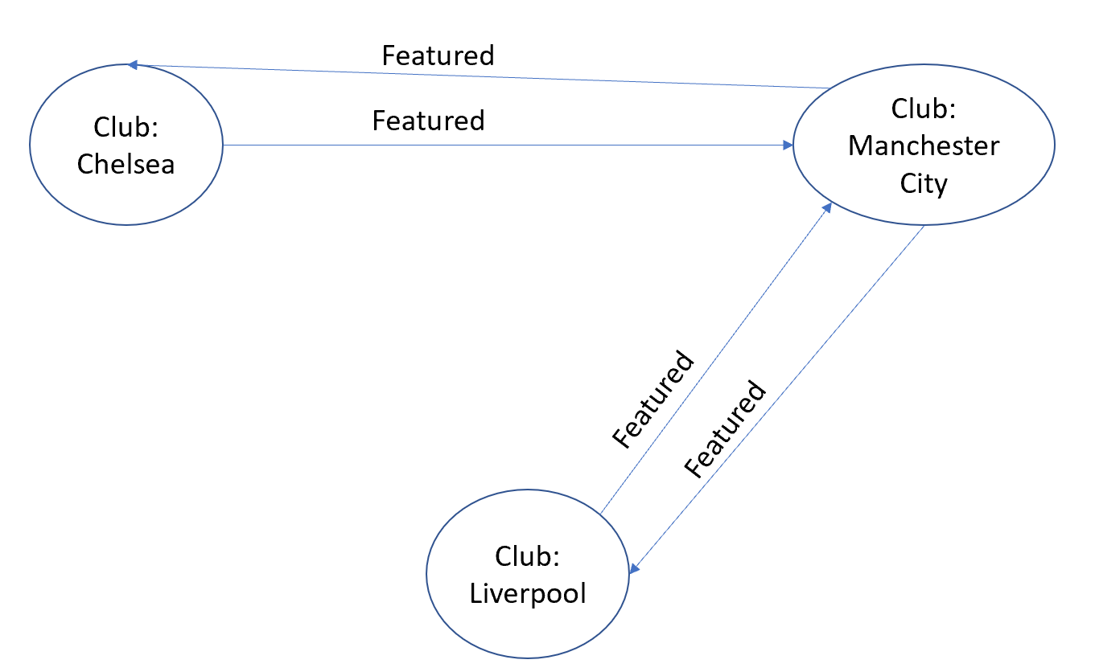

### Database properties

Below is a table displaying all the properties and types of nodes and relationships that will be used in the database. This table will show what information will be stored and where it will be stored.

Nodes:

|  |  |
| --- | --- |
| Types: | Club |
| Properties: | Name: This will store the name of the football team. |

Relationships:

|  |  |
| --- | --- |
| Types: | Featured |
| Properties | Round: Which round the match is played in.  Date: When the game took place.  homeTeamFullTimeScore: This is the amount of goals the home team were able to score during the match.  awayTeamFullTimeScore: This is the amount of goals the away team were able to score during the match.  homeTeamHalfTimeScore: This is the amount of goals the home team were able to score by the end of the first half of the game.  awayTeamHalfTimeScore: This is the amount of goals the away team were able to score by the end of the first half of the game.  losingTeam: This is the team that loses the game. If it’s a draw then Draw will be entered here.  winningTeam: The team that won the game. If it’s a draw then draw wil be stored here.  matchTied: would only be displayed on drawn games and will have Draw stored in the property. |

### Database Schema

To display the schema of the database run the code below. This will show you the structure of the database with all its types in.

Code: Call db.schema

Result:

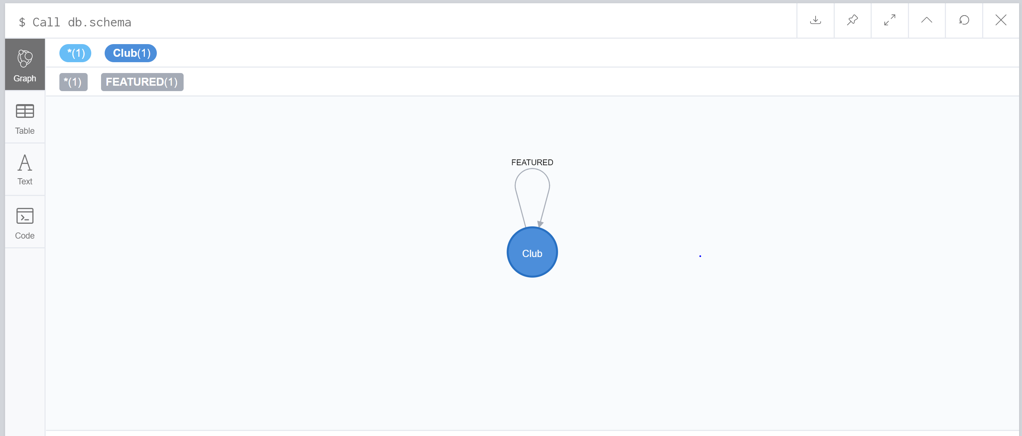

# Database Build

Below is the step by step guide to how the database is built in Neo4j.

The first thing is to load the data that we are going to use in order to build the database from in to the database. Then we will build the nodes first and populate them with the team names.

Code:

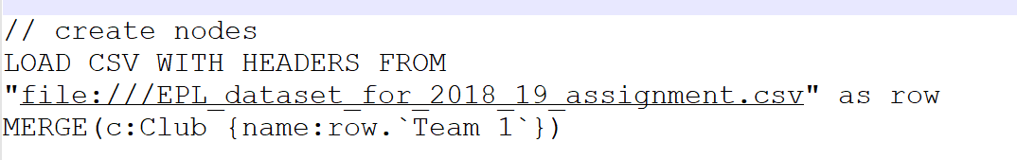

Result:

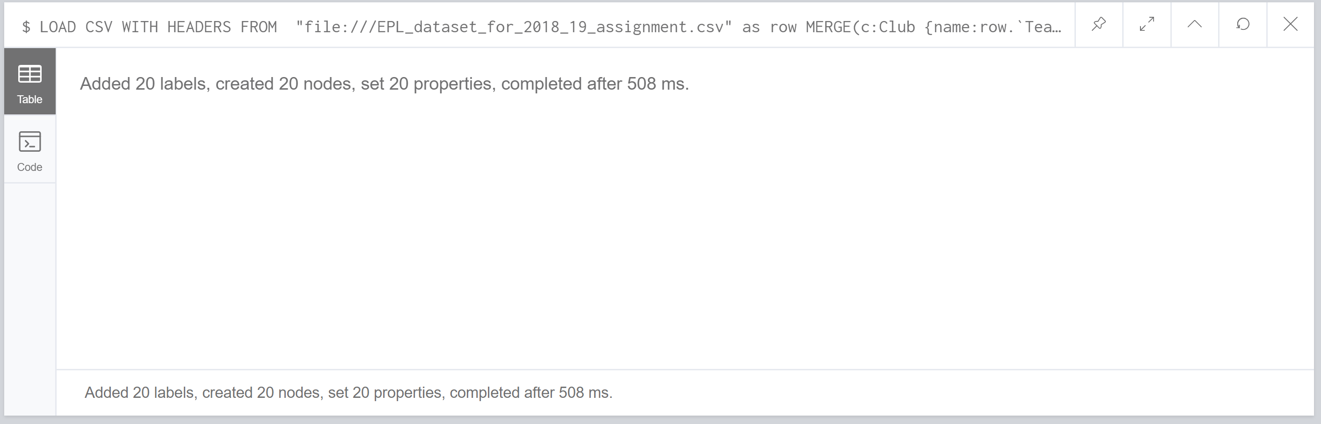

The next step is to create the relationships and to pull through the required information from the data file.

Code:

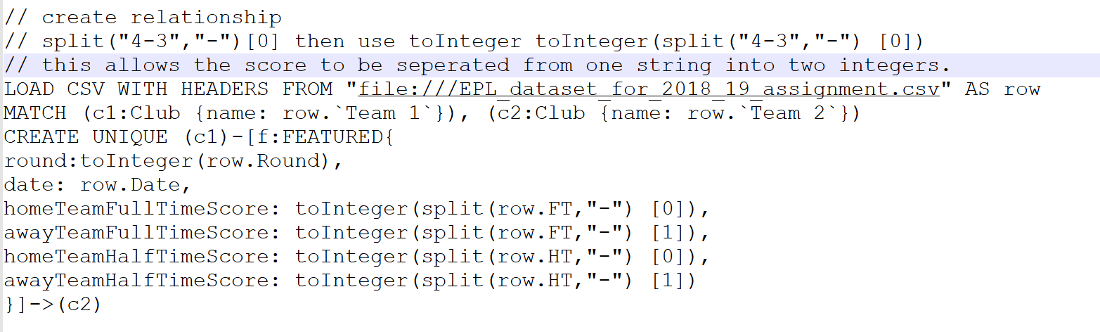

Result:

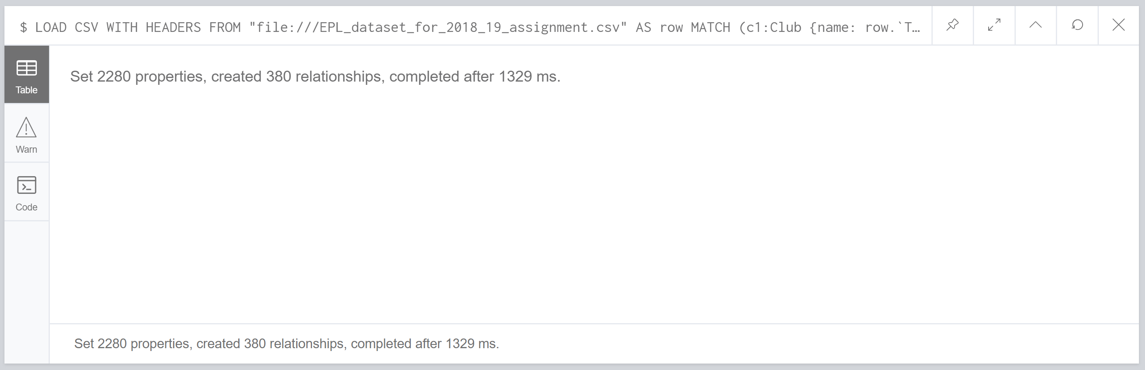

The last step is to find out the result of the match and to store it as properties so more advanced query’s can be done on the relationships. This is done by running three different queries on the database to find out the whether the home team won and adding properties to those relationships, find out if the away team has won and adding properties to those relationships and lastly if the match resulted in a drawn and adding properties to those relationships.

Find out if the home team has won code:

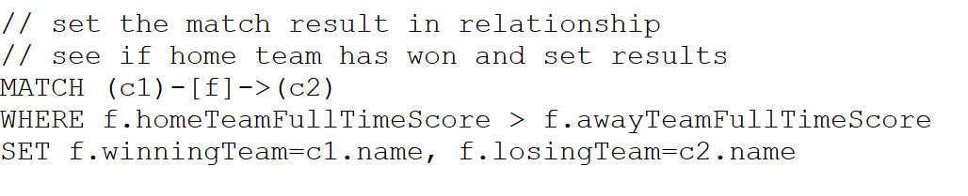

Result:

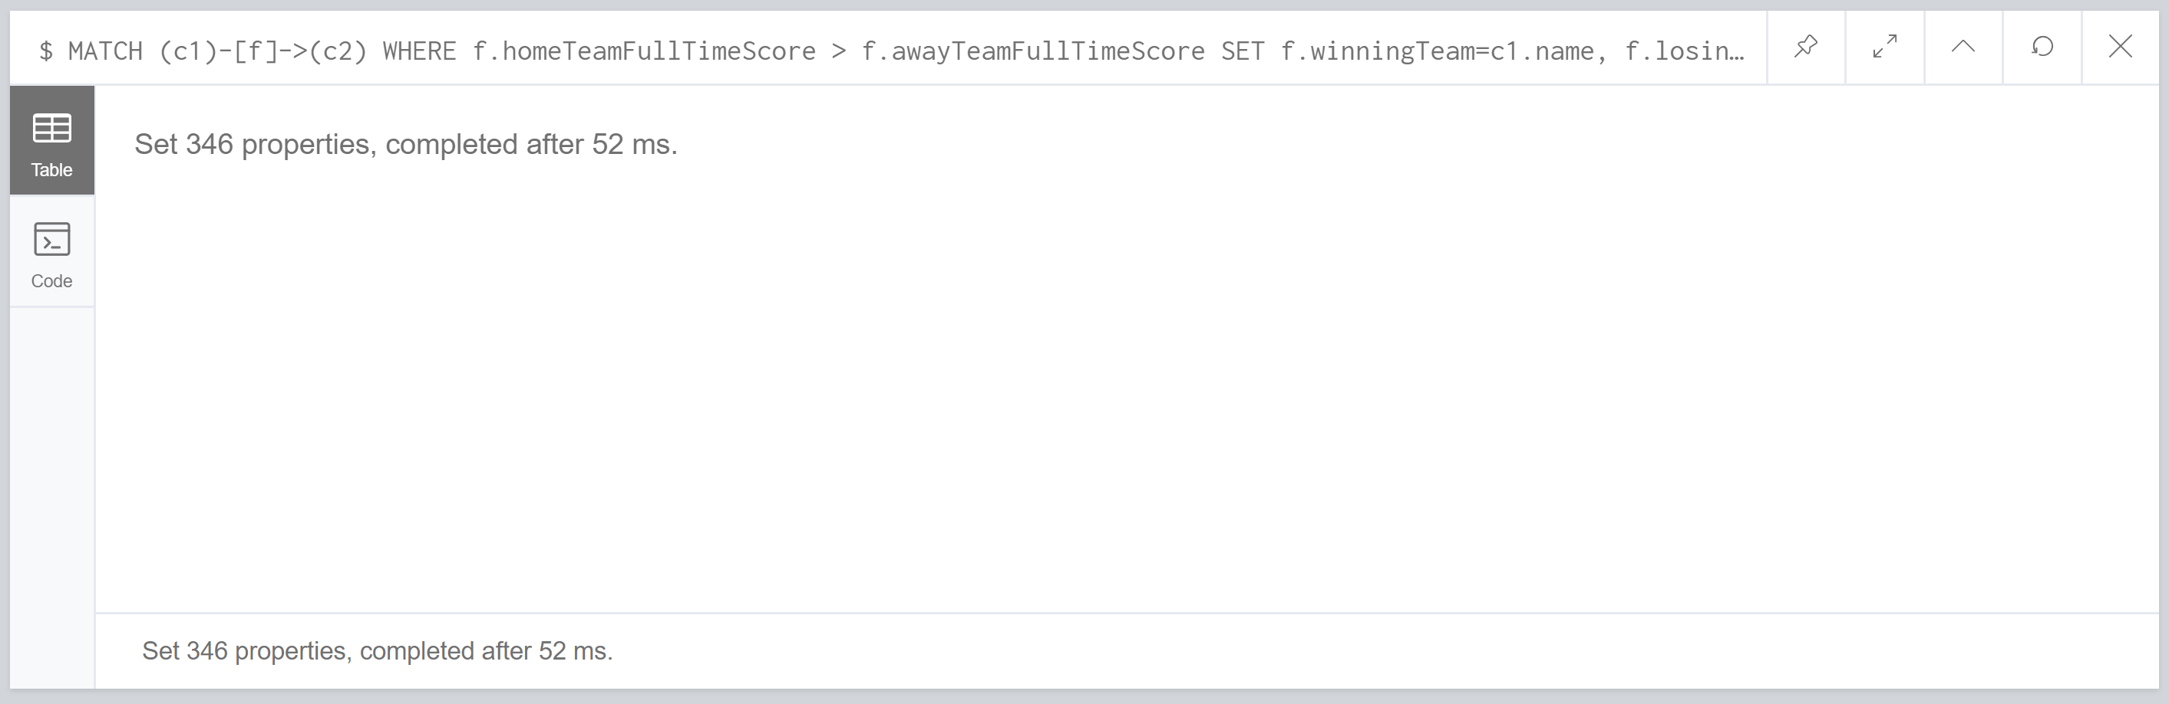

Find out if the away team has won code:

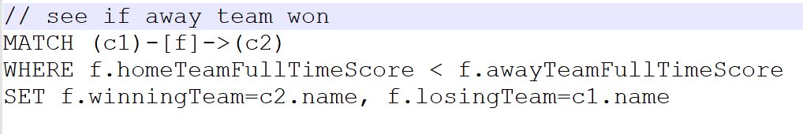

Result:

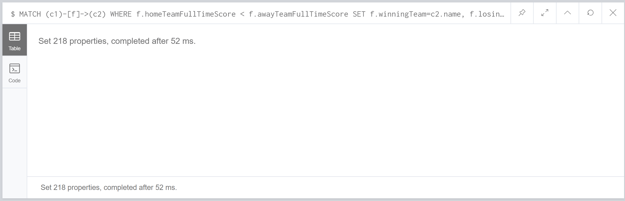

Find out if the match resulted in a draw and add the relevant properties code:

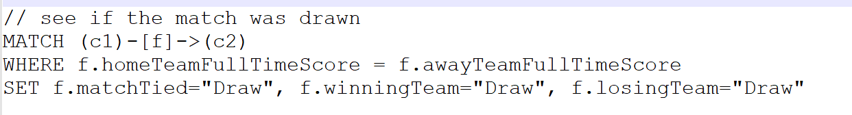

Result:

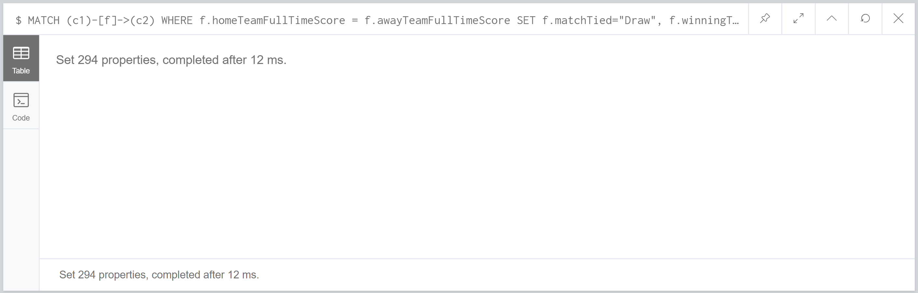

To view the database at this stage it would look like this in Neo4j:

(Hint: be careful running this code as because of the size of the database it will slow down a considerable amount and take a few seconds to load)

Code:

MATCH (n) RETURN n

Result:

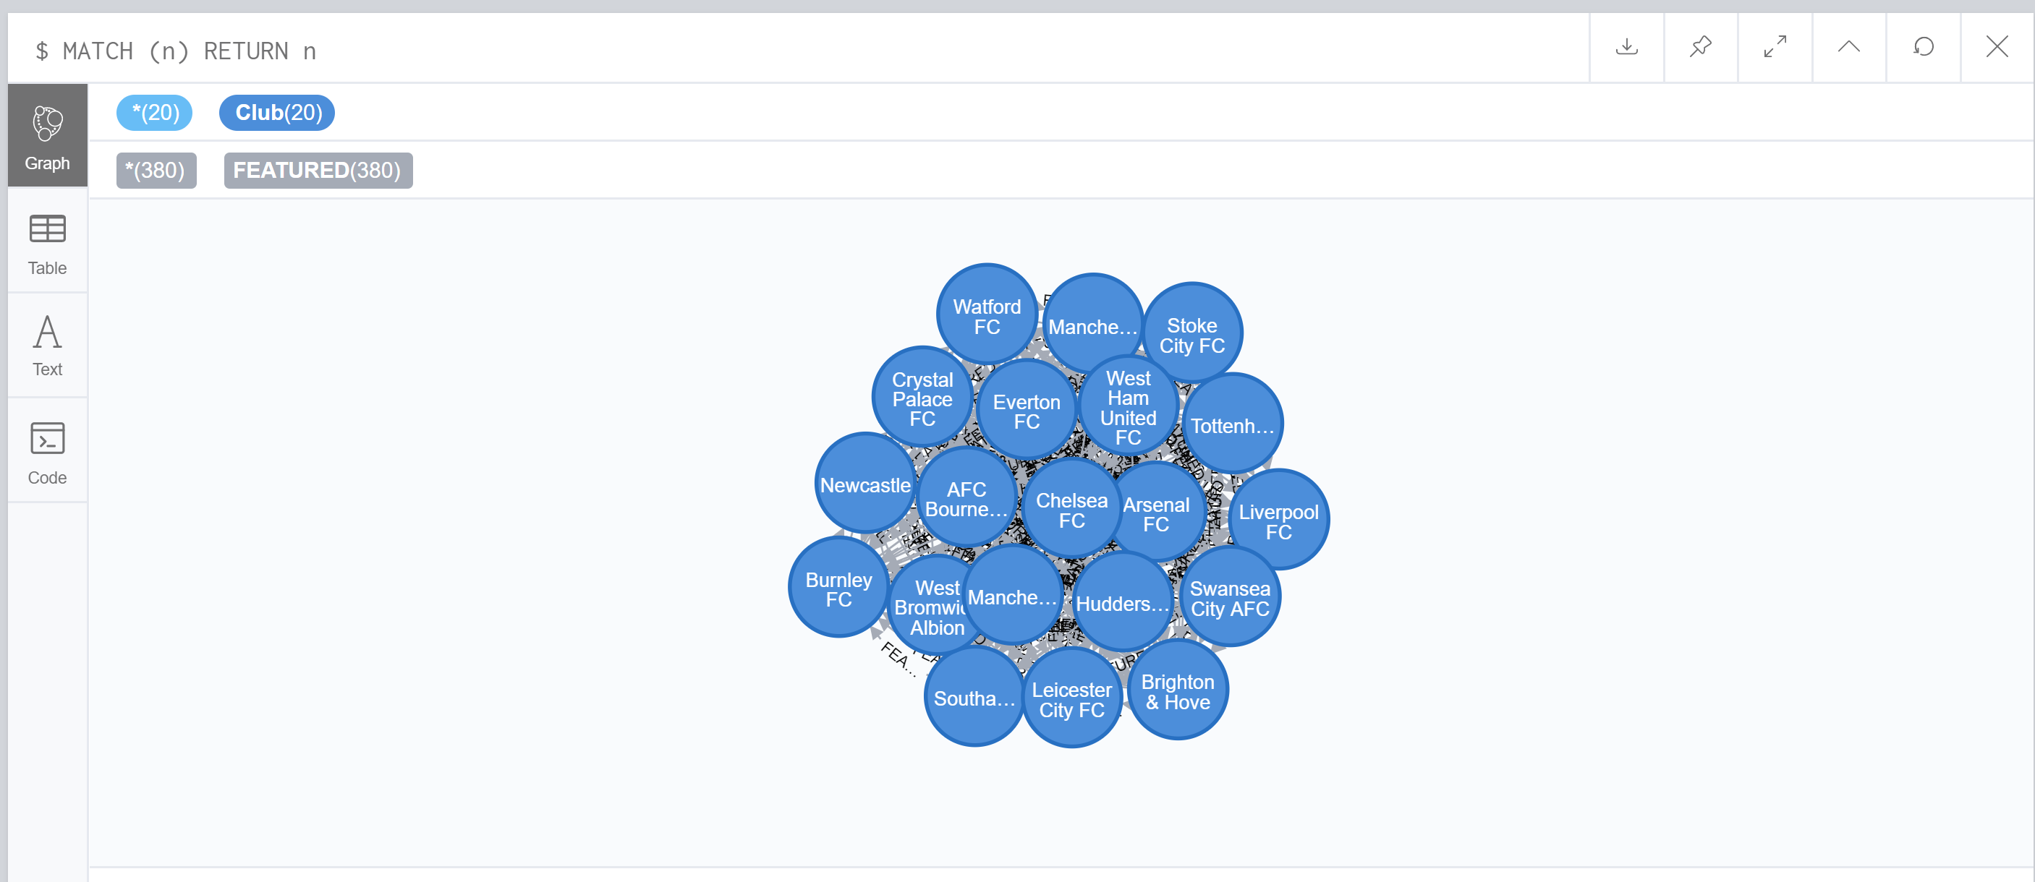

# Database queries

In this section of the report is a list of queries that pull through information from the database. These queries are ranged from simple queries and more complicated advanced queries. A brief description of the query will be added to make it easier to read and understand what the query is doing and what has been pulled through. In this section there are 10 queries which were requested by the assignment brief all 10 queries have been attempted and have produced a valid output.

## Query 1: Display the total number of matches played

This query will pull through the amount of games that have been played throughout the EPL 17/18 season. The response has been formatted in order to improve readability of the query.

Code:

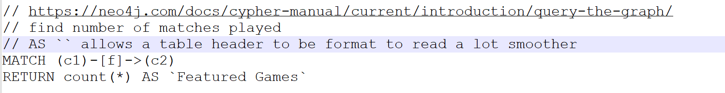

Result:

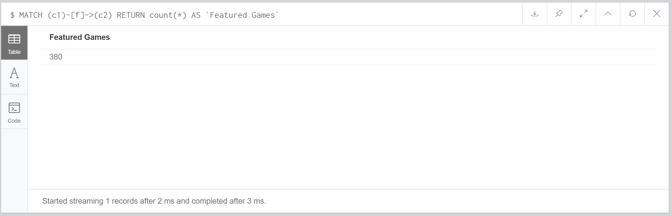

Summary: The query uses the match syntax to pull through all the relationships that are the same as (c1)-[f]->(c2). After it has pulled through all of these games it will return the information by counting all the returned matches by using count(*) and then format the output by adding AS `Featured Games` which make the results a lot more readable.

Reference: [1] Neo4j, URL: <https://neo4j.com/docs/cypher-manual/current/introduction/query-the-graph/>

## Query 2: Display details of all matches involved “Manchester United FC”

This query will find all the matches where the club Manchester united are involvedand display the details in a readable format for the user to view.

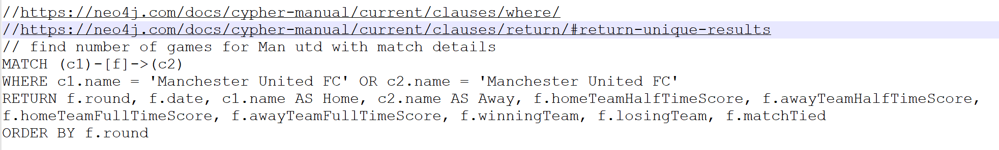Code:

Result:

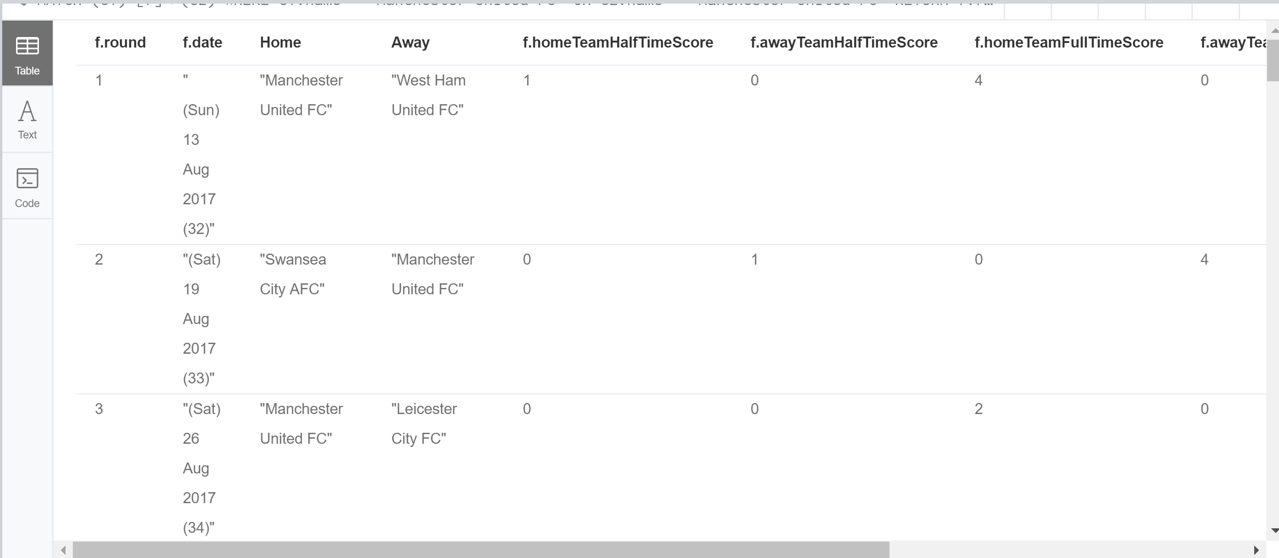

Summary: the query uses a where clause in order to set the criteria so the database only pulls through the relevant information once the criteria has been met the data that has been pulled through is formatted and then displayed.

Reference:

[2] Neo4j, URL: <https://neo4j.com/docs/cypher-manual/current/clauses/where/>

[3] Neo4j, URL: <https://neo4j.com/docs/cypher-manual/current/clauses/return/#return-unique-results>

## Query 3: Display all the teams that played the EPL matches in the season

This query will display all the teams that make up the EPL league and display them to the user in a readable format. The results will be displayed in alphabetical order.

Code:



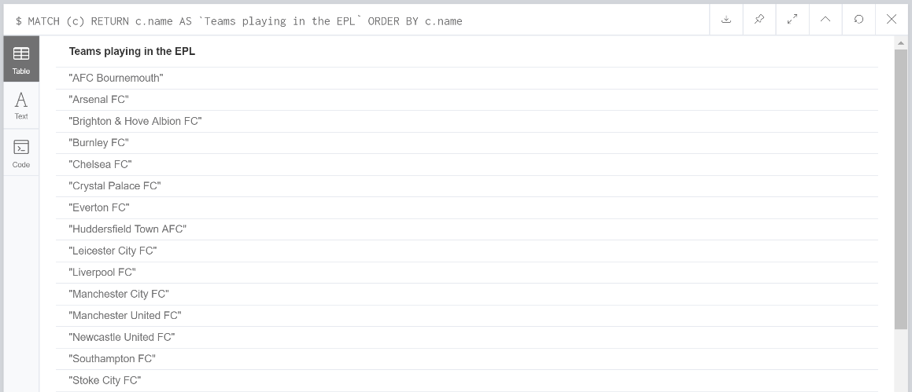Result:

Summary: Order By syntax has been added to the basic query in order to format the results in alphabetical order. It is set as a default with the ORDER BY function that the results return in alphabetical order so no additional criteria’s need to be added.

## Query 4: Display the team with the most “win” in January

This query will pull through the team that has won the most games in January.

Code:

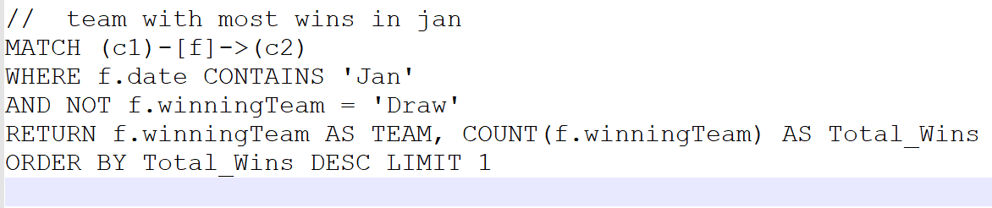

Result:

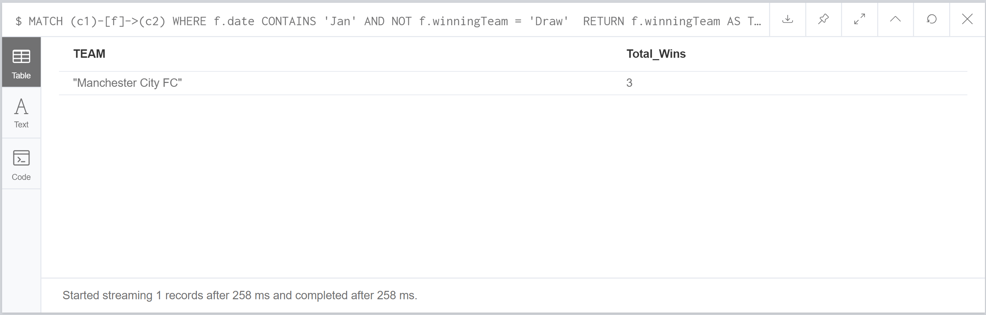

Summary: This query uses two criteria’s in order to find the required data to be pulled through. The first criteria is pulling through all the data that is related to the month of January by restring the date property. The next criteria is removing all the matches that ended in a draw. After the correct data has been pulled through the amount of winning teams are counted up for each team and returned. The query wants just the team with the most wins, this is done by restricting the results to just pull through the top result and to order the list by descending order.

## Query 5: Display the top five teams that have the best scoring power

This query will return the top five teams that have scored the most goal over the season.

Code:



Result:

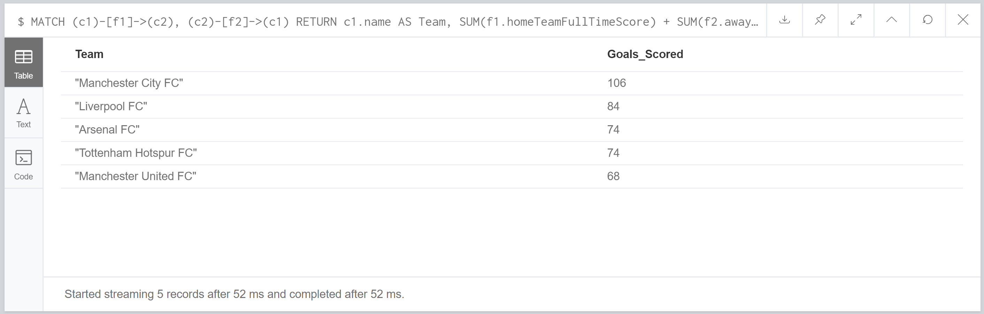

Summary: This pulls through all the goals each team has scored for when they are both the home team and the away team. The query will then sum the scores up and add both the totals together.

## Query 6: Display the top five teams that have the worst defending

This query will display the top five teams that have conceded the most goals in the EPL which results in them having the worst defence in the league.

Code:



Result:

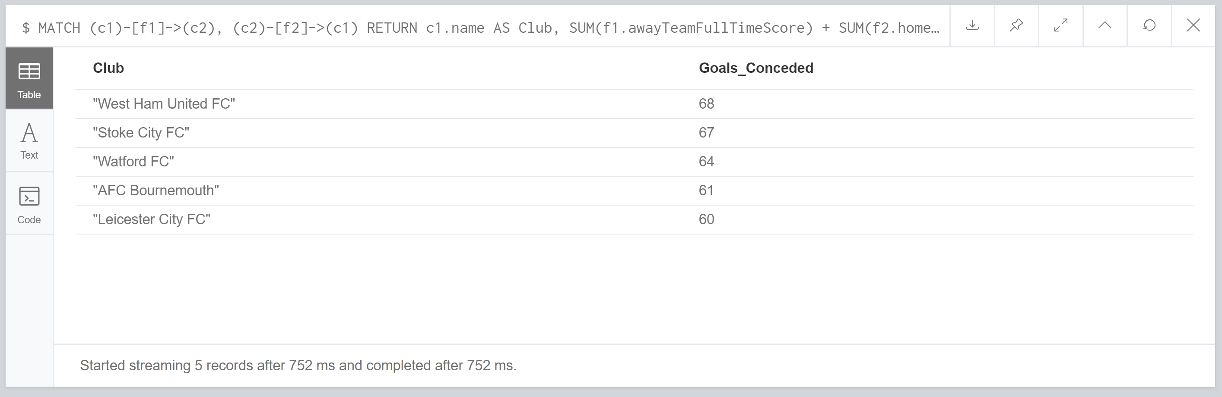

Summary: The query works the same as finding the team with the best scoring power but in reverse. It pulls through all the sores for goals that have been scored against a team. This is then added up using the SUM function returning to totals for when the team was at home and when they were playing away. This required the two sum functions to be added together to give an overall total of the amount of goals scored against a team. The order by and limit functions were used to restring the results to 5 teams that had the most goals scored against them.

## Query 7: Display top five teams that have the best winning records.

This query will pull through the top 5 teams that have won the most games throughout the season.

Code:

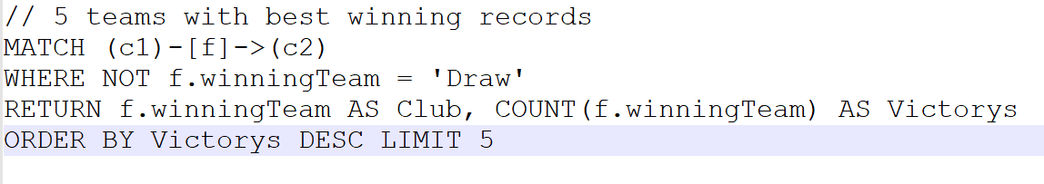

Results:

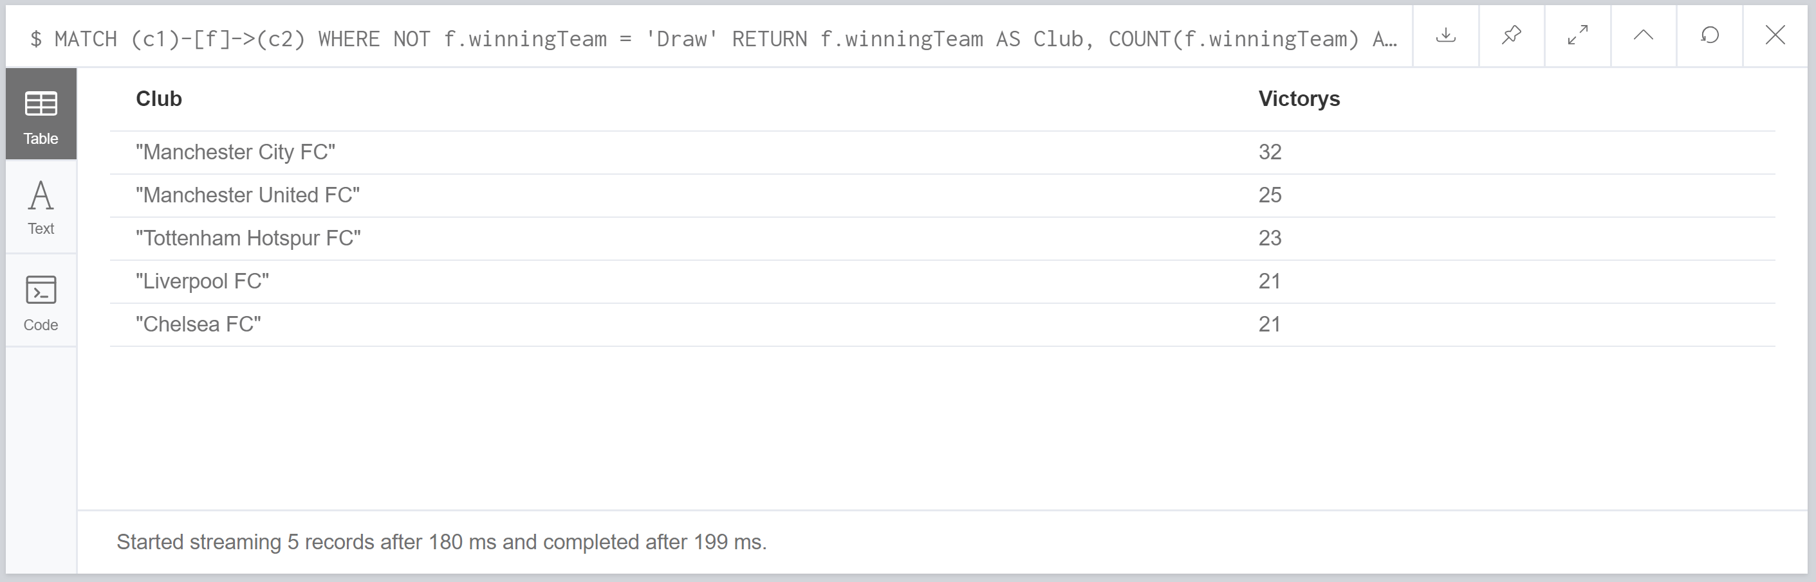

Summary:

The query pulls through all the games and removes any draws from the winningTeam property. This then allows the count function to group all the same winningTeams and count how many there were of one team. This allows us to order the teams by their wins by using the ORDER BY and LIMIT functions.

## Query 8: Display top five teams with best half time result

This query will display the top five teams that have the best goal difference at the end of the first half.

Code:

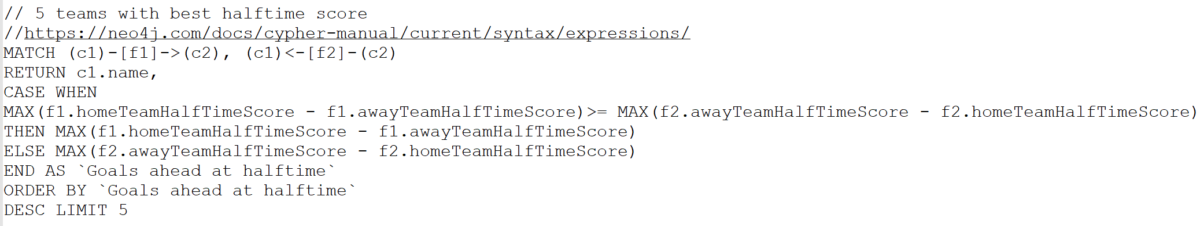

Result:

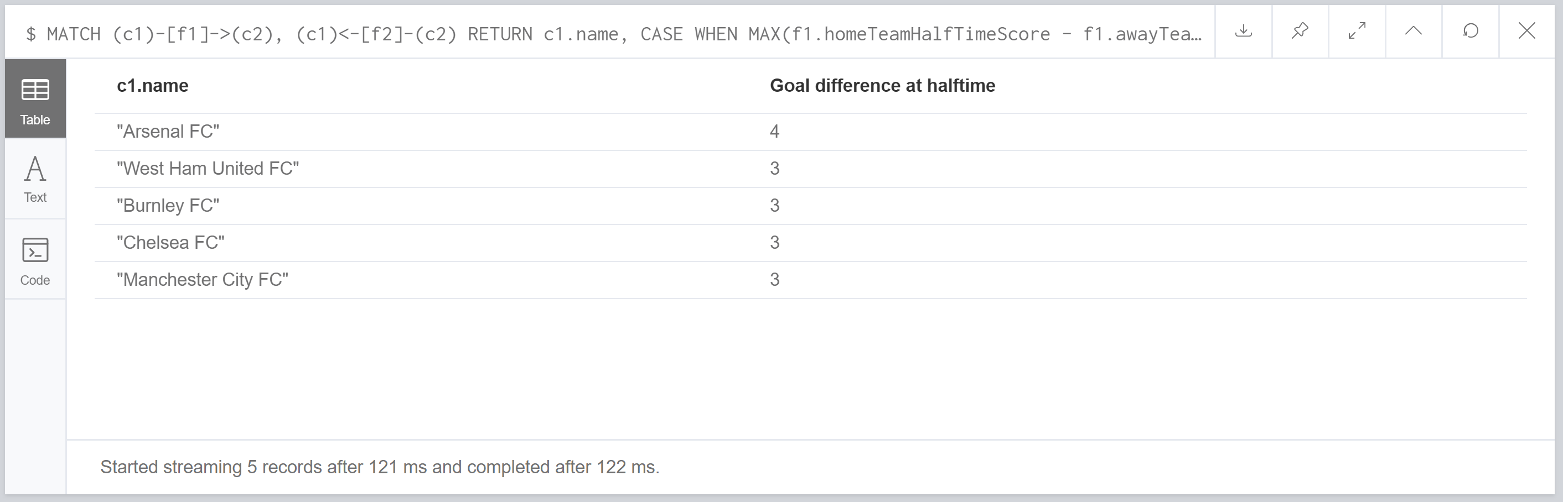

Summary:

This query runs a case expression in order to find out the goal difference at the end of the first half for all the games. It then finds out whether the home team is ahead or the away team is ahead. Depending on the answer will decide whether the home team score is taken away from the away teams score or the other way around to get the goal difference. After this is done the MAX function is used in order to pull through the highest number and then the ORDER BY and LIMIT is used to format the output from the highest difference to the lowest goal difference limiting it to 5 teams.

Reference:

[4] Neo4j, URL: <https://neo4j.com/docs/cypher-manual/current/syntax/expressions/>

## Query 9: Which teams had the most “loss”

This query will pull through the team that had lost the most games during the season. Due to the query using plural teams but doesn’t specify how many teams this query will pull through the top five teams that have the most losses. This is because the previous queries have limited the teams to five and the results are clearer as multiple teams have the same number of losses.

Code:

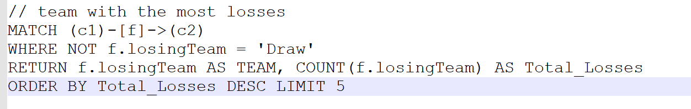

Result:

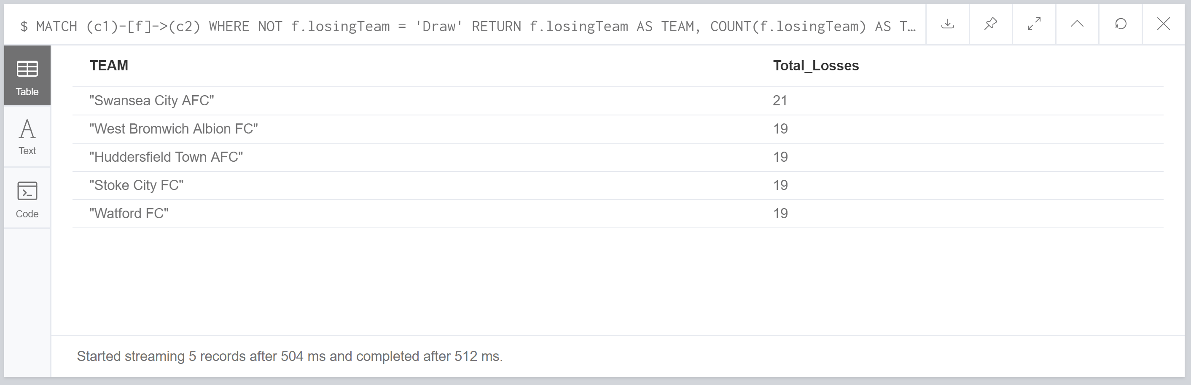

Summary:

This query counts the amount of times a team populates the losingTeam property in a relationship and then will return the results in descending order due to the formatting on the returned output.

## Query 10: Display the team with the most consecutive “wins

This query will pull through the team that has won the most amount of games in a row.

Code:

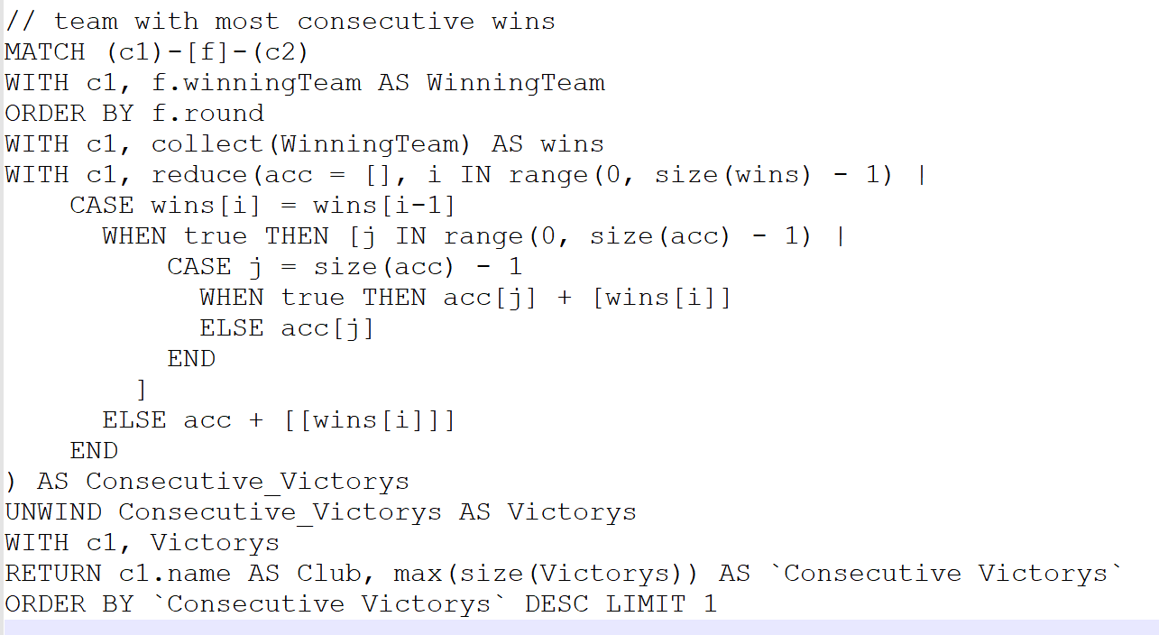

Result:

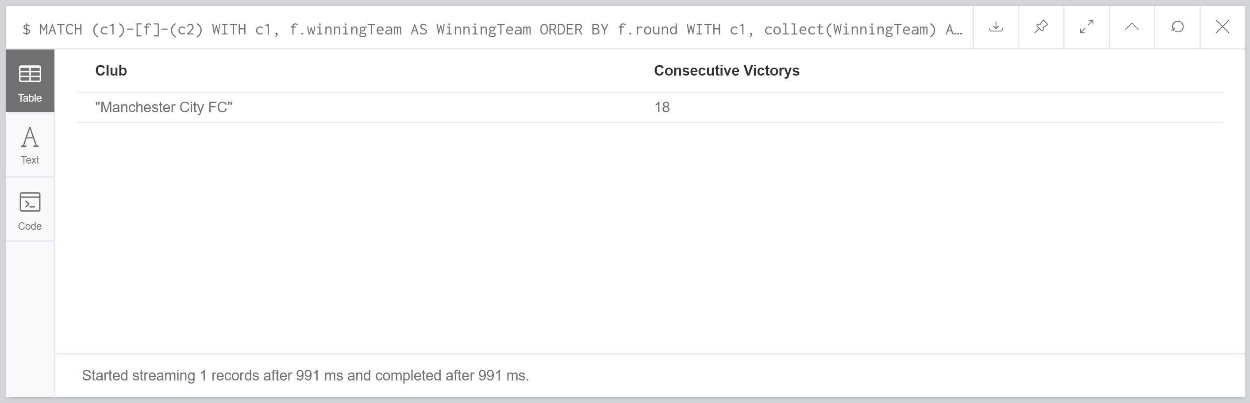

Summary:

This query pulls through all the times a team has won and stores them in a list the while loop will then unwind the teams results and add them to a array in order to count up how many times they have won before the next match result is anything other than a win. This is then put in order so by using the MAX function so the highest amount of wins a team has got consecutively will be outputted. The teams are then ordered by their highest consecutive wins total.

Reference:

[5] Gabor Szarnyas, URL: <https://stackoverflow.com/questions/48340317/list-the-most-consecutive-wins-in-cypher>

# Database Evaluation

In this section of the report The database will be evaluated by how well built it is and how it could be improved or done differently.

The database is constructed in a way to have the same number of nodes as there are teams in order to keep it easy to read. All the nodes represent each team in the EPL. The data for each of the matches played is stored in the relationship so when querying the main information would be in the relationship. This makes it easy to understand what the MATCH feature needs and what to reference when trying to pull through properties. This way provides positives as it’s easy to understand the logic and what is required in the querying.

Another approach would be to create match nodes as well as nodes for the clubs. This would mean that two club nodes will point to a match node that stores all the data for the match. This would be clear and easy to read as well but the reason why this database wasn’t designed with this approach is you have one type of node that only has one property and a relationship which wouldn’t have any properties, so all the properties are still in one type of node which could be of type Match for example. Now the way the database was actually done was store all the properties in the relationship which means only one type of node is needed. This cuts out on additional nodes and it makes the relationships more useful as instead of not storing any data they now store all the match information. If the database had stored match information in another type of node then you would have 380 nodes for matches plus 20 nodes for the teams and 760 relationships. The way the database has been done you have 380 relationships and 20 nodes.

A downside to the way the database has been made is the way the match result is stored for draws. As the property is stored even when a game was won and lost by teams it will just store a null value which doesn’t do anything. A more efficient way to do this is just to store Draw in winning and losing team as it does at the moment and then query the database using either winning team equals draw or losing team equals draw instead of using the match tied property this method would completely remove the match tied property.

# Learning Diary Evaluation

This section of the report will evaluate the learning diary and what has been learnt and what needs to be looked and practiced further. This will also investigate what has been understood well and the developer is comfortable at.

The developer has attempted all the exercises that have been included in the lecture slides. All the exercises have produced a valid response, but errors have occurred and noted in the learning diary.

The first few weeks gave me a good insight into the background of NOSQL these weeks taught me why NOSQL was even created. This gave me the understanding as to what NOSQL’s purpose was, it also cleared up that NOSQL wasn’t there to replace SQL and relational databases it was designed to solve a problem of scalability. I originally struggled to grasp the concept of the issue but after researching it a little further I was able to find a more simplistic understanding as I find that easier to understand knowing terminology isn’t my forte.

The next few weeks were studying basic functions and looking at creating and querying a database. I found understanding the syntax to this quiet quickly and everything was a lot easier to understand than when I compared it to SQL which I preferred. Understanding the syntax wasn’t too hard when walked through because it was well explained and clear as you could display it in the console when ran. I find being able to view the database as a graph helpful when your trying to understand what the query’s are doing. The main struggle through the next few weeks was trying to remember the syntax from memory for these basic database creation or querying syntax.

The next section of NOSQL was the SET INDEX and CONSTRAINT features. I understood how to use these pretty comfortably but what I questioned is why do we need these. This made me investigate when they are used within bigger databases. Constraints stopped duplication which help tackles user error. Set allows properties to be added at a later point in the creation of the database so not everything to the database needs to be created from the start. It can be added when it is required for the first time. Allowing more flexibility. The part of this section that I struggled with was understanding Indexing. I had to look further into indexing in order to understand its usefulness better.

The next stage was understanding MERGE this took a little bit of time and going through each of the cases helped make it clearer what to expect when you use MERGE within the database.

As we got into the later weeks of the term, I found it hard in week 8 which was understanding the shortest path functions and it took me a bit of practice to get the syntaxing correct for loading files from CSV. After looking at loading from CSV I started testing out other files that you could load from this took a lot of practice and time just to fully understand.

The fundamental understanding I took from the term was why NOSQL was used and was able to understand the basic syntaxing and creation of a Graph database using Neo4j. I also was able to get an understanding of the different types of databases that NOSQL has to offer and the problem that NOSQL was created to solve. I also was able to find good documentation sources for further learnings to help understand more advanced functionality. I have a really strong understand of using aggregate functions as I have constantly used them and practiced them.

The main areas that require further research and work on is using the path functions e.g. shortestpath. Other areas include using lists and unwinding them and what they can be helped for as I feel the understanding I have of them isn’t enough to get the full potential out of using these features. I would like to be able to understand more advanced queries that contain while loops with a mix of collect, reduce, unwind features as I have found these harder to understand. For example without the references then I wouldn’t have been able to complete query 10 but with the help of the reference I was able to adapt it to my database in order to get a valid result. I feel more practice with these and I’ll have a better understanding of how the inner features work. The issue here isn’t the while loop but more what is going on during the while loop.

In summary I think I am at a good standard in my understanding of NOSQL I feel confident in my ability to create basic querys on a database but I also understand that a lot more work is needed in order for me to understand more advanced features and how to properly use them to their fullest extent this will come with a practice and gaining as much knowledge as possible.

# Appendix

## Learning Diary

### Week 2:

Exercises:

What's NoSQL? NoSQL is a database design that is implemented in order to solve some of the issues that come with Relational databases. These issues are mainly down to scalability, efficiency and cost effectiveness.

Reference: [6] Wikipedia, 16 November 2018, at 01:46 (UTC), NoSQL, access: https://en.wikipedia.org/wiki/NoSQL, date acessed: 12/10/2018

What’s the rationale of NoSQL movement? The rationale of NoSQL movement is the understanding of the original problems that arose from companies using relational database systems. The main issues was the reading and writing from and to servers that stored the data. At first big companies would implement the Master/slave idea to solve this issue. A problem with master/Slave at the beginning was that reading from the slaves worked fine but writing to the master would still cause issues as there was only one master server. The solution to this was to use multiple master servers to deal with the load. This was an improvement but the master would have to take time sending information with the other master servers. This solution wasn't good enough as more data was collected. The next solution was to create partitions and store the servers all around the world. This ment that servers would only deal with specific data E.g. users starting in A would have all their data stored on one server, B would be on another one. The issue from this was that the servers would have to interact with each other and the more often they interact then the efficiency and downtime would start to rise. This lead to NoSQL being created which was a cloud based solution using different methods to group and store data together improving efficiency and lowering downtime for the users.

Reference: [7] Ian Wrigley, n.d, Understanding the "NoSQL movement", access: https://www.alphr.com/realworld/355477/understanding-the-nosql-movement, date accessed: 12/10/2018

What are the different kinds of NoSQL data stores? Briefly describe how they work. Key-values stored: all items are stored as either a key or an attribute paired up with its value, each value stored can also have a type which allows additional functionality.

Document-databases: each key is paired to a document. Documents contain key and value pairs or even other nested documents in order to store related data.

wide-column stores: this works by storing data in columns instead of storing data in rows this helps bigdata querying.

Graph stores: graph stores data and relationships. Each data is linked to another through a relationship.

Reference: [8] MongoDB, n.d, What is NoSQL?, access: https://www.mongodb.com/nosql-inline, date accessed: 12/10/2018

What are the different kinds of NoSQL data stores? Briefly describe how they work. Key-values stored: all items are stored as either a key or an attribute paired up with its value, each value stored can also have a type which allows additional functionality.

Document-databases: each key is paired to a document. Documents contain key and value pairs or even other nested documents in order to store related data.

wide-column stores: this works by storing data in columns instead of storing data in rows this helps bigdata querying.

Graph stores: graph stores data and relationships. Each data is linked to another through a relationship.

Reference: [9] MongoDB, n.d, What is NoSQL?, access: https://www.mongodb.com/nosql-inline, date accessed: 12/10/2018

Do some research and compare relational databases to NoSQL databases from different aspects such as schema/data structure, scalability, performance, data integrity, query languages, etc.

Data model: NoSql makes it easier to add data to the database and changes when needed due to the fact it doesn't need a schema defined first whereas Relational databases does.

Data Structure: Data that is stored today is different and less structured than in the past. Data in the past was structured so it was easier for relational databases to store but now it's unstructured and different relational databases struggle to store it in a structured sense. NoSQL can store unstructured data a lot easier and more efficiently.

Scaling: Scaling is one of the main differences and reason why NoSQL has been adopted by larger companies. It is a lot cheaper to scale out a NoSQL database than a relational database.

Development model: relational databases aren't open source so they tend to have a cost just to get started in building a database project. NoSQL is open source which means you can start a database project without incurring any fees.

Reference: [10] MongoDB, n.d, NoSQL Vs Relational Databases, access: https://www.mongodb.com/scale/nosql-vs-relational-databases, date accessed: 12/10/2018

Find out some challenges faced by traditional firms that use relational databases in adopting NoSQL databases. The first major challenge that face users going from a relational database to a NoSQL one is that the user needs to get out of the typical relational mindset where you have a lot more rules to follow in order to acomplish storing data correctly. Users find they think they need to make and have a lot more structure and integrity when moving to NoSQL but they didn't need it.

Secondly when moving to NoSQL the main focus is on scalability this has lead to the sacrifice of ACID which is the atomic, consistent, isolated, durableness of the database. This means that data validation will need to be increased on the front end part of the app before the data is sent to the database.

Thirdly developers have to research into different NoSQL companies that have compromises for the ACID issue, This can be using different methods when running querying or inserting so some tasks will use ACID like searching by ID and other tasks will use BASE like searching on something other than an ID.

Fourthly a relational database guarantees to be valid where as NoSQL doesn't, this means some of the company data could be out dated and no longer used. This means developers have to come up with a way to find out how to best manage data that could end up being in valid. An example of this could be a product that eventually gets dropped by the business and is no longer sold.

The fifth issue is that NoSQL doesn't have any stored procedures. This is an issue of moving the business logic that was used in relational databases would need to be integrated into the app itself before the data is moved to the NoSQL database.

The sisth issue is that NoSQL isn't as popular as relational databases on the use of triggers. Developers have to utilize the different variations that NoSQL companies have designed as an alternative to using triggers. An example of this MongoDB use tail-end cursors to monitor changes.

The seventh issue is that even though NoSQL doesn't use a scema the app will have a scema so the developer will need to think of how the database will deal with changes to old objects. this can be solved by running scripts on the database to add the new attributes to an object.

Reference: [11] Judah Himango, Sep 20, 17, The Biggest Challenges of Moving to NoSQL, access: https://dzone.com/articles/the-biggest-challenges-of-moving-to-nosql, date accessed: 12/10/2018

Further questions:

1)Does NoSQL use the master/slave method or is this only for Relational databases? NoSQL does in fact use the master/slave infastructure but it is slightly different from how Relational Databases use it. NoSQL allows each of the slaves to become the master if they need to be. This method helps to stop any failures to the servers effect the database itself.

Reference: [12] chris Heald, sep 4 2010, reliability: Master/slave pattern is doomed?, accessed: https://stackoverflow.com/questions/3644128/reliability-master-slave-pattern-is-doomed date accessed 12/10/2018

2) How can you improve horizontal scalability ? A lot of improvements to scalability is mainly down to how memory is used. Memchached showed that in-memory indexes can improve the scalability of a database.

Referenced: [13] Rick Cattell, December 2011, Scalable SQL and NoSQL Data Stores, Access: Scalable SQL and NoSQL Data Stores.pdf, Date accessed: 12/10/2018

3) What is MySQL Cluster? MySQL Clusters is a function that replaces the DB engine with another one. This allows data to be sharded over multiple servers. This method uses in-memory and disc-based data to allow real-time responses. MySQL Clusters allow databases to write/read to more nodes a problem does occur that after a few nodes are used they run into a bottleneck effect which slows the process down. The work on MySQL clusters is still being worked on and should be able to show improvements eventually.

Reference: [14] Rick Cattell, December 2011, Scalable SQL and NoSQL Data Stores, Access: Scalable SQL and NoSQL Data Stores.pdf, Date accessed: 12/10/2018

Summary:

To summarise the information learnt this week I understood that my original thought that NoSQL would replace Relational databases and everything would eventually use NoSQL was incorrect. It is incorrect because what I learnt to be the case was that NoSQL isn't a fix all perfect solution. What NoSQL does is focuses on solving issues that the major companies face when using Relational databases which is growth and scaling of data. NoSQL won't replace Relational databases because while fixing these short comings of Relational Databases, NoSQL have occurred short comings of their own which relational database solve and is what their main strengths are which is the implementation of ACID. I now realise that NoSQL is infact just another option you could use when creating a database. Developers should look into what they need for their app and look at what they might need in the future as well. They can then compare their findings with the functionality of both relational databases and NoSQL in order to determine which is the better fit for them. An example of this could be a bank, banks have a high priority on data protection and security so naturally they will look at relational databases as they have the implementation of ACID.

I was unsure what the issues was going from relational databases to NoSQL. The main issues for a developer is getting out of the mindset of programing a Relational database, instead the developer should think about what the NoSQL database can do and if the issues aren't solved with the functionality of the database then the developer should think about how they can implement it on a front end level.

### Week 3

Exercises:

* Learning how to start Neo4j in the lab
* Learning how to play with the Movie graph database

Below are screen prints to show the workings of the Movie graph database.

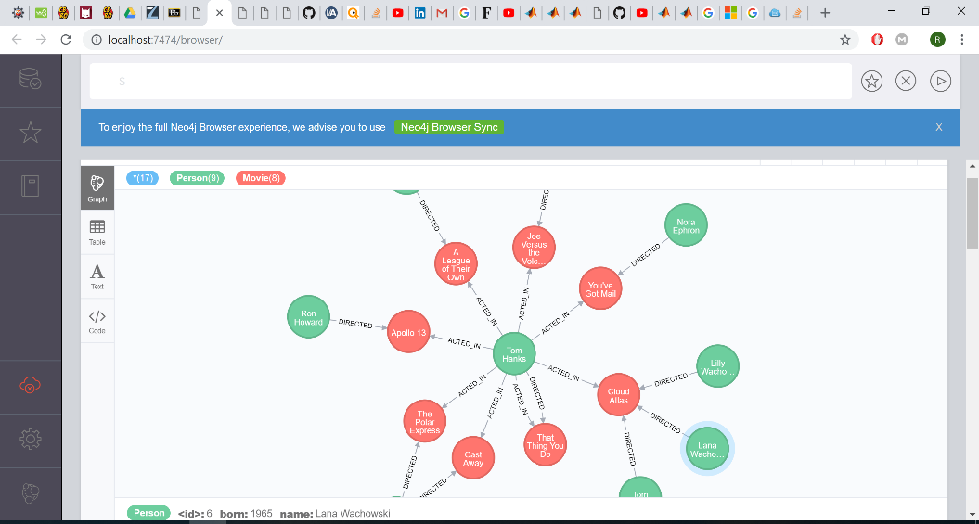

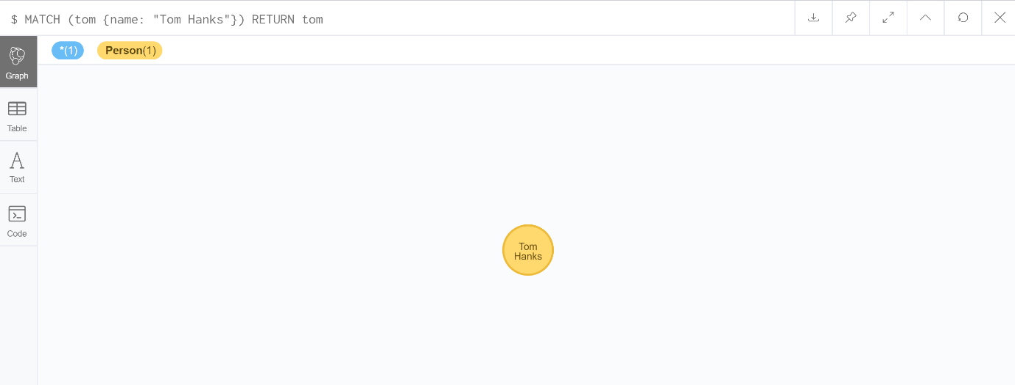

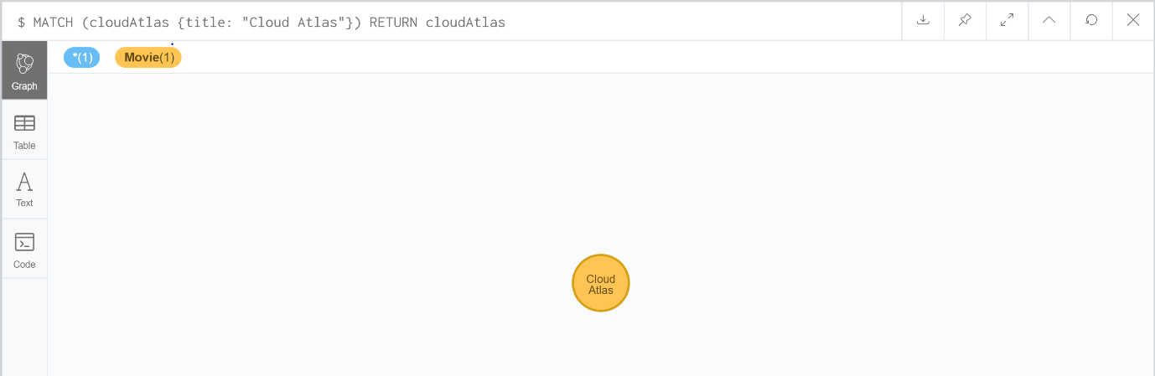

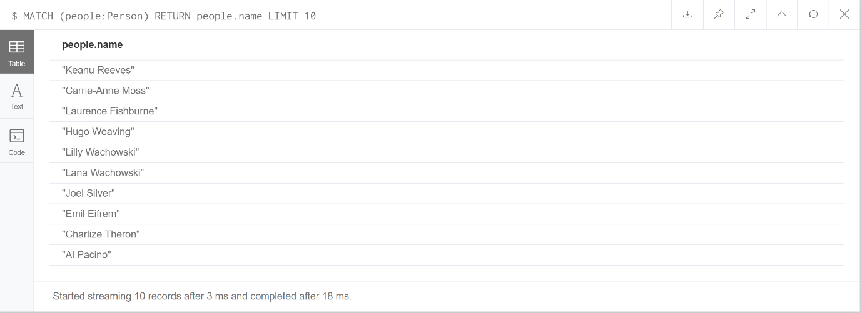

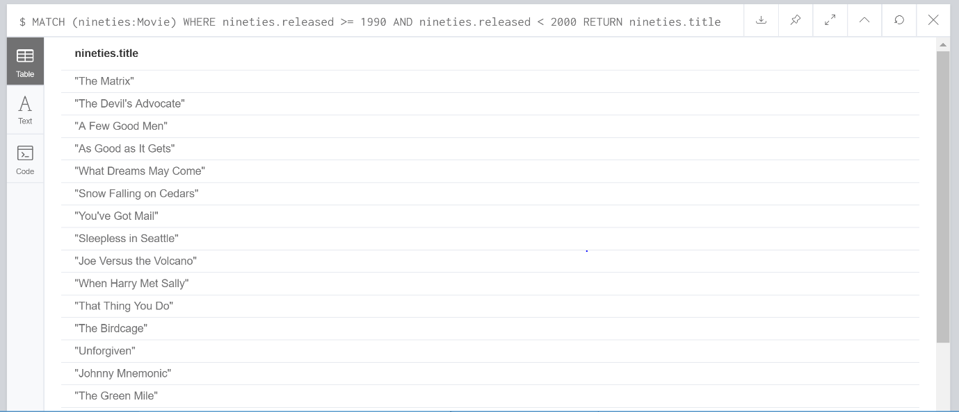

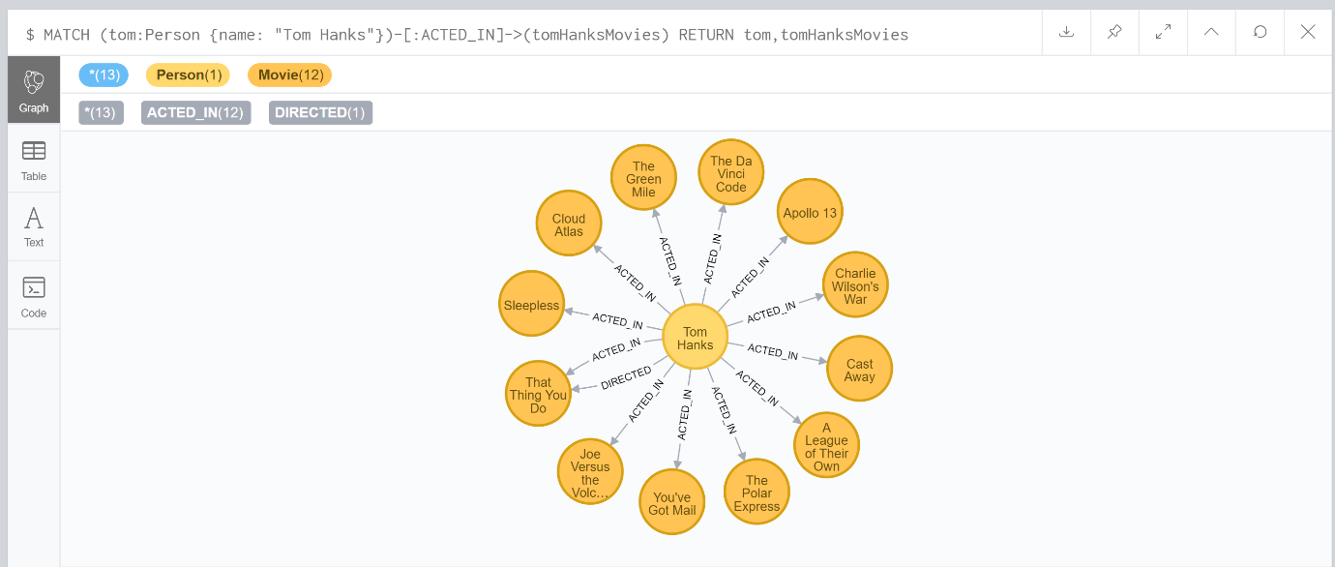

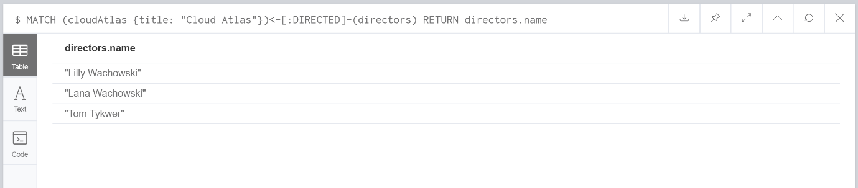

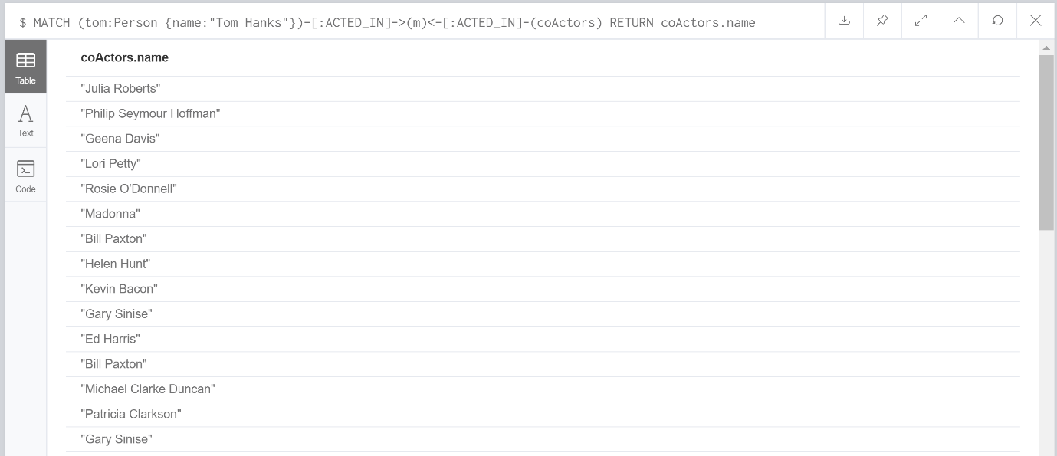

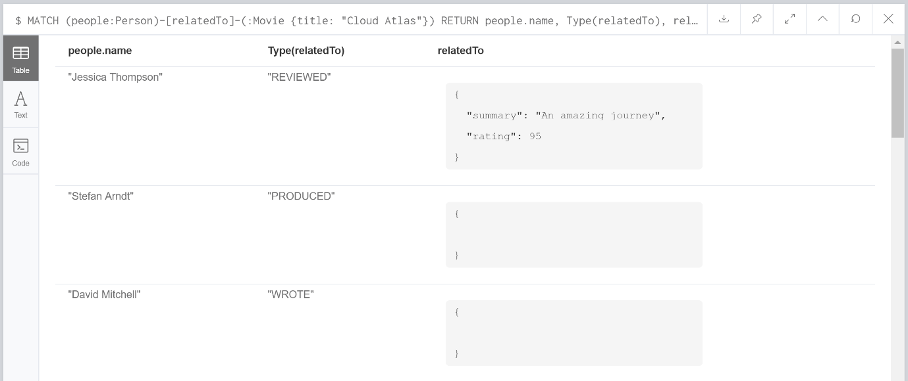

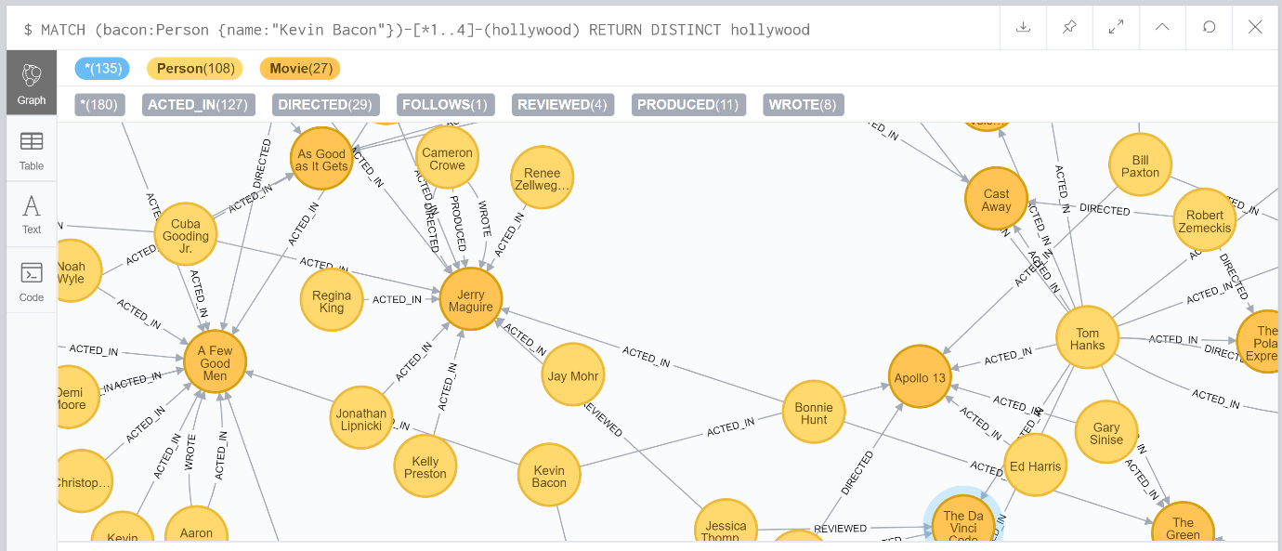

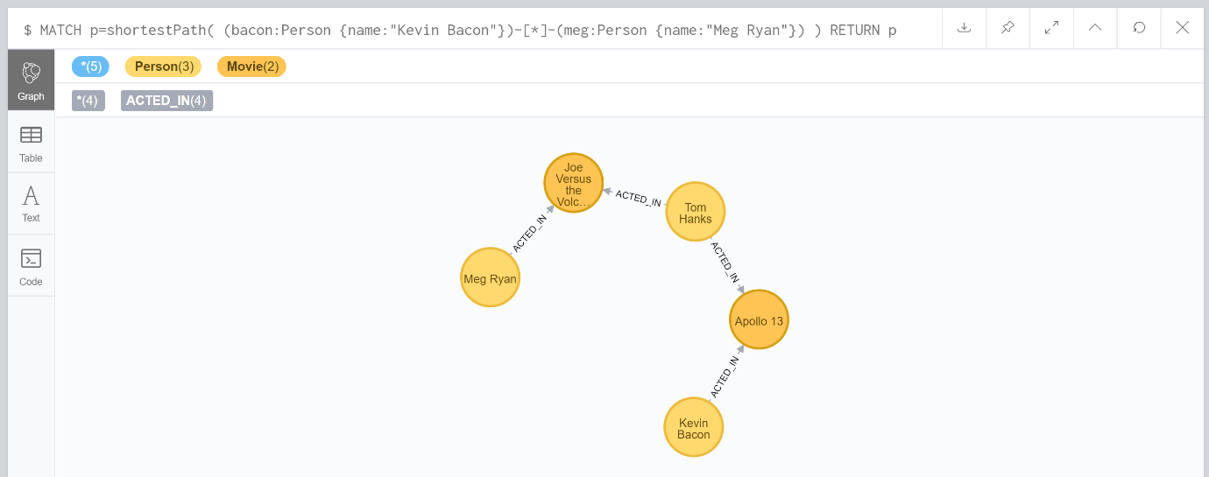

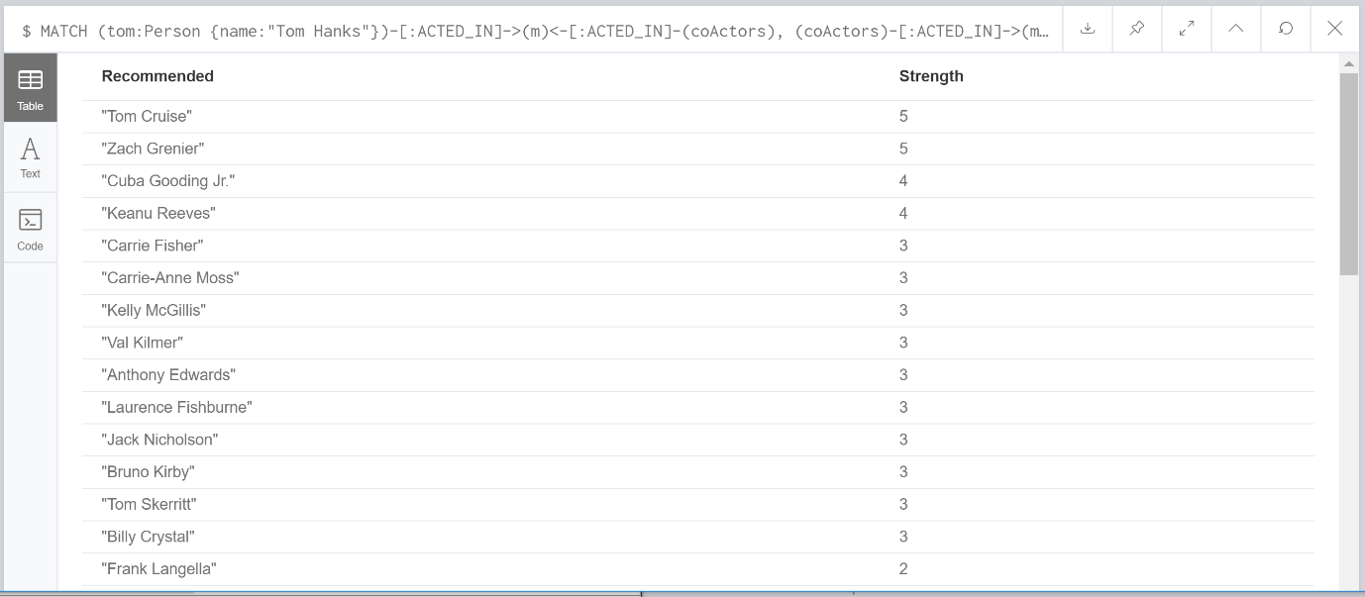

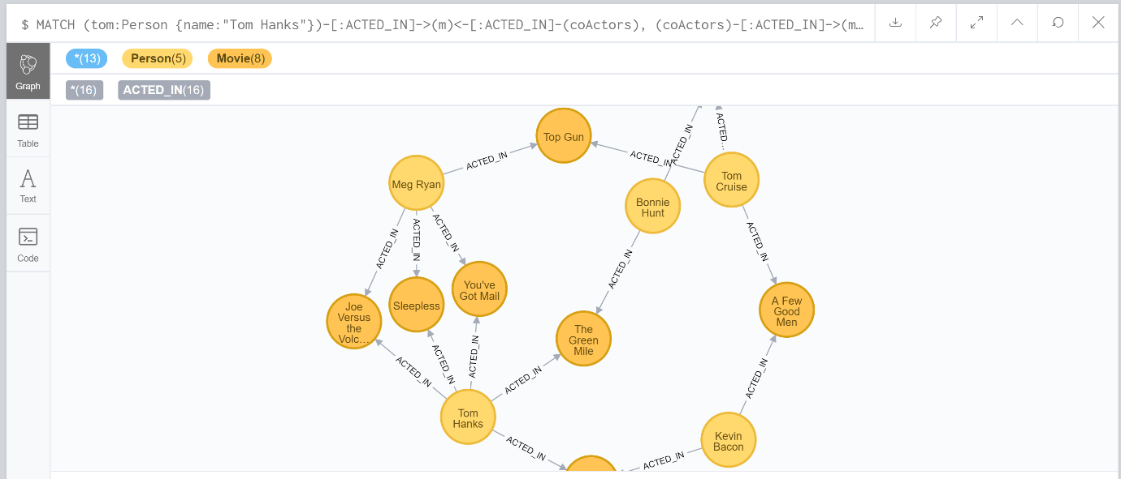

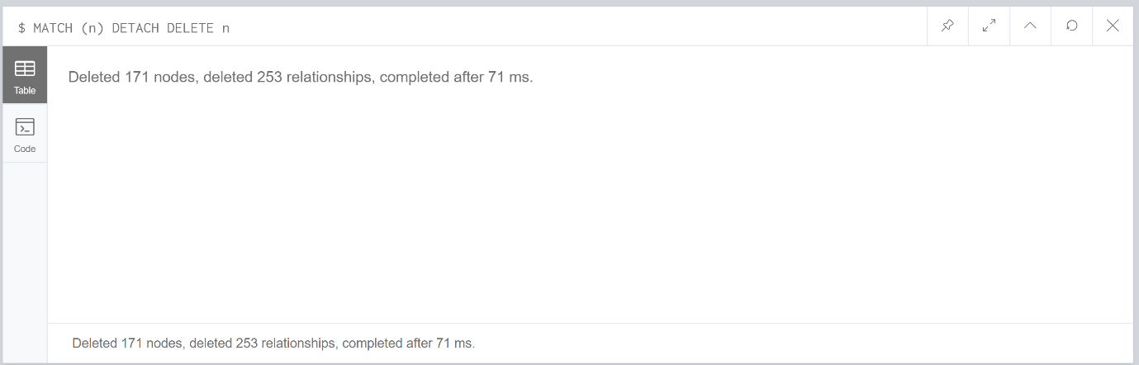

Further research:

1. Look into [1..] for a better understanding of how they work on databases.

This allows limitation on the number of relationships that are outputted so for [1…5] this will pull through nodes that are between 1 – 5 relationship chains away from the match criteria.

Reference: [15] Neo4j, URL: <https://neo4j.com/docs/cypher-manual/current/clauses/match/>

1. Read introductive documentation to understand the basic syntax to a further extent from the Movie graph.

I have read the referenced documentation and it has given me a clearer understanding of what the basic queries are trying to accomplish and why we use them to query the database.

Reference: [16] Neo4j, URL: <https://neo4j.com/developer/cypher-query-language/>

Summary:

This week I have learnt how to query a graph database and how to limit or restrict the output of the query by using key words. The movie graph example helped me understand the syntax for creating a database and how to query it. After working through the movie graph I wanted to look into documentation which I could clearly understanding and constantly use in order to further my understanding. I found neo4j.com/developer/ easy to follow and allowed me to understand the queries of the movie graph a lot better. This site could become useful in understanding querying the database a lot more. I am still struggling to understand the restrictions on relationships i.e. [1…3] syntax that is used further research into this is required.

### Week 4

Exercises:

Start the Neo4j database

Clear the database using the DETACH DELETE command

Create simple graph nodes and relationships

Delete some nodes and relationships

Log your learning activities and reflection in your learning diary

Answers:

MATCH (n) DETACH DELETE n --- This deletes everything in the database so I can start from scratch.

CREATE (s:Club{name:'Northampton Saints'}) --- creates a club node with a label/property of name storing Northampton Saints inside it.

CREATE (s:Club{name:'Saracens'}) --- creates a club node with a label/property of name storing Saracens inside it.

MATCH (s1:Club{name:'Northampton Saints'}), (s2:Club {name:'Saracens'})

CREATE (s1)-[P:Played]->(s2) --- This will find the two nodes previously made through the match and create a relationship called played from one team to the other.

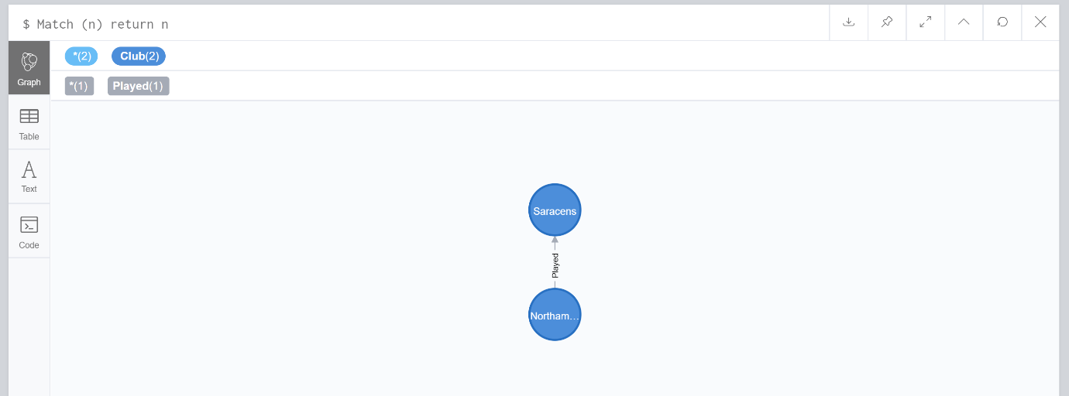

MATCH(s1)-[p:Played]->(s2)

DELETE p --- This code will find the relationship between two nodes and delete the relationship played leaving just the two nodes on their own.

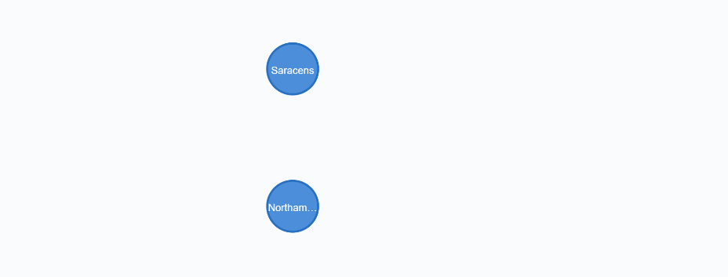

Errors:

MATCH (s1:Club{name:'Northampton Saints'}) (s2:Club {name:'Saracens'})

CREATE (s1)-[P:Played]->(s2) --- This error occurred because I missed a comma after the first node in the match line.

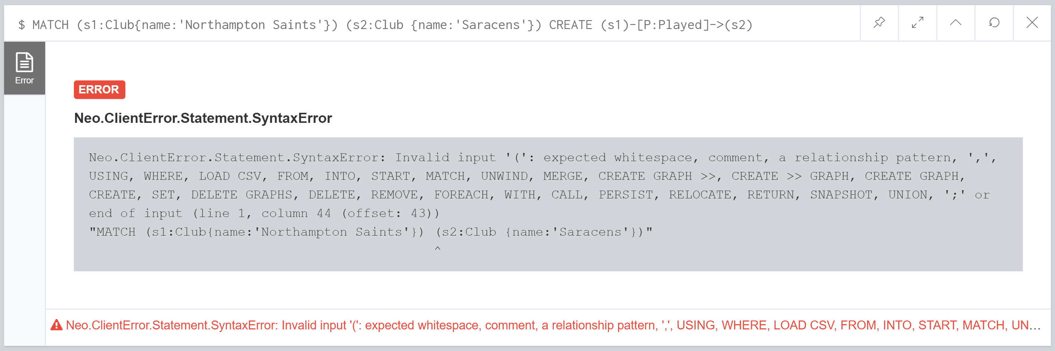

MATCH(s1)-[Played]->(s2)

DELETE p --- this error was caused because I missed of a variable infront of the relationship so it didn’t know what p was needed p:

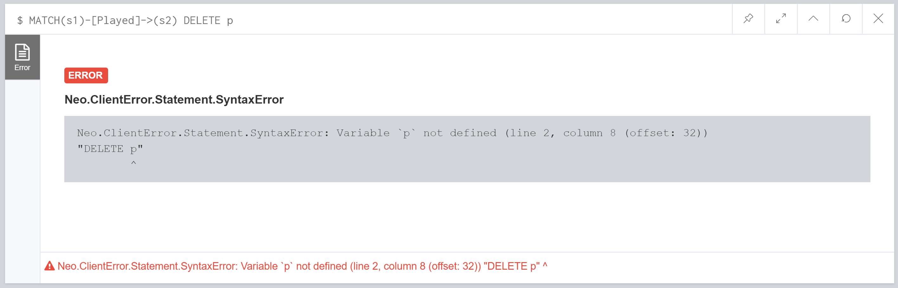

Further research:

1. Try creating multiple nodes at the same time in order to save time.

I haven’t been able to find documentation on this and tried to combine the nodes in order to test out this theory but I don’t think it is achievable.

Tests:

CREATE (s:Club{name:'Northampton Saints'}), (s:Club{name:'Saracens'}) --- didn’t work due to the variable already being used.

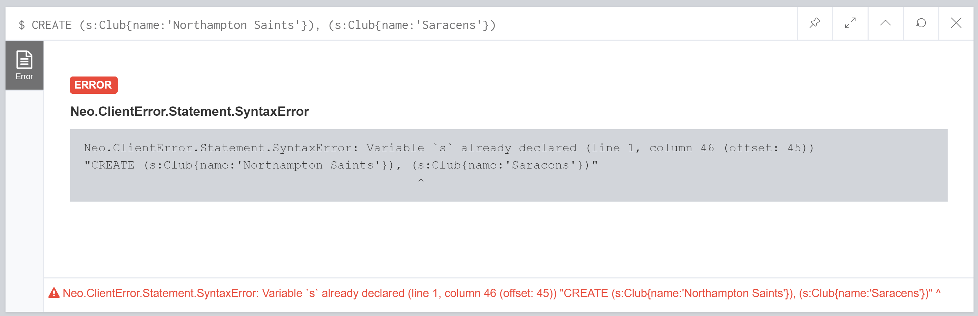

CREATE (Club{name:'Northampton Saints'}), (Club{name:'Saracens'})--- resulted in the same error but on Club this time

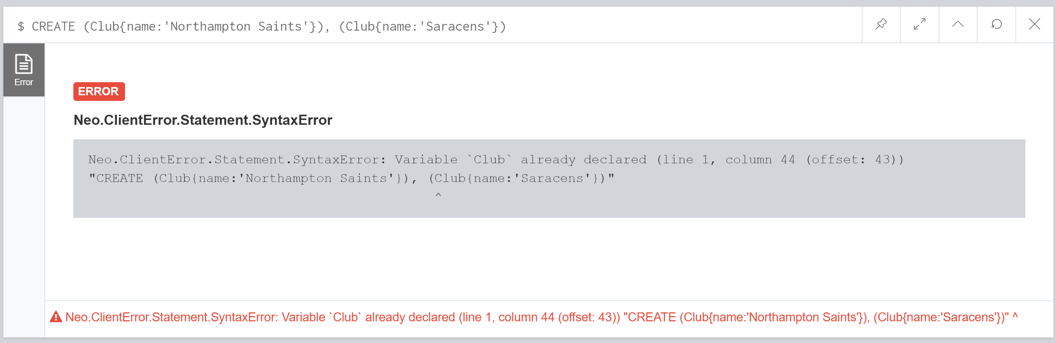

CREATE (Club{name:'Northampton Saints'},{name:'Saracens'}) --- error on using the comma in that position.

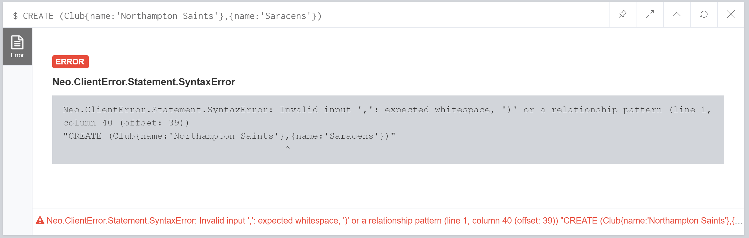

Summary:

This week I have looked at creating a simple database and deleting a relationship by using variables. I have a good understanding of this and decided to try and make the process more efficient by looking into creating multiple nodes at once of the same type. Unfortunately, all my tests that I tried have failed and I haven’t been able to find any documentation on this online. I should question whether this is possible to do. I also need to keep practicing the basics as remembering the correct syntax is awful and is important to getting the queries to work. This is evident as all the errors I got were caused by missing commas or missing variables. The logic for the queries and most important sections are there so that shows I understand what is going on but i need to be more accurate with the syntax.

### Week 5

Exercises:

* Start Neo4j
* Create a Module node with code: CSY3024

CREATE (s:Module{code:'CSY3024'})

* Create another Module node with the same code: CSY3024
* What happens? Why?

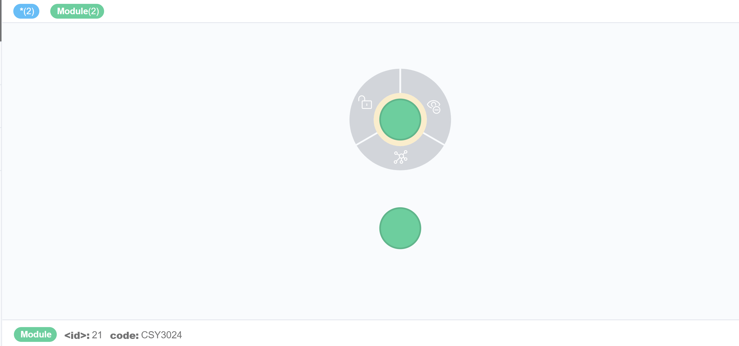

The System creates duplicate nodes because there is no constraint telling the database that having a duplicate is incorrect.

* Recall the duplicated actor/movie nodes and think about a solution to prevent it.

If there was a constraint then the system will throw out an error.

CREATE CONSTRAINT ON (s:Module) ASSERT m.code IS UNIQUE;

The above code will create a constraint on module nodes that are created which have a m.code. This means that any module nodes created can’t have the same m.code value as other nodes already in the system.

* Start the Neo4j database
* Using the reference codes in the early slides and practice how to add, remove properties in nodes/relationships and add and remove labels.

The following code removes the code property from a node.

MATCH (m:Module{code:'CSY3024'})

REMOVE m.code

RETURN m

The following code removes a label to a node.

MATCH (m:Module{code:'CSY3024'})

REMOVE m:Module

RETURN m

This still displays the properties of the node if there is any when you return the node.

The following code adds a label to a node.

MATCH (m:Module{code:'CSY3024'})

SET m:Module

RETURN m

* Log your learning activities and reflection in the diary.

Further research:

1. Understand using indexes and what is it good for.

Indexes are used to speed up the process of finding data within the database you do this by creating an index on a node and then searching for nodes with that index. This isn’t used as often because in queries you naturally use a default index for example search for specific node types and then by name again so using an index wouldn’t make it any faster to find this node.

Reference: [17] Neo4j, URL: https://neo4j.com/docs/getting-started/current/cypher-intro/schema/

1. What does traversal mean.

Traversal means searching each node and through the graph and either search for something or update the node.

Reference: [18] Wiki, URL: <https://en.wikipedia.org/wiki/Tree_traversal>

Summary:

In summary using set is really useful because it allows you to add properties to the database when needed if suddenly a database needs to store new data then set can be used in order to add it to created nodes or relationships. Constraints are a useful tool to help protect the database from user error. I still don’t fully see the purpose of indexes and haven’t been persuaded really by researching it further as to why I should look to use them maybe if I keep looking into it I could find out their usefulness but this also could be a bit redundant.

### Week 6

Exercises:

* Start Neo4j database
* Create some nodes and relationships based on the diagram on the previous slides (or a similar diagram of your choice).
* Practice the MERGE clause for all the nine different cases listed on the previous slides.
* Log your learning activities and reflection in your diary

MERGE (p:Player{name:"James"}) --- checks to see if node exists if it doesn’t then create one.

ON CREATE SET p.createtime = timestamp() -- puts a time property when the node is created this is null because the node already existed.

ON MATCH SET p.foundtime = timestamp() – how long until the node was found property

RETURN p.name, p.createtime, p.foundtime

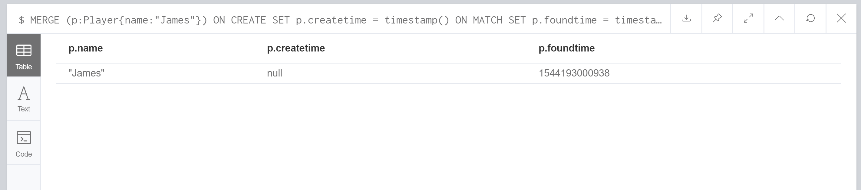

Case 1: Using merge when the two nodes and the relationship already exists will find them and as there is no change to the details nothing will be changed in the database.

MERGE (p:Player{name:"James"})-[:Plays]->(g:Game{name:"Rugby"})

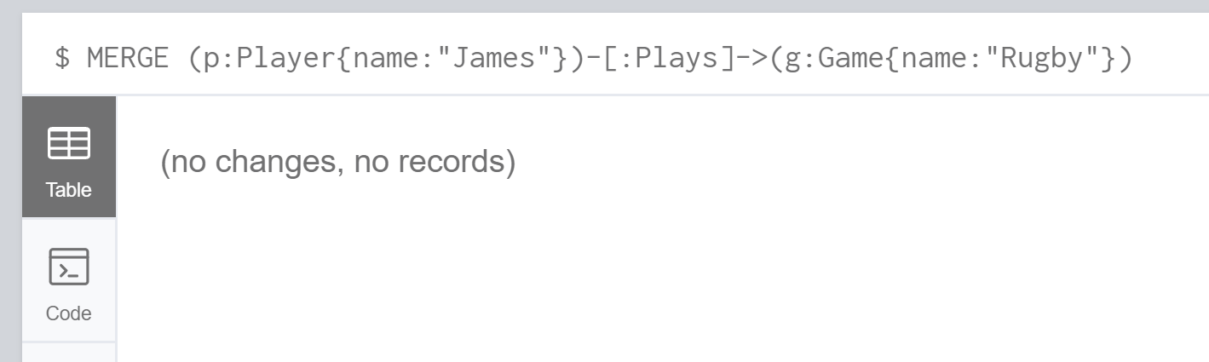

Case 2: Using merge when two nodes exist but not the relationship. This will create two additional nodes exactly like the ones already in the database and join them together with the relationship stated in the merge statement. You can see this below.

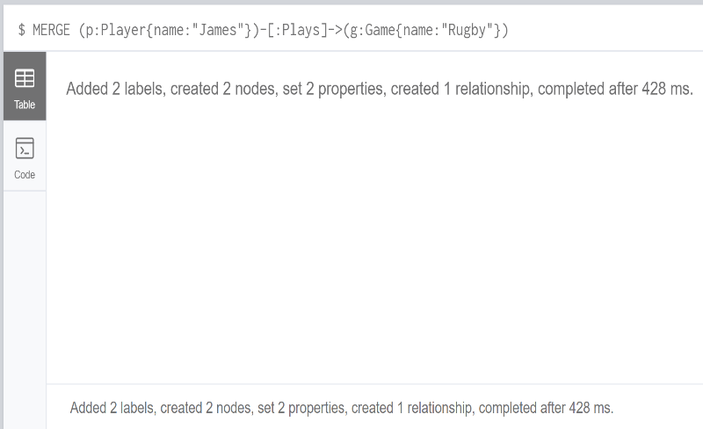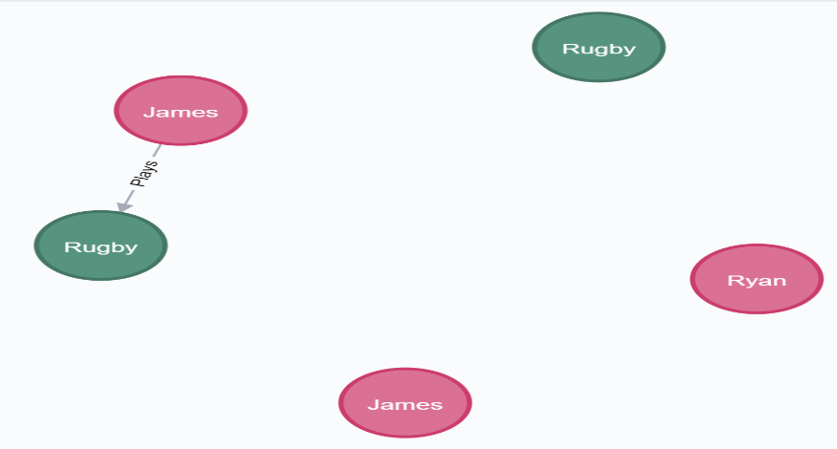MERGE (p:Player{name:"James"})-[:Plays]->(g:Game{name:"Rugby"})

Case 3: Using the merge statement with only one node already in the database so the relationship and the opposite node won’t be found. This will result in the database creating the entire merge statement. So you will have 1 node duplicated and it will be linked to another node by a relationship stated by the merge statement. This can be viewed below.

MERGE (p:Player{name:"James"})-[:Plays]->(g:Game{name:"Rugby"})

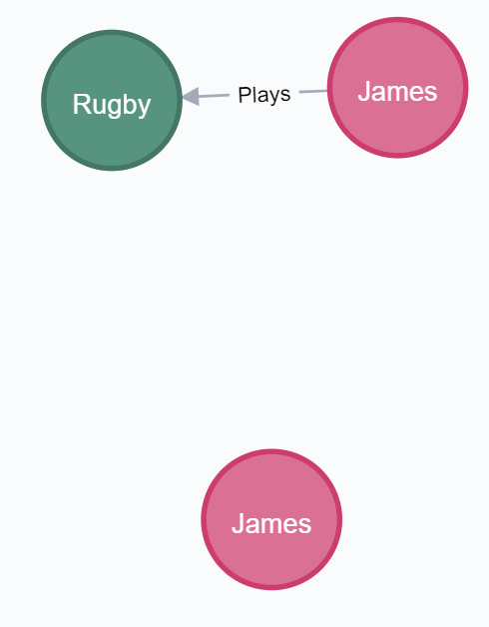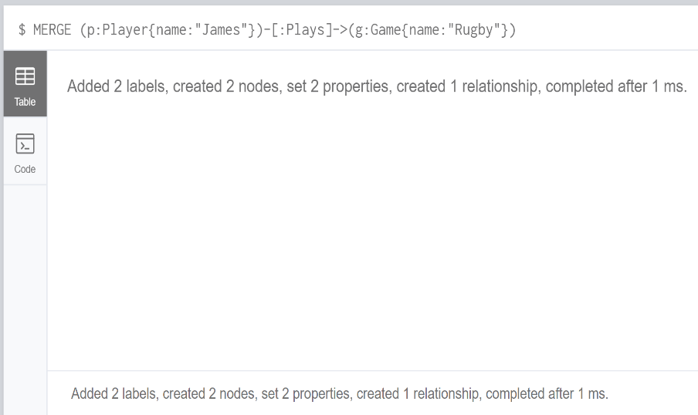

Case 4: If there is a constraint on a node and the merge statement try’s to create a duplicate of that node the system will output an error as you’re not allowed to break the rule set by the constraint.

CREATE CONSTRAINT ON (p:Player) ASSERT p.name IS UNIQUE

MERGE (p:Player{name:"James"})

MERGE (p:Player{name:"James"})-[:Plays]->(g:Game{name:"Rugby"})

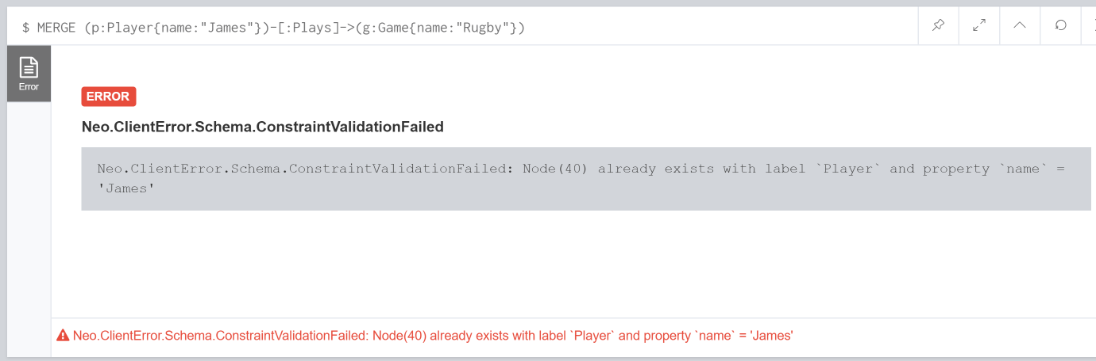

Case 5: Using merge when all nodes and relationships exist but there is an extra property on one of the nodes. This creates a duplicate of what is already in the database because the merge statement doesn’t match entirely to what’s in the database.

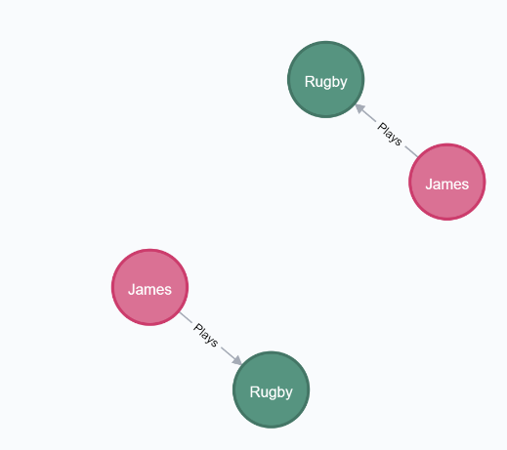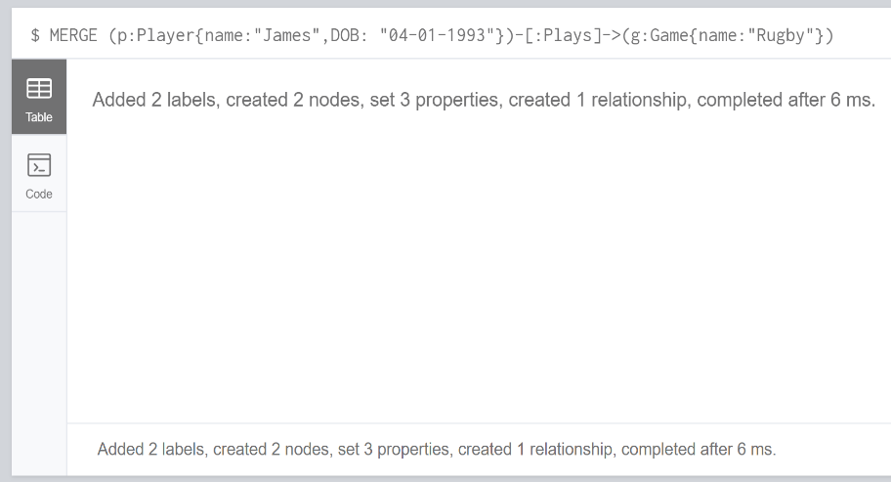MERGE (p:Player{name:"James", DOB: "04-01-1993"})-[:Plays]->(g:Game{name:"Rugby"})

Case 6: Using merge that has two nodes and a relationship that match but the direction of the relationship is different. This will cause the database to duplicate the already stored relationship and nodes and put the relationship direction the opposite way.

MERGE (p:Player{name:"James"})<-[:Plays]-(g:Game{name:"Rugby"})

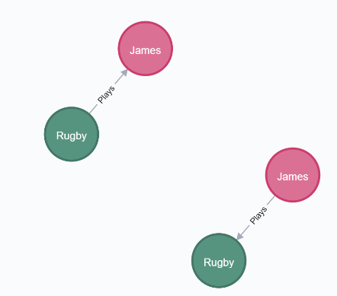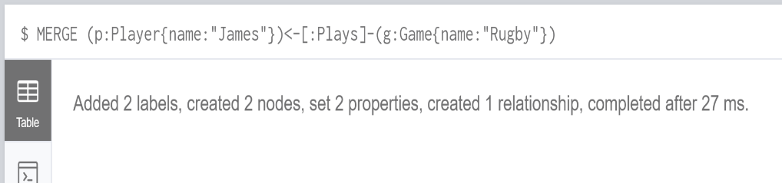

Case 7: Using match and merge when two nodes exist but no relationship. This will create the relationship as both nodes are already in the database.

MATCH (p:Player{name:"James"}), (g:Game{name:"Rugby"})

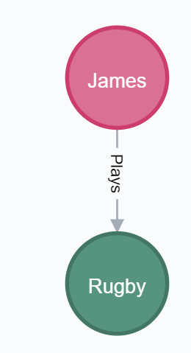MERGE (p)-[:Plays]-(g)

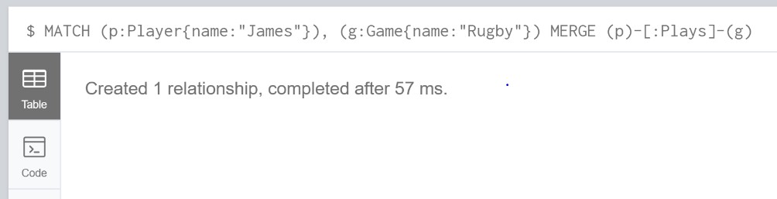

Case 8: Using merge on two nodes exist with a relationship using no direction relationship. This will make no changes to the database as the relationship already exists.

MATCH (p:Player{name:"James"}), (g:Game{name:"Rugby"})

MERGE (p)-[:Plays]-(g)

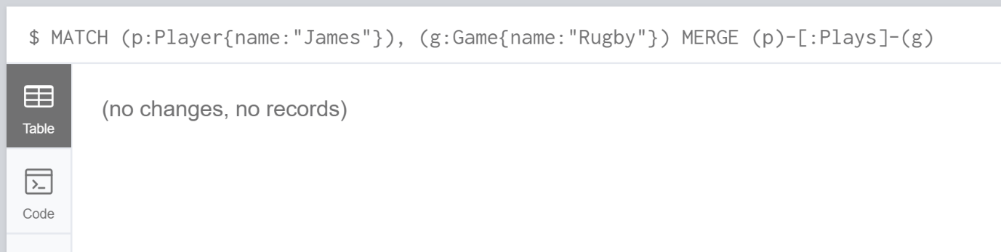

Summary:

To summarise this week of work it took me a while to grasp the merge concept, so I had to investigate it a lot and play around with it more in order to understand when it will work as I want it to. This meant a few recaps in lesson was needed and questions reiterated. After the lesson I have a better understanding of merge and through doing the cases I believe I now know what to expect in each of the scenarios when using merge this could be a useful feature to use but only if the circumstances are correct.

### Week 7:

Exercise:

Refer to the diagram on the previous slide, and write some

commands to create a KNOWS relationship between the ‘Scott’ and

‘Gary’ nodes with an attribute: value ‘since:1996’.

MERGE (scott:Person{name:'Scott'})

MERGE (gary:Person{name:'Gary'})

CREATE UNIQUE (scott)-[:KNOWS{value:'Since:1996'}]->(gary)

RETURN *

The above code will create the two nodes and the relationship if they don’t already exist. If the nodes and relationship already exist it will just display them. This will aso add the properties to the already existing nodes if they didn’t exist.

Exercise: • Create some graph nodes (without an attribute called ‘marked’) and

relationships based on the model on the previous slide.

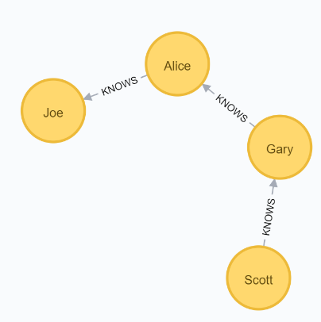

Run the FOREACH command from the previous slice to set the value

of ‘marked’ attribute to ‘TRUE’.

MATCH p=(begin)-[*]->(end)

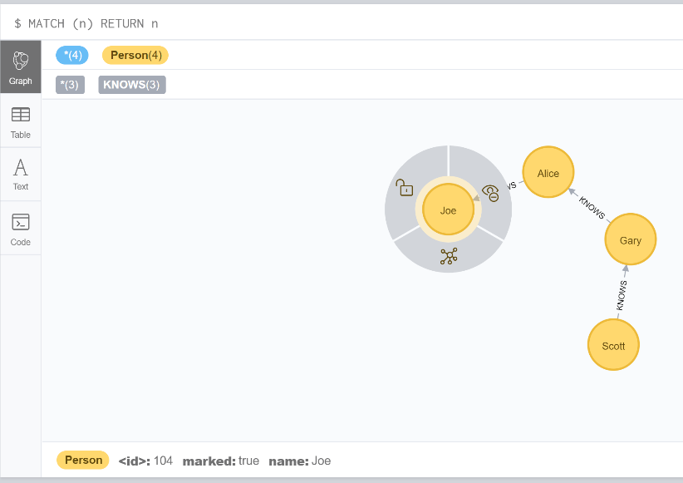WHERE begin.name='Scott' AND end.name='Joe'

FOREACH (n IN nodes(p) | SET n.marked = TRUE)

• Add additional property to each relationship using FOREACH and the

relationships() function.

• Verify the output.

MATCH p=(begin)-[*]->(end)

WHERE begin.name='Ryan' AND end.name='Rugby'

FOREACH (n IN nodes(p) | SET n.hasStartedPlaying = TRUE)

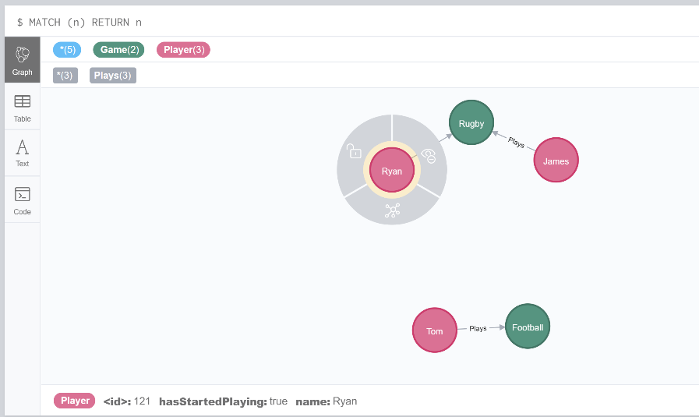

Further research:

1. Look into reading more into loops

Loops can be used to create and update nodes. You need to make sure that if you create a node inside a foreach loop then in order to use it outside of the loop you need to reference it in the match criteria at the start of the query. Loops allow you to run this on multiple nodes that meet the criteria which would be a more efficient way of updating information.

Reference: [19] Neo4j, URL: <https://neo4j.com/docs/cypher-manual/current/clauses/foreach/>

Summary:

Loops are a really good tool to use to update nodes but you need to make sure that anything created in the loop will not be referenced outside of the loop unless you have specified in the MATCH section of the query. Understanding how the loop works was pretty straight forward as the logic is the same in other languages which makes it easier to pick up and be able to use. Apparently Neo4j has updated the UNWIND which may be used in certain cases instead of the foreach loop further research will need to be done into this for me to feel comfortable using UNWIND instead of foreach.

### Week 8

Exercises:

Log on to NILE to find the csv files

• Using the LOAD CSV command and load the data and create graph

nodes with corresponding attributes and relationships.

LOAD CSV WITH HEADERS FROM

"file:///computing_modules.csv" as row

MERGE (m1:Module{code:row.code, title:row.title, level:row.level, credits:row.credits})

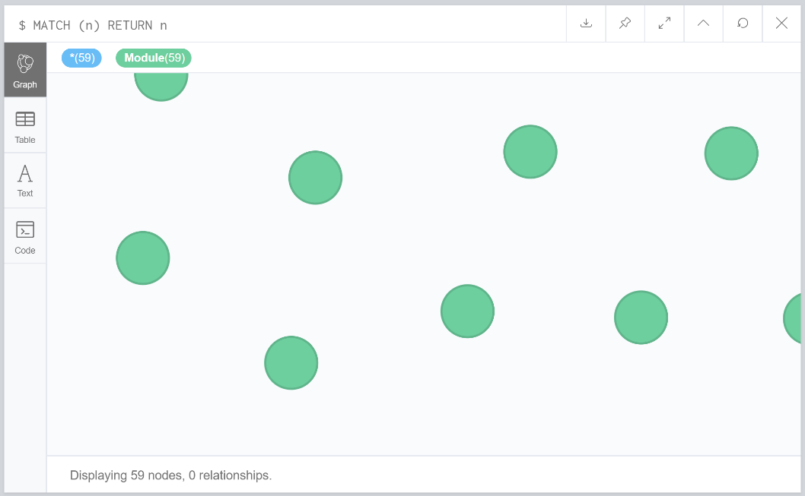

### Week 9:

Exercises:

• Create some nodes and relationships based on the model from previous slides.

MERGE (scott:Person{name:'Scott', age: 24})

MERGE (gary:Person{name:'gary', age: 22})

MERGE (amber:Person{name:'Amber'})

MATCH (scott:Person{name:"Scott"}),(amber:Person{name:"Amber"})

MERGE (scott)-[:KNOWS{value:'Since:2002'}]-(amber)

MATCH (scott:Person{name:"Scott"}),(gary:Person{name:"gary"})

MERGE (scott)-[:KNOWS{value:'Since:1998'}]-(gary)

• Run the reference commands on the previous slides to practice WHERE clause.

Boolean Operations:

And: MATCH (n) WHERE n.name='Scott' AND n.age = 24

RETURN n

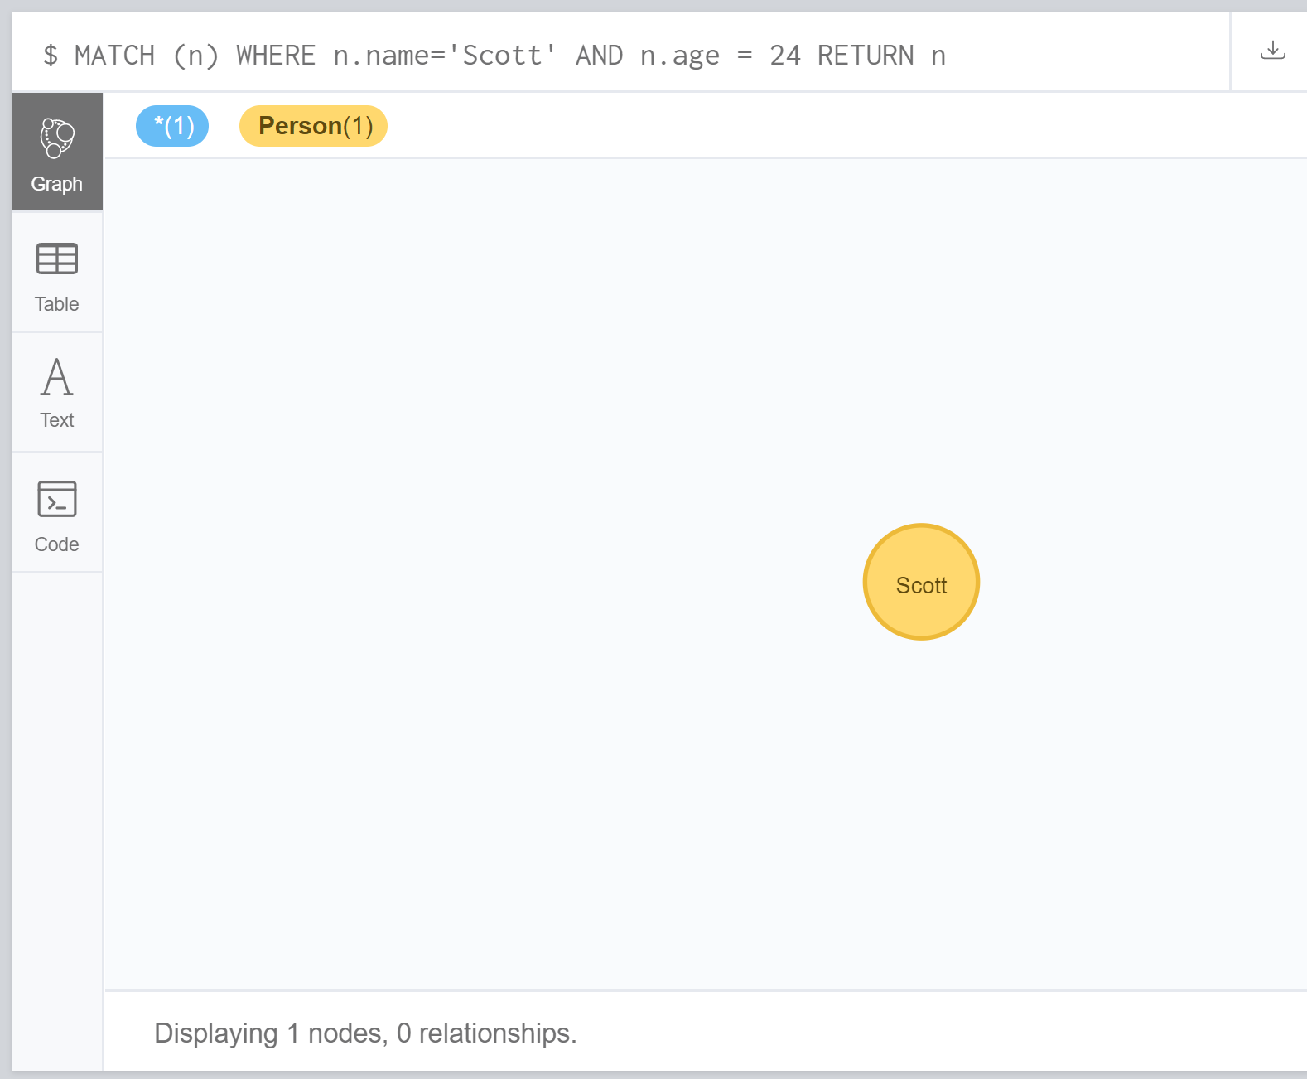

Or: MATCH (n) WHERE n.name='Scott' OR n.name = 'gary'

RETURN n

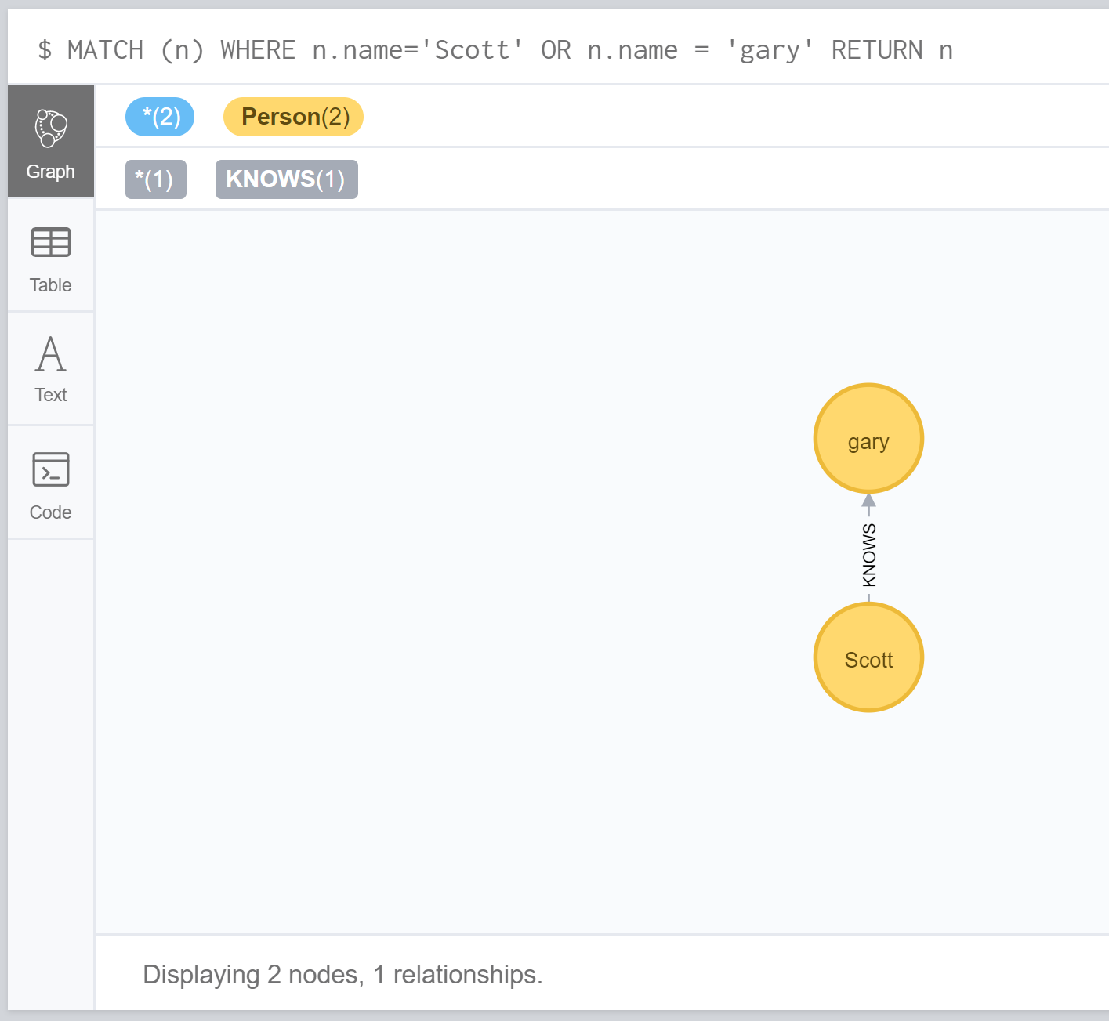

Not:

MATCH (n) WHERE NOT n.name = 'gary'

RETURN n

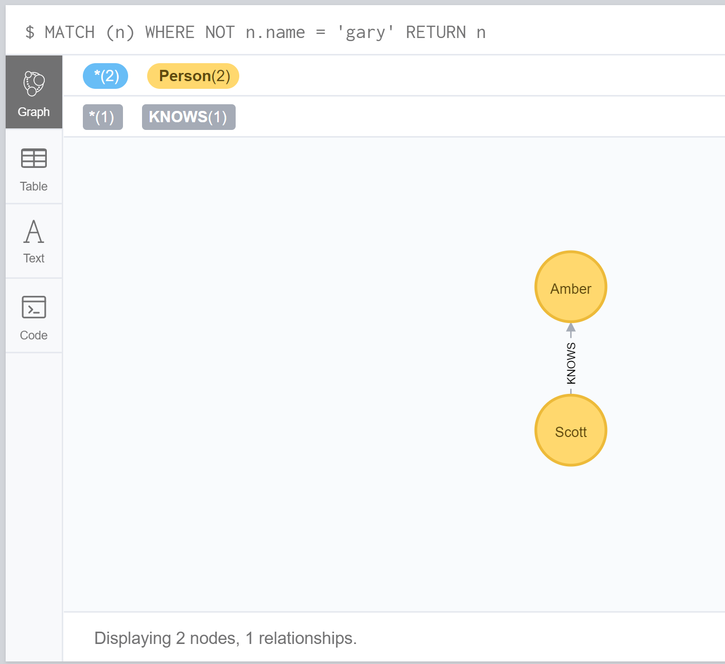

Filter On Node Label:

MATCH (n) WHERE n:Person RETURN n

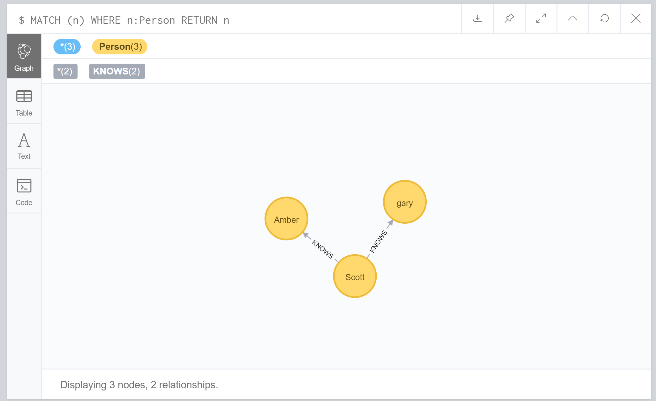

Filter On Node Property:

MATCH (n) WHERE n.age < 24 RETURN n

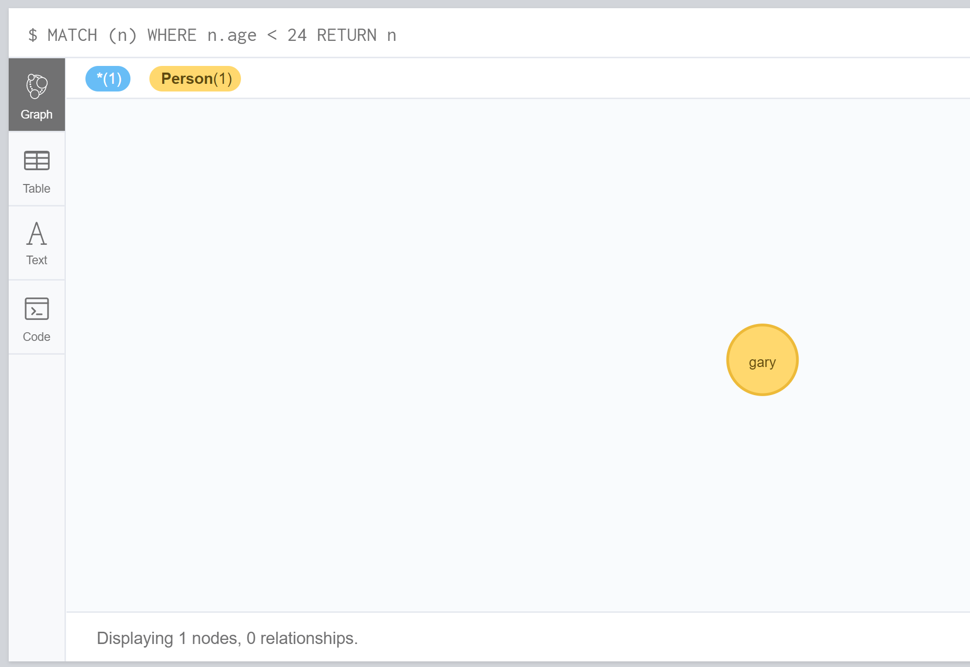

Filter On Relationship Property:

MATCH r = (n)-[k:KNOWS]->(f) WHERE k.value = "Since:1998" RETURN r

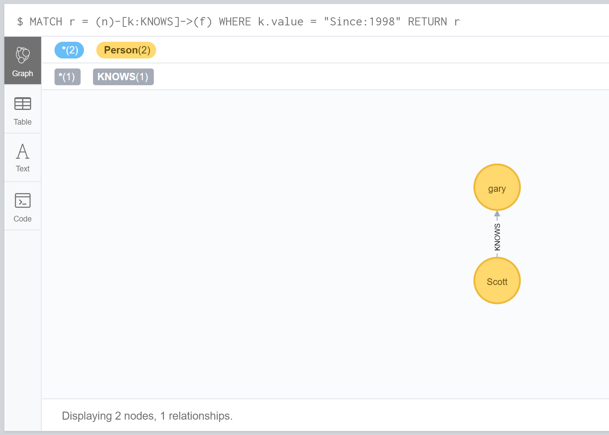

Property Exists:

MATCH (n) WHERE exists(n.age) RETURN n

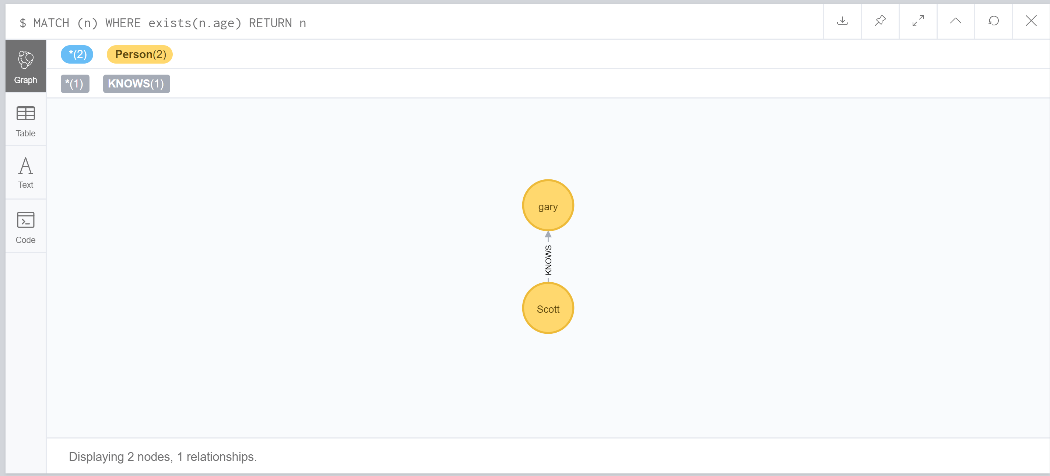

Match The Start Of A String:

MATCH (n) WHERE n.name STARTS WITH 'ga' RETURN n

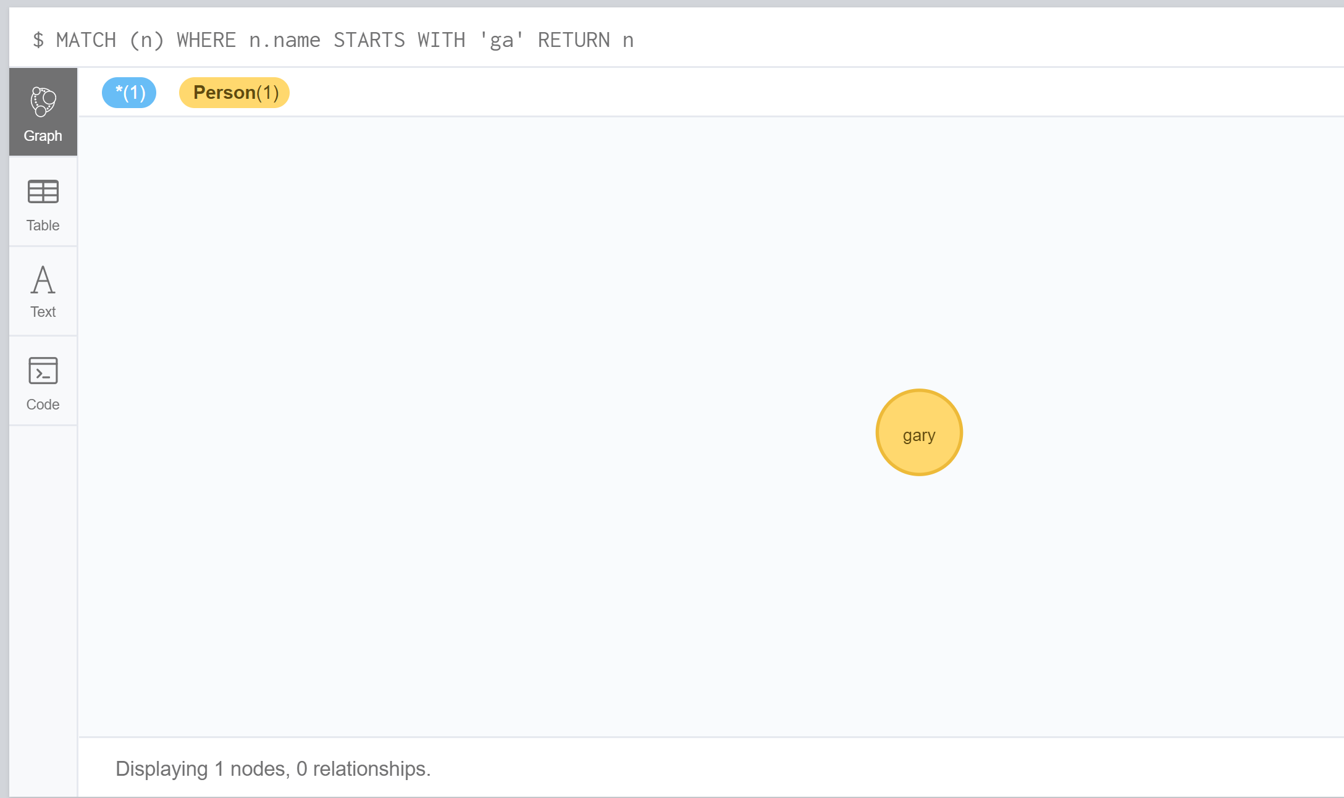

Match The End Of A String:

MATCH (n) WHERE n.name ENDS WITH 't' RETURN n

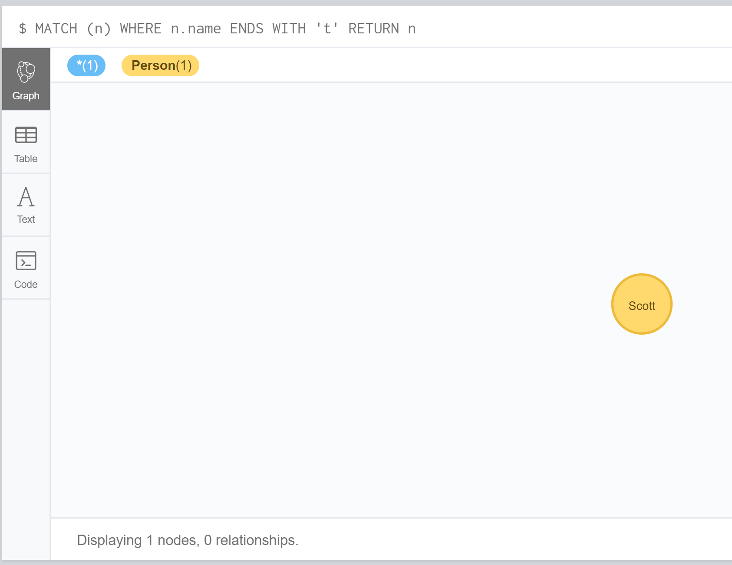

Match Anywhere In A String:

MATCH (n) WHERE n.name CONTAINS 'a' RETURN n

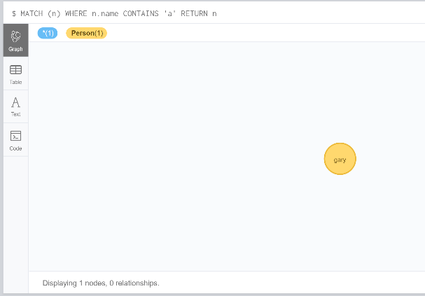

String Matching Negation:

MATCH (n) WHERE NOT n.name ENDS WITH 'y' RETURN n

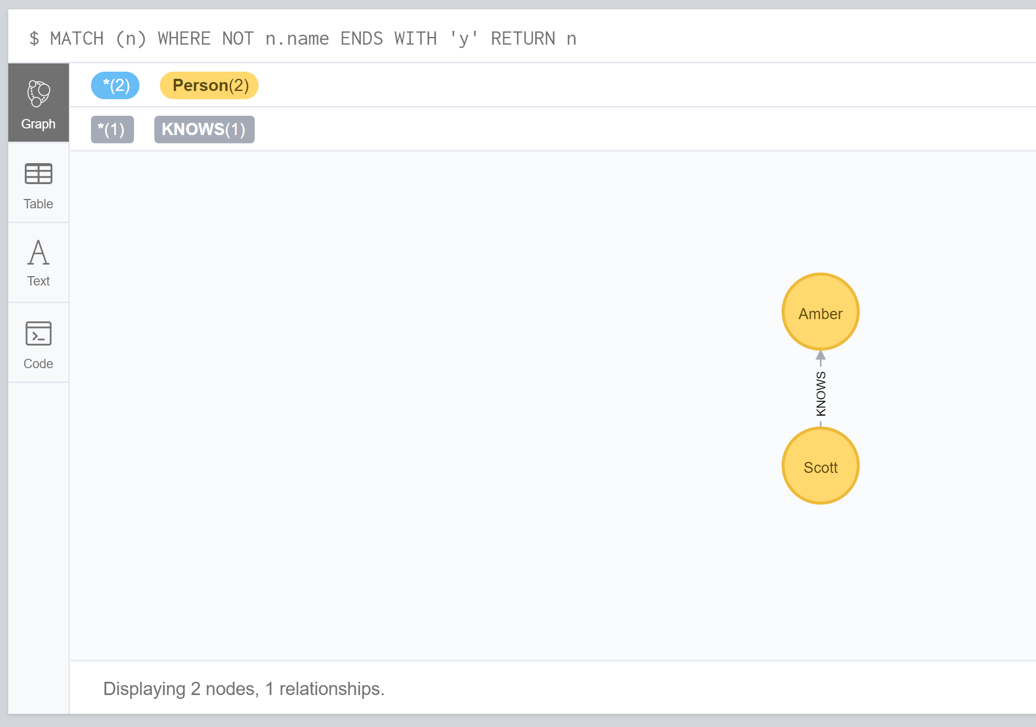

Regular Expressions:

MATCH (n) WHERE n.name =~ 'Sco.*' RETURN n

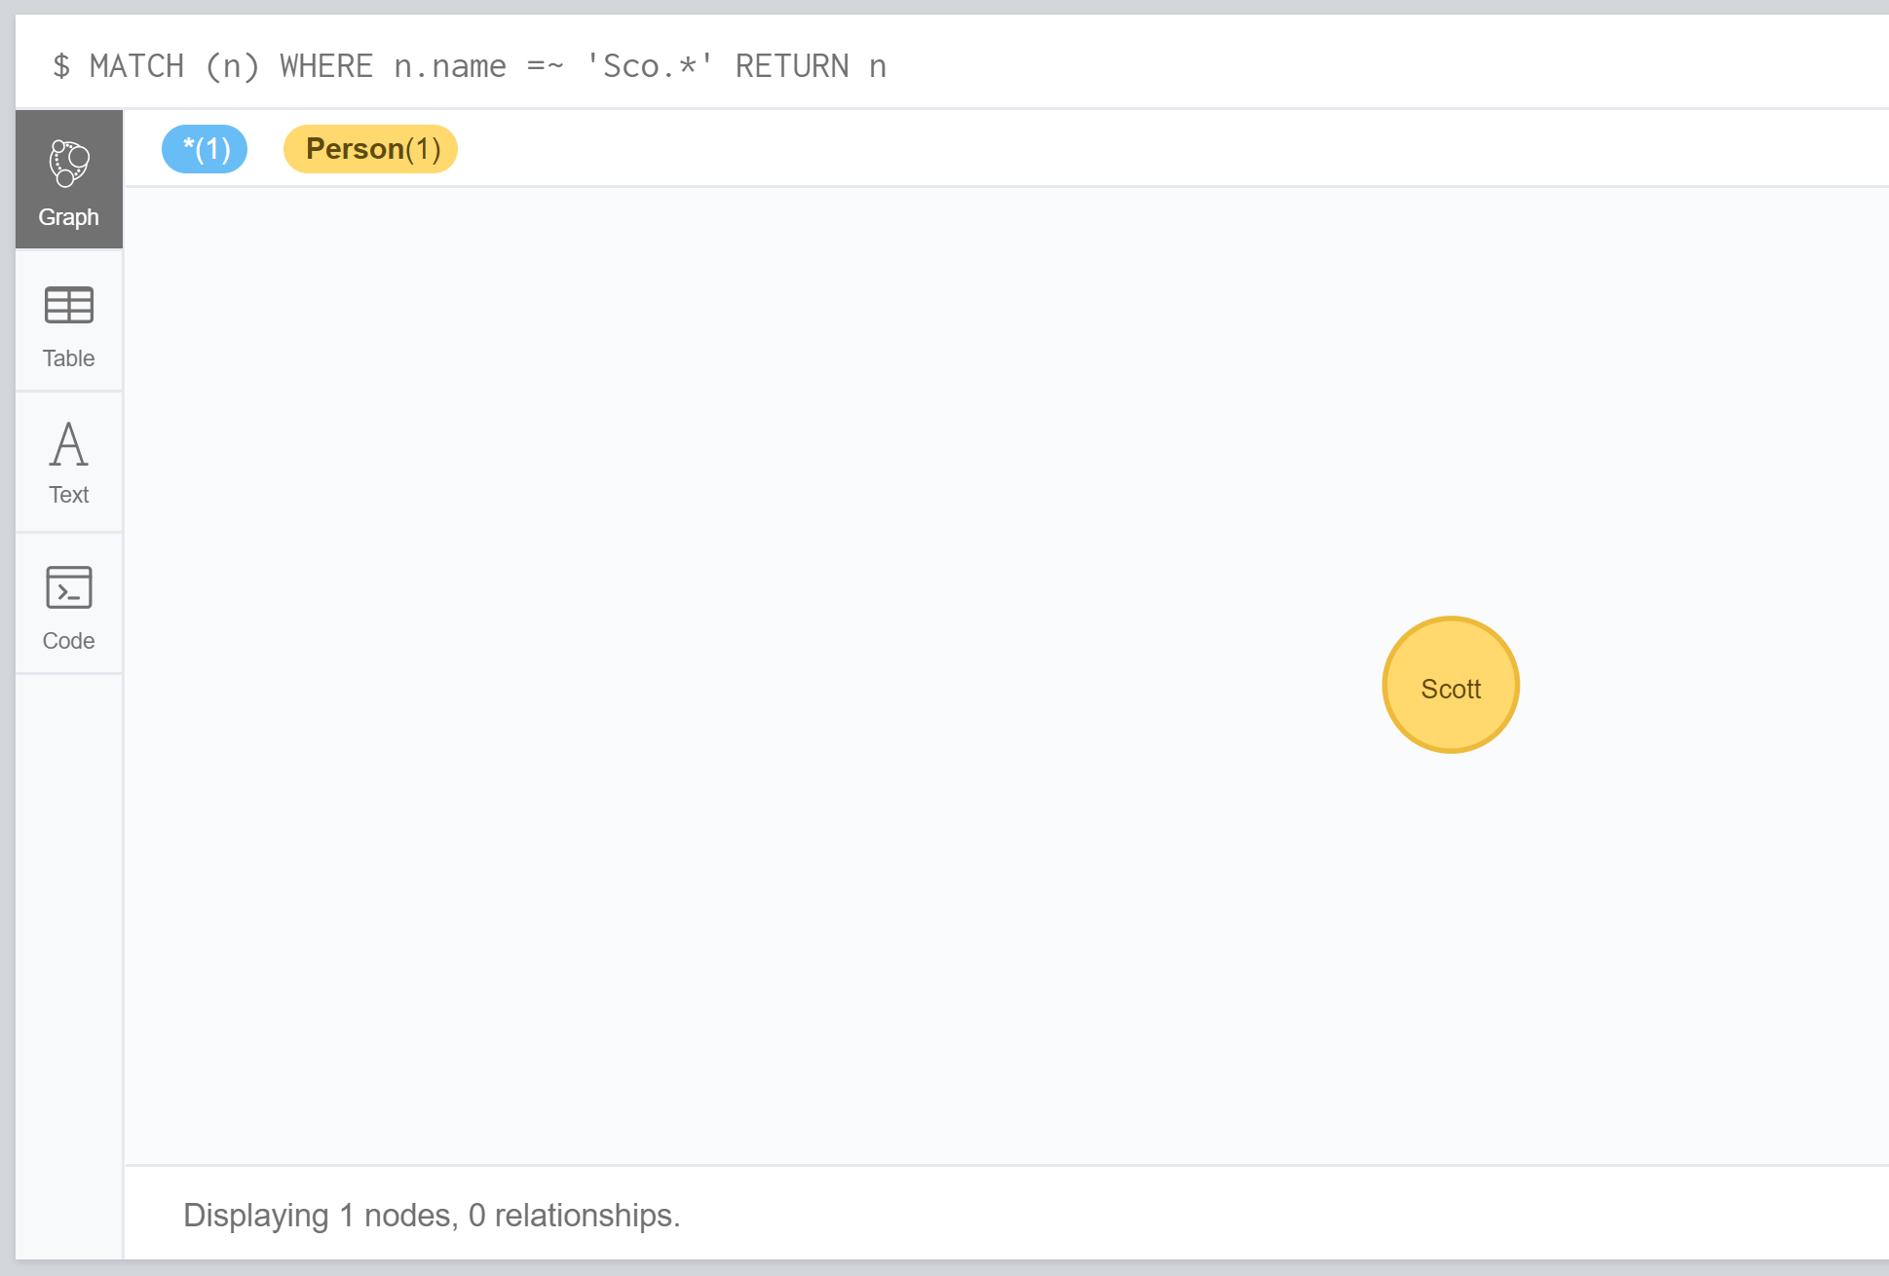

Case Insensitive Regular:

MATCH (n) WHERE n.name =~ '(?i)AM.*' RETURN n

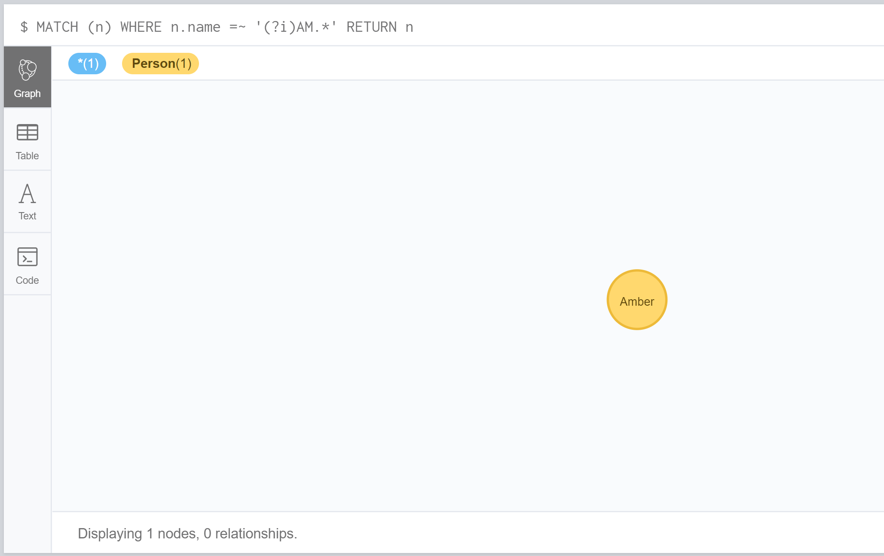

Using Path Patterns In Where:

MATCH (n{name:'Amber'}), (others)

WHERE others.name IN ['Scott', 'gary'] AND (n)--(others)

RETURN others

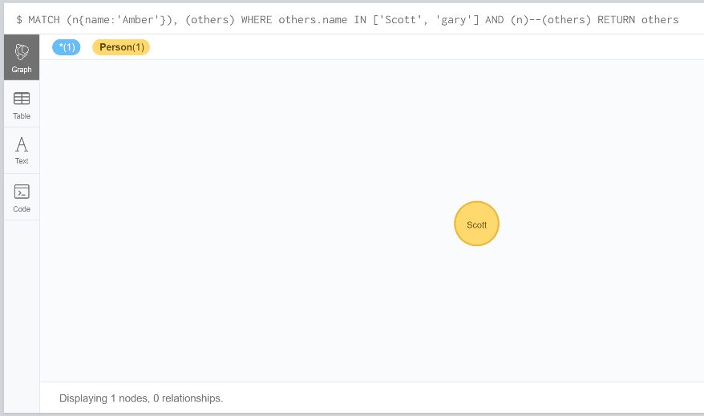

Filter On Patterns Using Not:

MATCH (person), (n{name:'gary'})

WHERE NOT (person)-->(n)

RETURN person

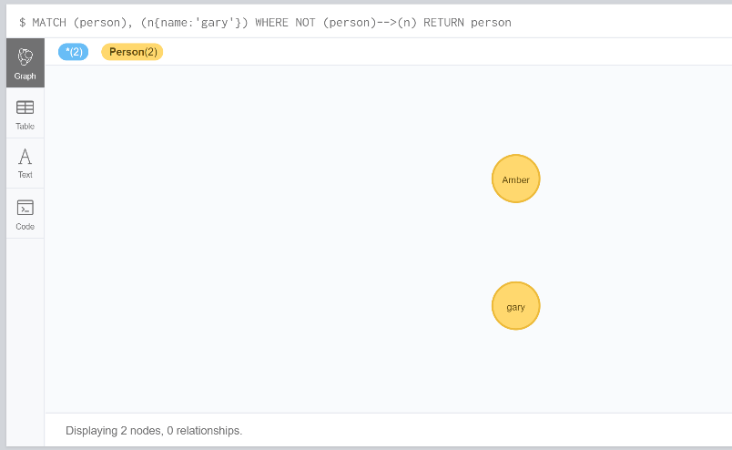

Filter On Patterns With Properties:

MATCH (n) WHERE (n)-[:KNOWS]-({name:'Scott'})

RETURN n

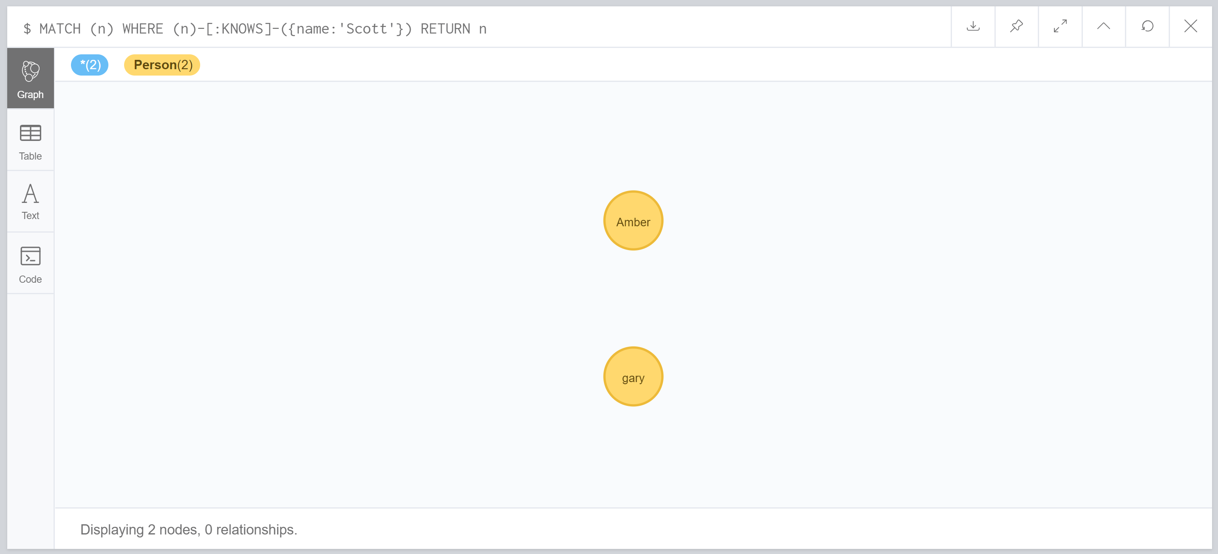

Filter On Relationship Type:

MATCH (n)-[r]->()

WHERE n.name='Scott' AND type(r)=~'K.*'

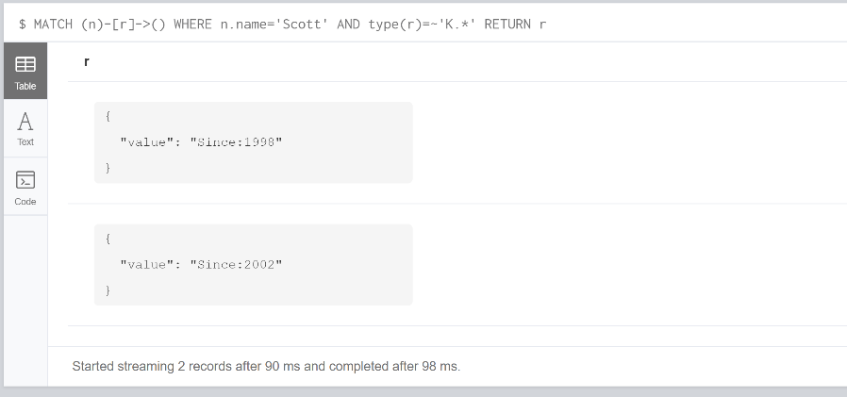RETURN r

List:

MATCH (a)

WHERE a.name IN ['Scott','gary']

RETURN a

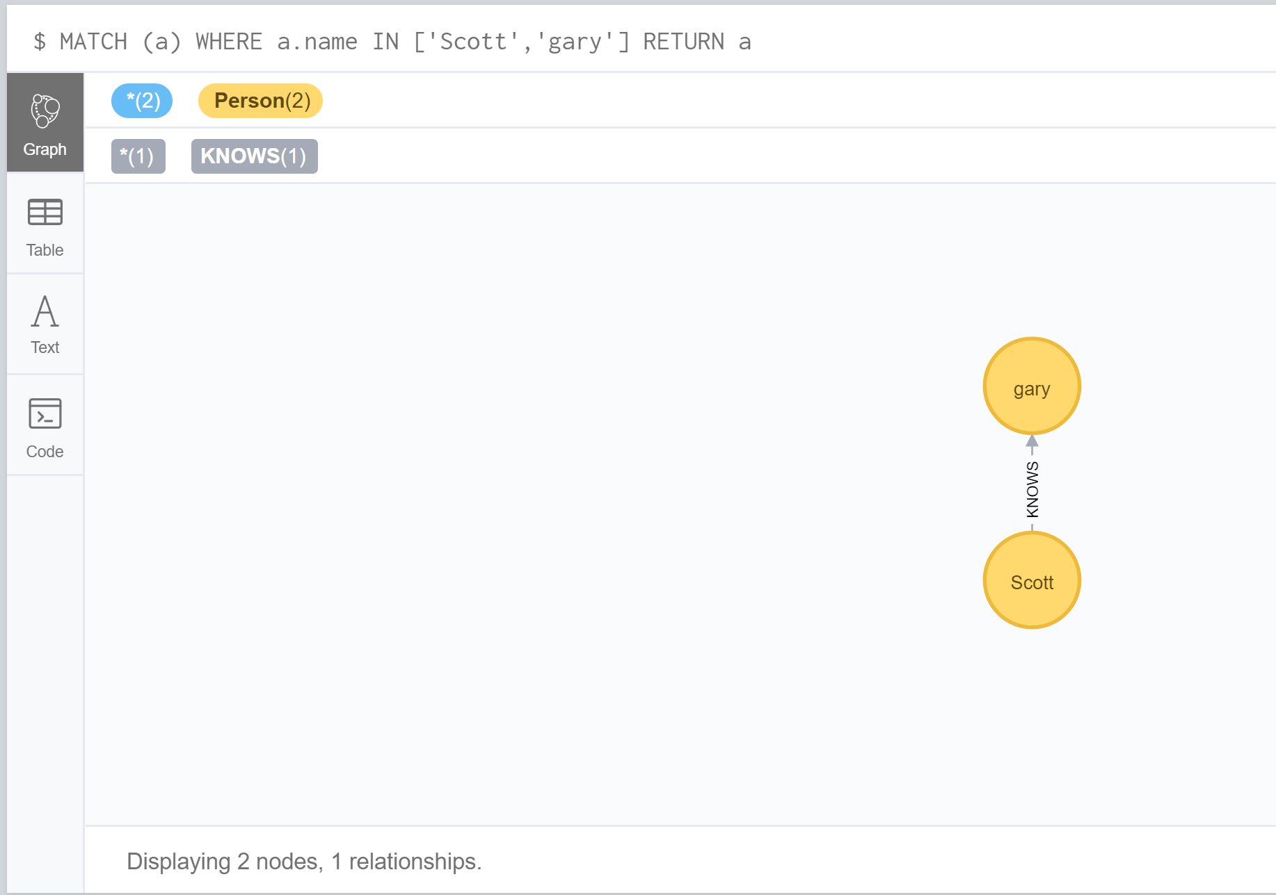

Missing Properties And Values:

MATCH (n)

WHERE n.age = 24

RETURN n

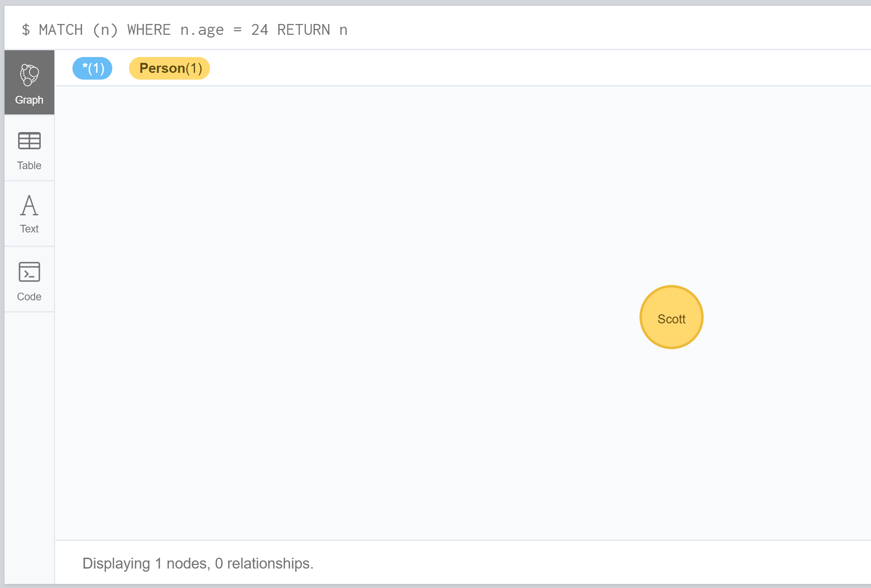

Create some nodes and relationships based on the model from previous slides.

Run the reference commands on previous slides to practice COUNT clause.

Count nodes:

MATCH (n{name:'Scott'}) --> (x)

RETURN count(*)

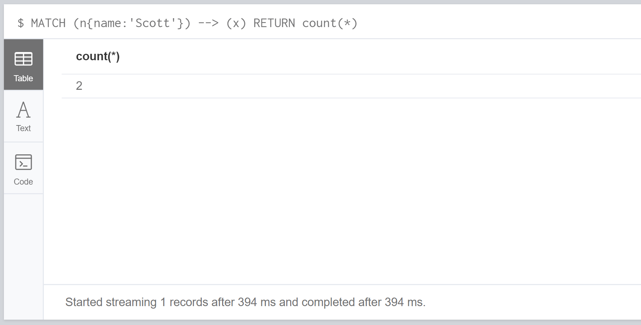

Group Count Relationship Type:

MATCH (n{name:'Scott'})-[r]->()

RETURN type(r), Count(*)

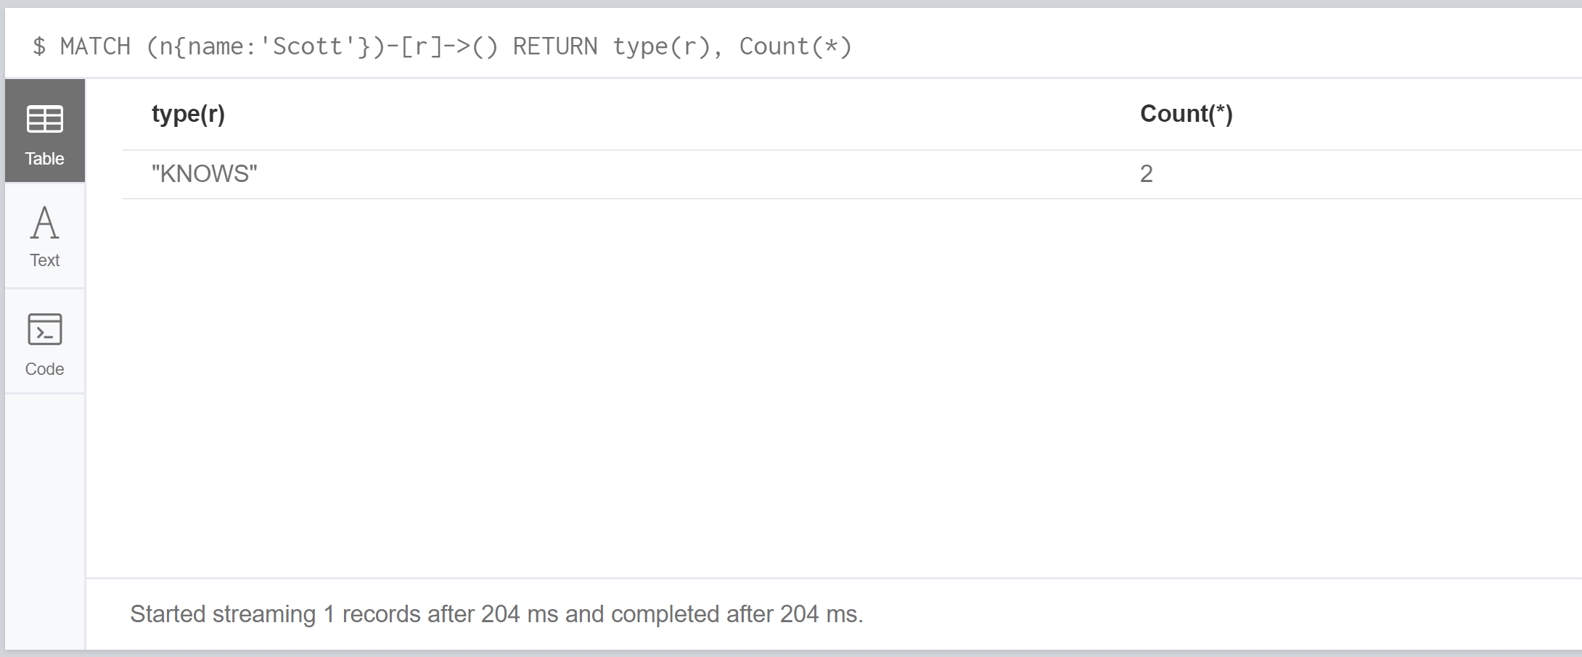

Count Entities:

MATCH (n{name:'Scott'})-->(x)

RETURN count(x)

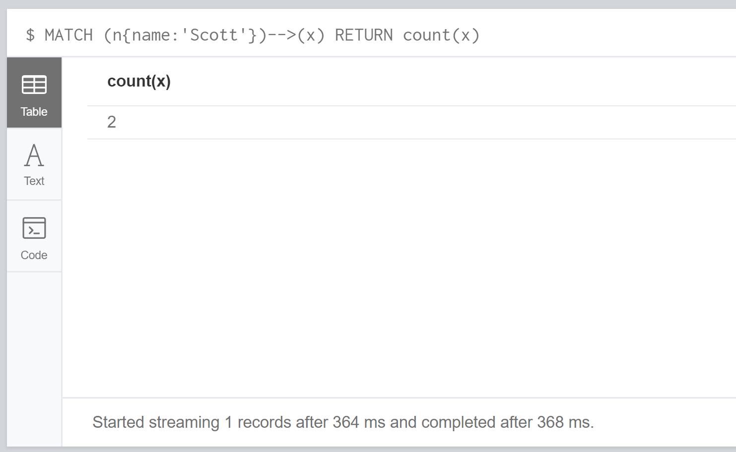

Count Non-Null Values:

MATCH (n:Person)

RETURN COUNT(n.age)

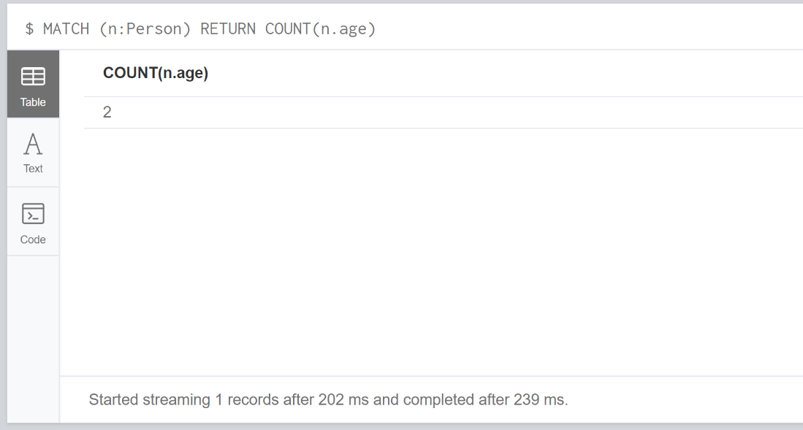

Summary:

This week we looked at criteria’s that could be used in order to pull through specific data. These Boolean expressions are commonly used in other programming languages so understanding how they work and read was easy to pick up. The problem I have at the moment is making sure I have the correct syntax which I find hard to remember and have to constantly reference back to other examples in order to make sure the syntax is correct and accurate to avoid getting errors. This just requires more practice the more I use these Booleans then the better I will be at remembering the syntax.

### Week 10

Exercises:

Create some nodes and relationships based on the model from previous slides.

Run the reference commands to practice the WITH command.

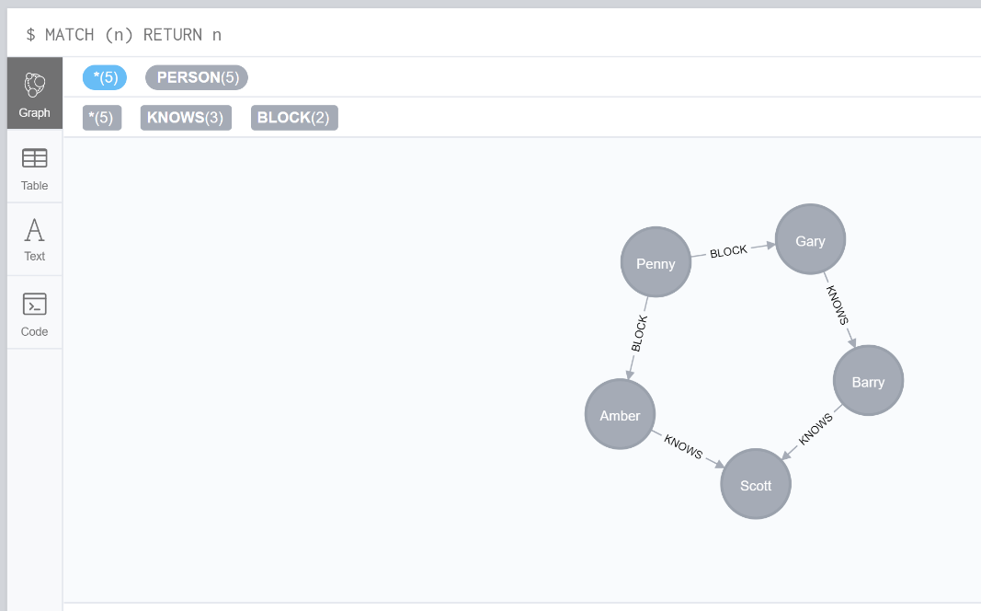

• Try to run the Cypher codes without the WITH clause to see what happens

Filter On Aggregate Function Results:

MATCH (g:PERSON{name:'Gary'})--(otherPerson)-->()

RETURN otherPerson

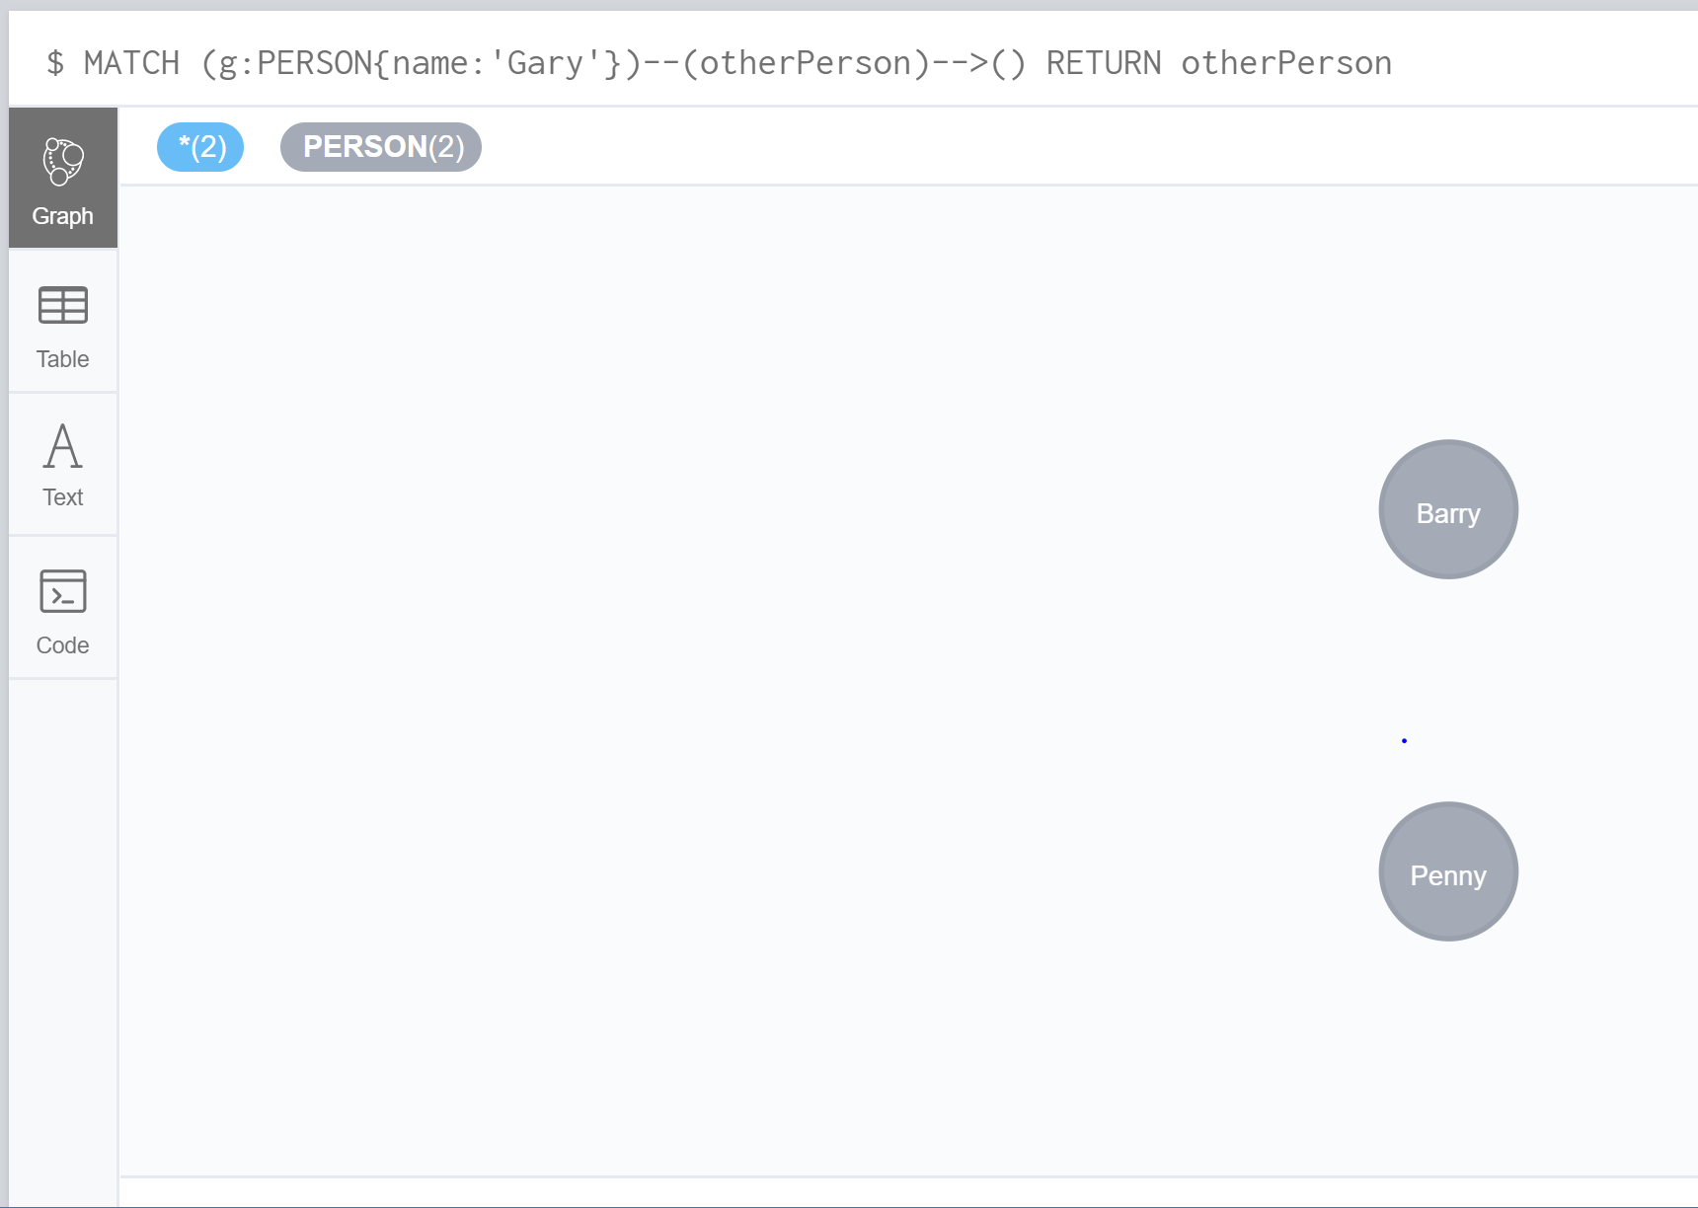

Sort Results Before Using Collect On Them:

MATCH (n)

ORDER BY n.name DESC LIMIT 3

RETURN collect(n.name)

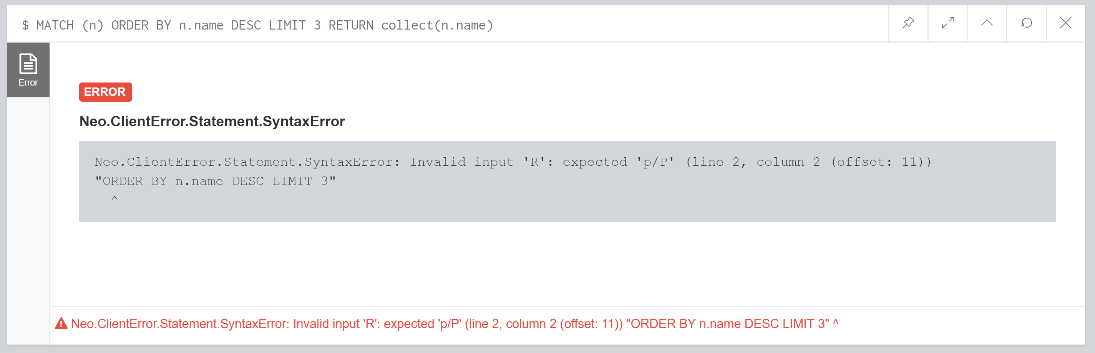

Limit Branching Of Your Path Search:

MATCH (n{name:'Garry'})--(m)

ORDER BY m.name DESC LIMIT 1

MATCH (m)--(o)

RETURN o.name

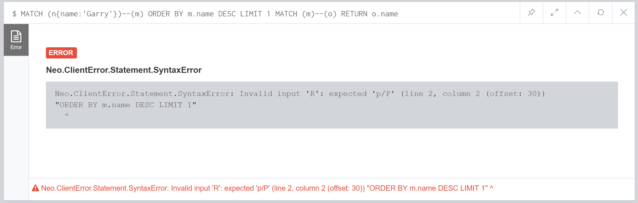

• Try to rewrite the Cypher commands to get similar outputs and reflect on the difference

Filter On Aggregate Function Results:

MATCH (g:PERSON{name:'Gary'})--(otherPerson)--()

WITH otherPerson, COUNT(*) AS foaf

WHERE otherPerson.name = 'Penny'

RETURN otherPerson

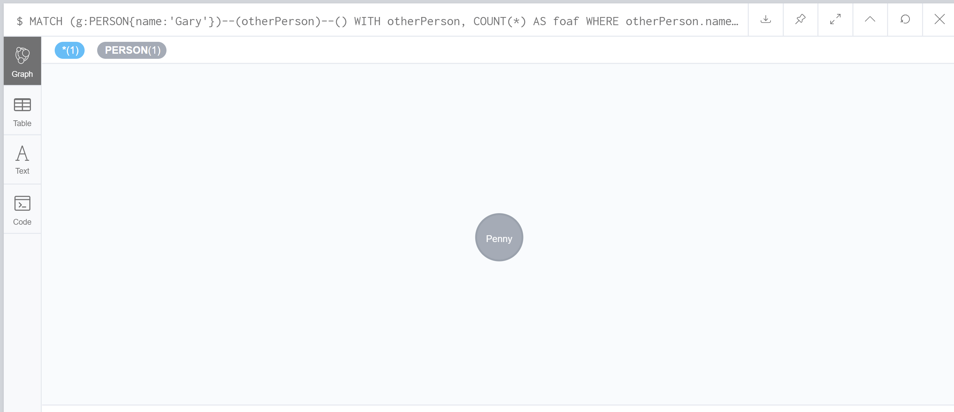

Sort Results Before Using Collect On Them:

MATCH (n)

WITH n

ORDER BY n.name LIMIT 4

RETURN collect(n.name)

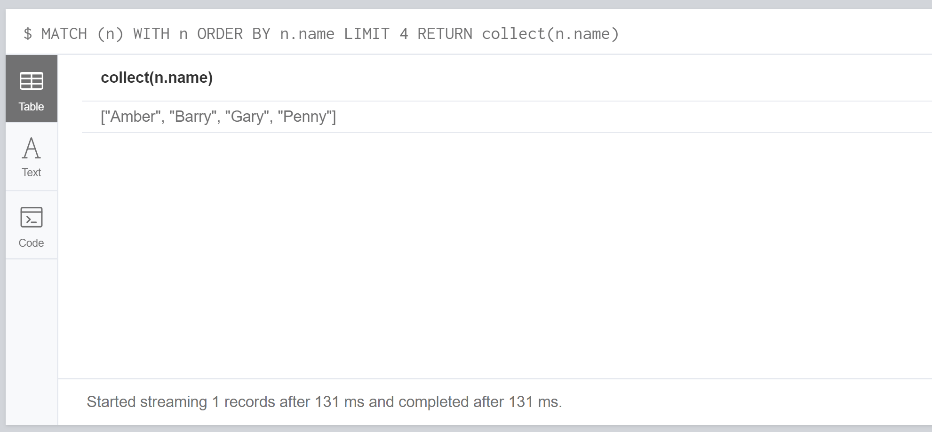

Limit Branching Of Your Path Search:

MATCH (n{name:'Gary'})--(m)

WITH m

WHERE m.name = 'Penny'

MATCH (m)--(o)

RETURN o.name

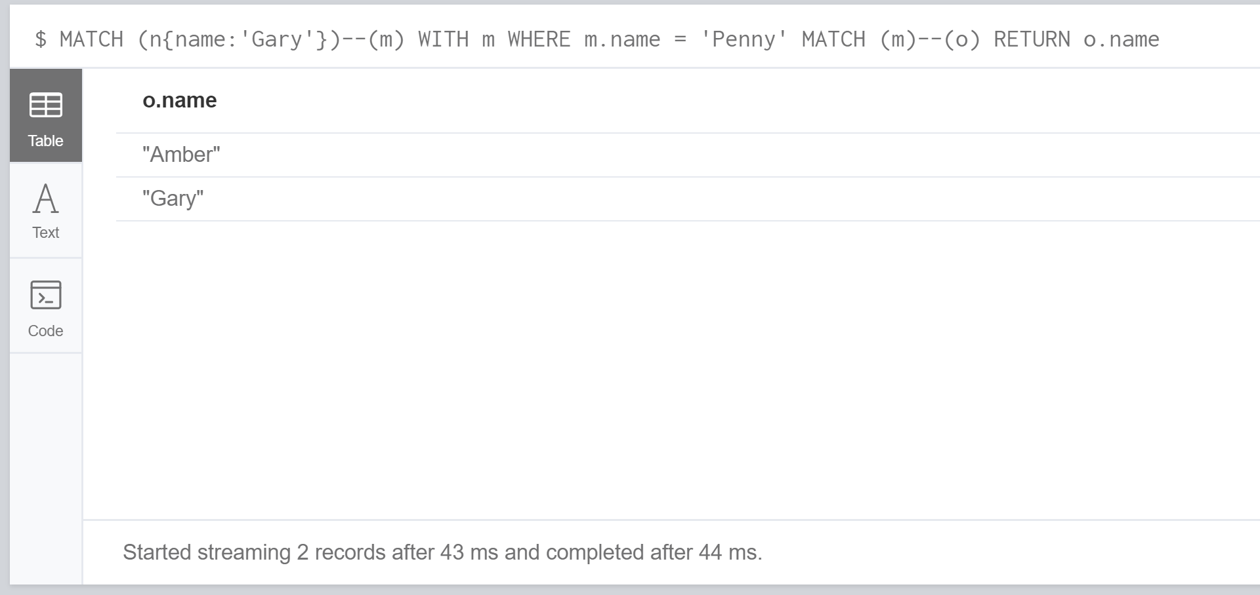

Create a Distinct List:

WITH ['Gary','Penny','Penny','Amber', 'Gary', 'Gary'] AS coll UNWIND coll AS x

WITH DISTINCT x

RETURN collect(x) AS SET

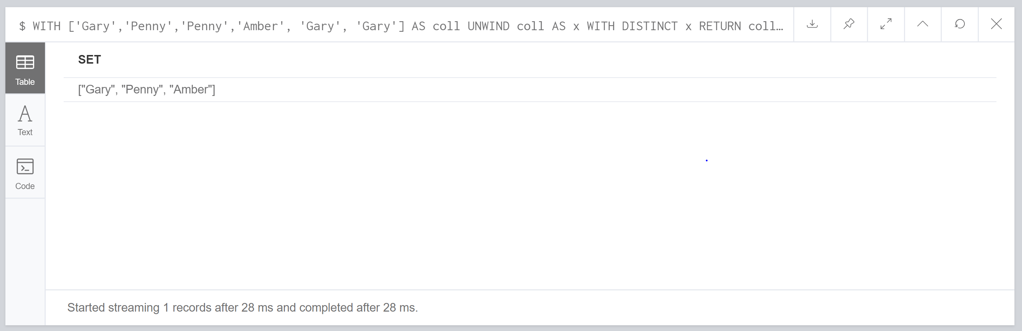

Exercises:

Write some Cypher commands with CASE expression to add a new attribute called ‘desc’

If the ’eyes’ is ‘blue’, set value of ‘desc’ to ‘blue eyes person’

If the ’eyes’ is ‘brown’, set value of ‘desc’ to ‘brown eyes person’

If the ’age’ is smaller than 30, set value of ‘desc’ to ‘young person’

Otherwise set the value of ‘desc’ to ‘ordinary person’

MATCH (n) DETACH DELETE n

CREATE (a:Person{name:'A', age:13, })

CREATE (b:Person{name:'B', age:33, eyes: 'blue'})

CREATE (c:Person{name:'C', age:44, eyes: 'blue'})

CREATE (d:Person{name:'D', eyes: 'brown'})

CREATE (e:Person{name:'E'})

MATCH (a{name:'A'}), (b{name:'B'}), (c{name:'C'}), (d{name:'D'}), (e{name:'E'})

CREATE (a)-[:KNOWS]->(b), (a)-[:KNOWS]->(d), (a)-[:KNOWS]->(c), (c)-[:KNOWS]->(e),

(b)-[:KNOWS]->(e)

MATCH (n)

SET n.desc=CASE

WHEN n.eyes='blue' THEN 'blue eyes person'

WHEN n.eyes='brown' THEN 'brown eyes person'

WHEN n.age < 30 THEN 'young person'

ELSE 'ordinary person'

END

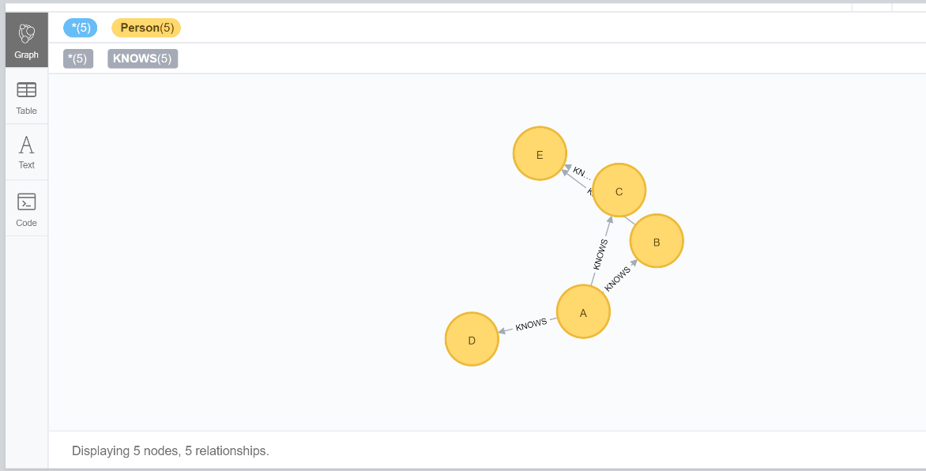

What if a person has blue eyes and age less than 30?

CREATE (a:Person{name:'A', age:13, eyes: 'blue' })

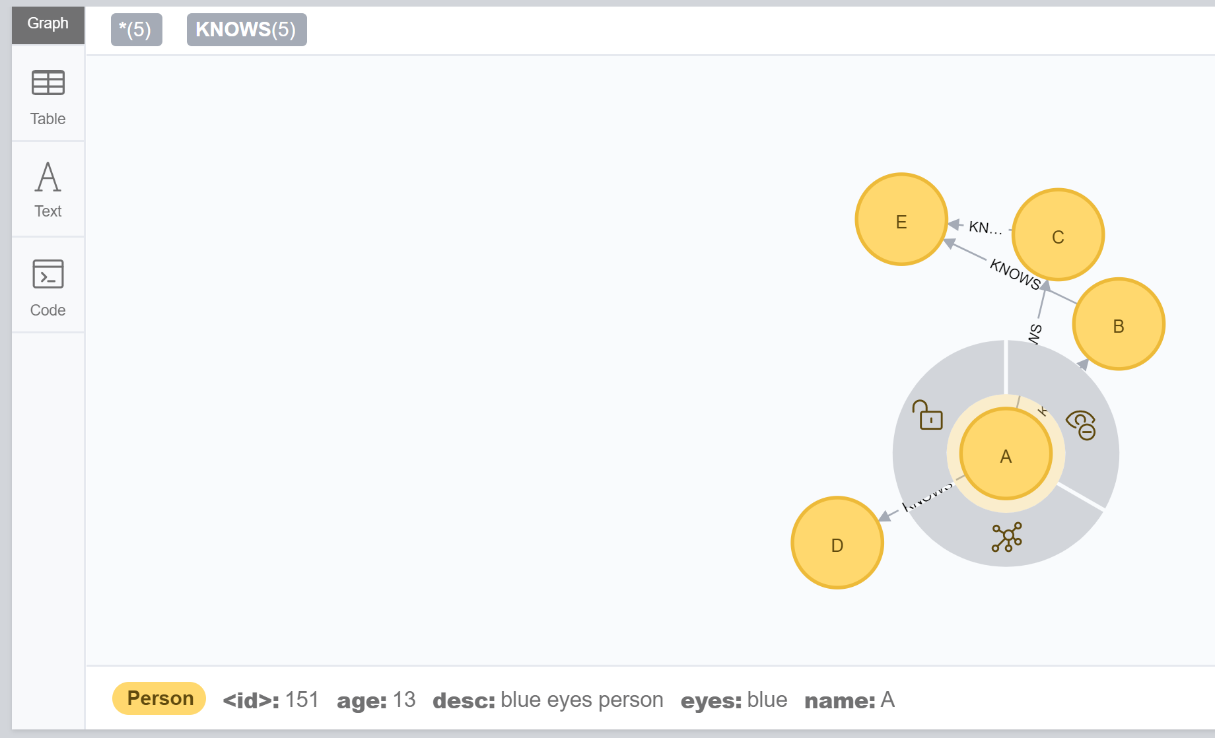

Desc comes back as ‘blue eyes person’ even when the age is under 30 as it meets the criteria of the first statement.

Exercises:

Run the commands on previous slides to test LIST

RETURN [0,1,2,3,4,5,6,7,8,9] AS list

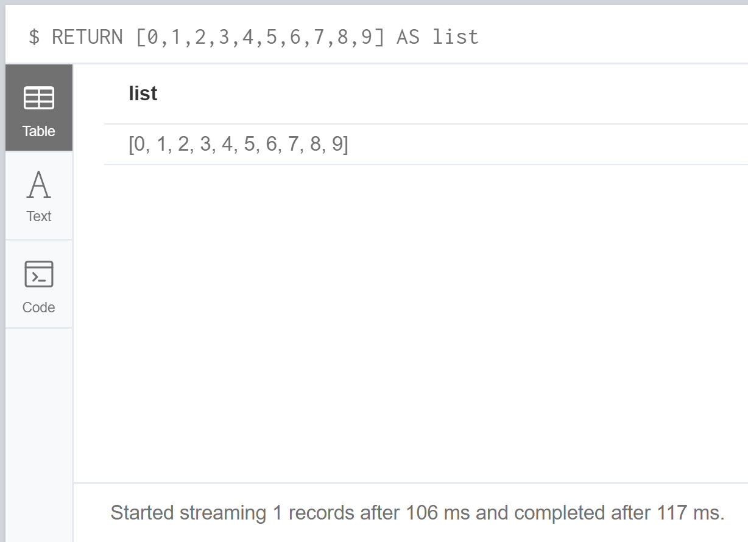

RETURN range(0,10) [3]

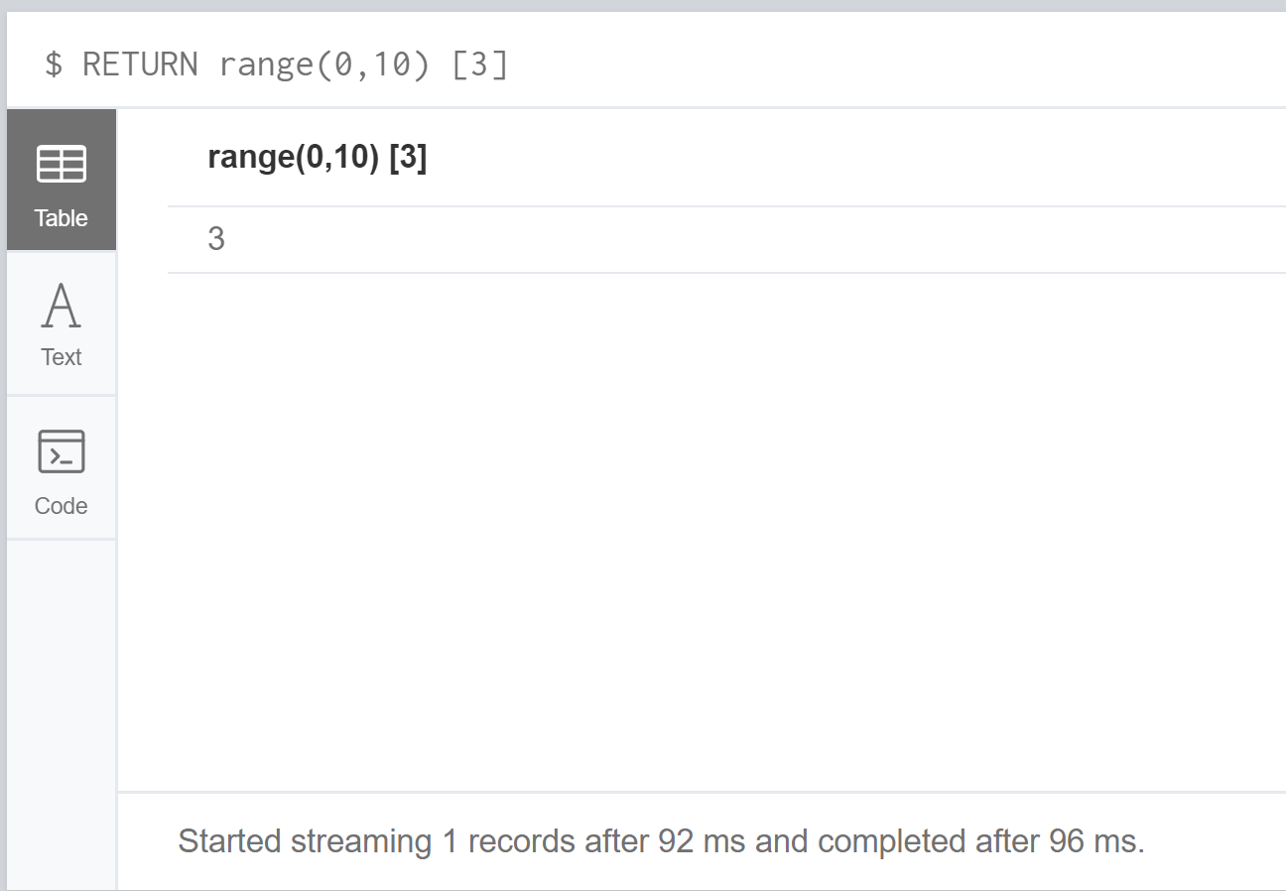

RETURN range(0,10) [-3]

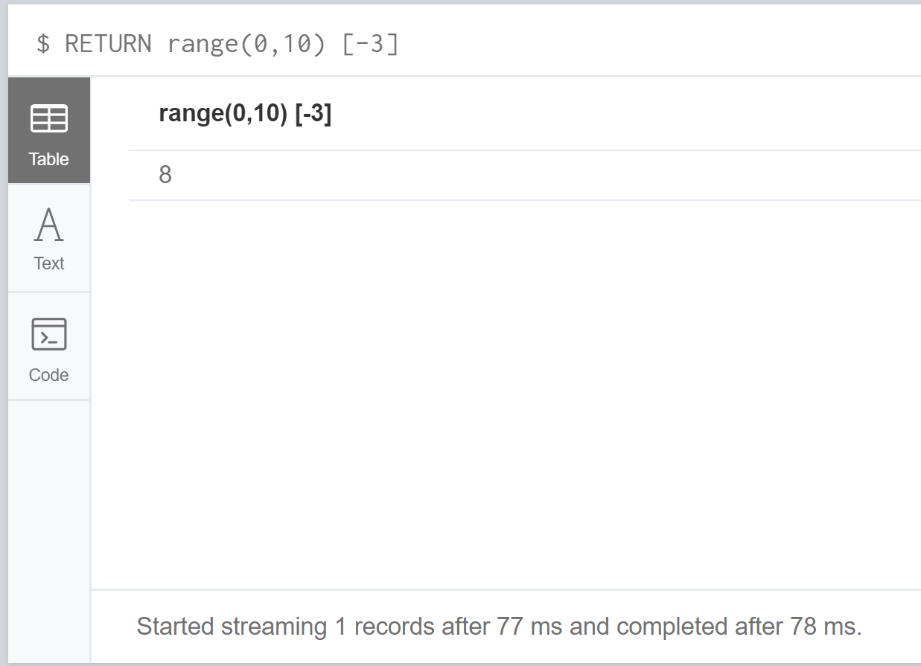

Range Of A List:

RETURN range(0,10) [0..3]

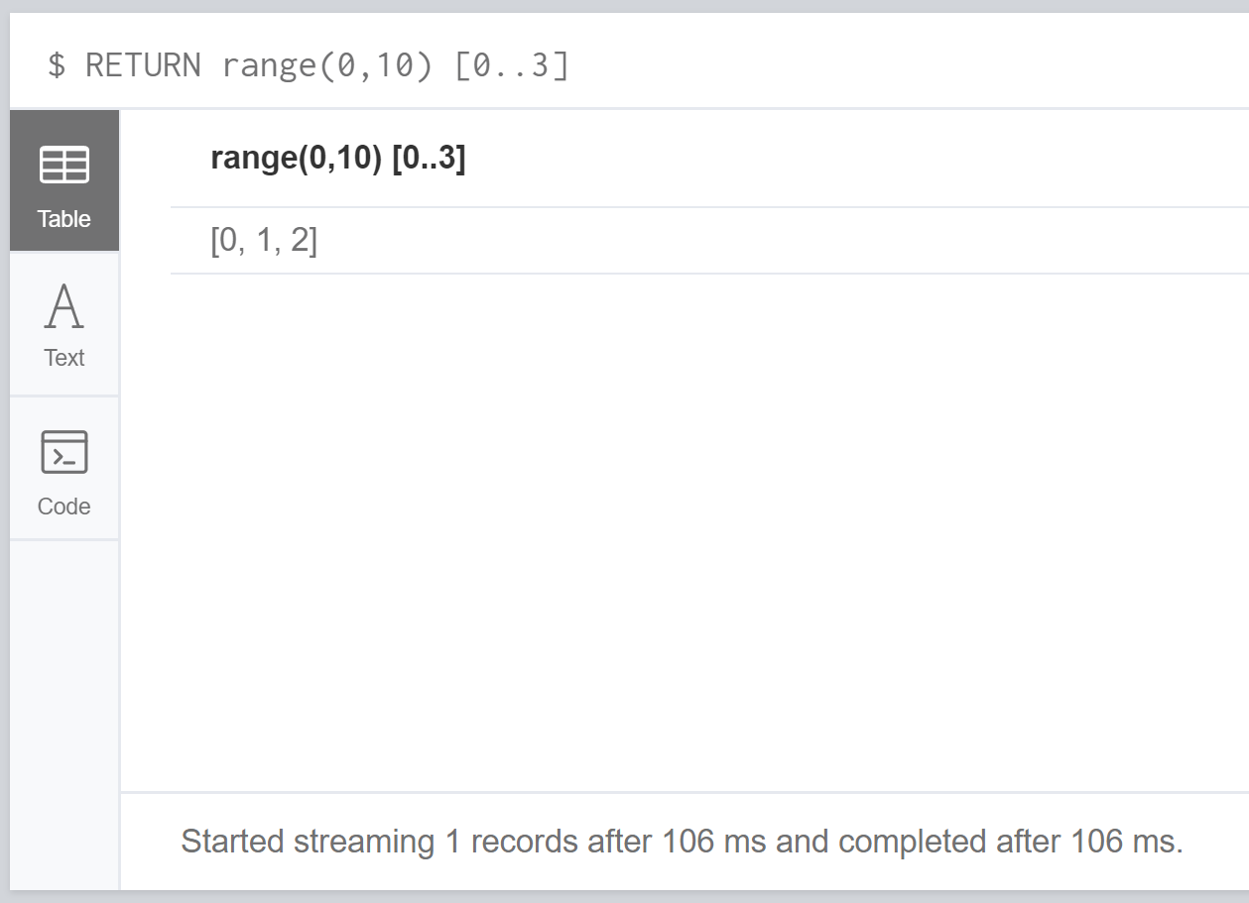

RETURN range(0,10) [0..-5]

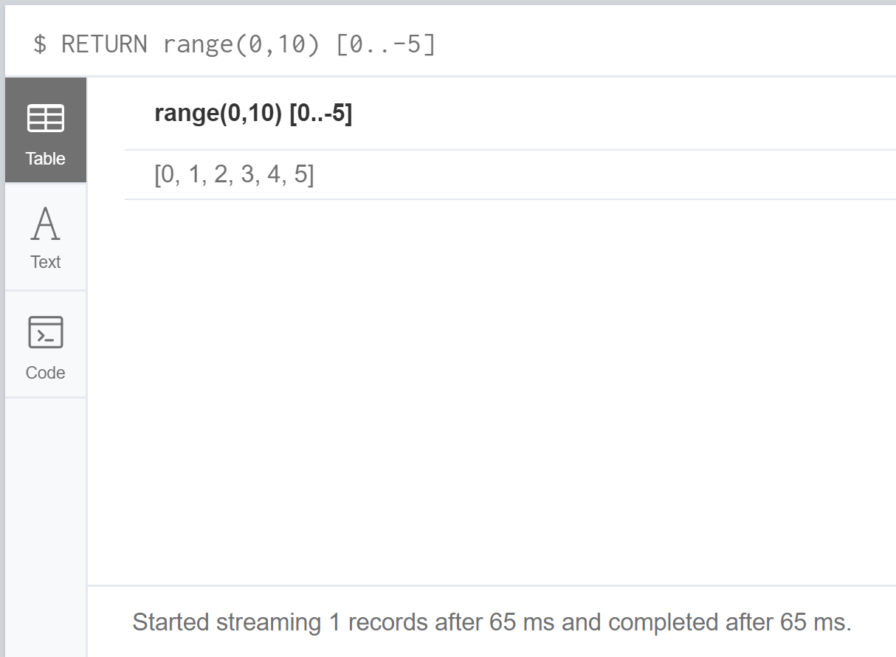

RETURN range(0,10) [-5..]

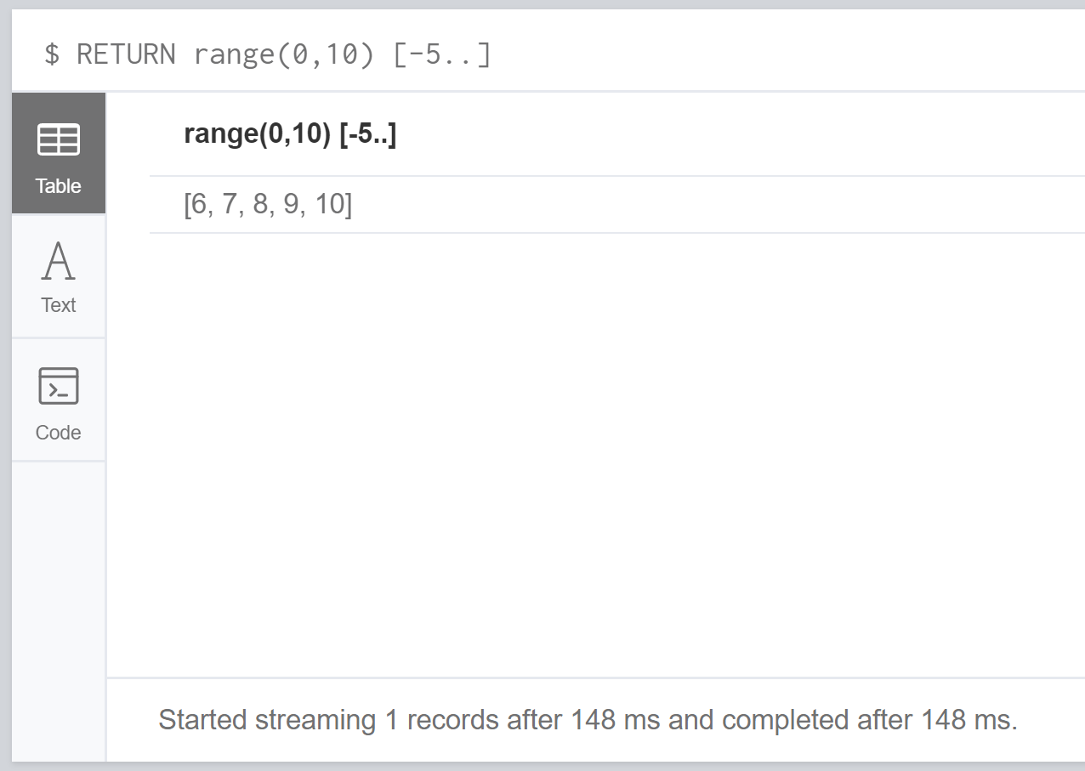

RETURN range(0,10) [..4]

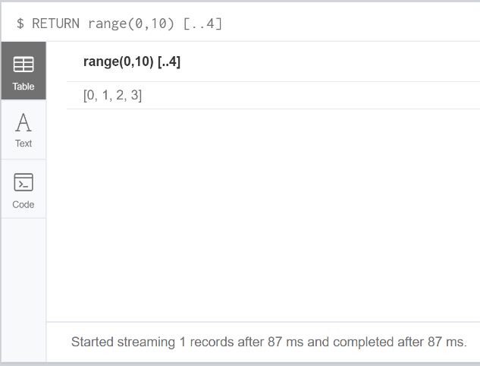

Out-of-bound List:

RETURN range(0,10) [15]

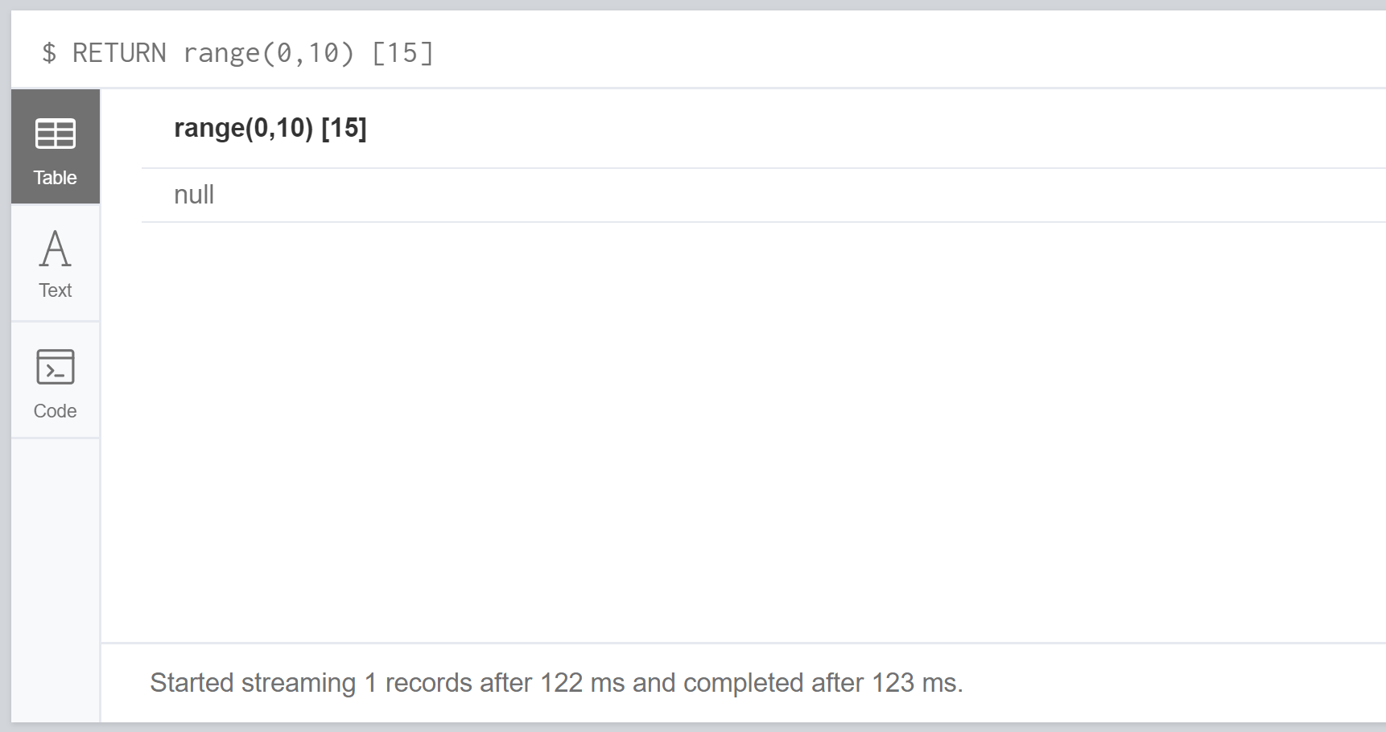

RETURN range(0,10) [5..15]

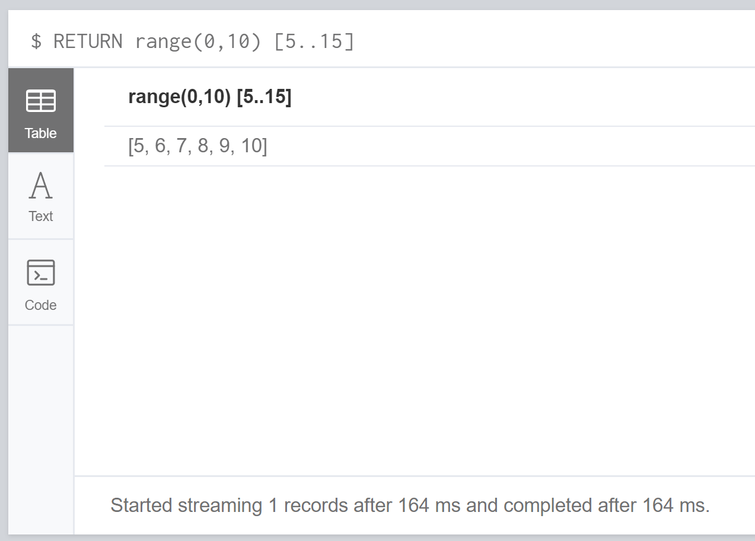

RETURN size(range(0,10) [0..3])

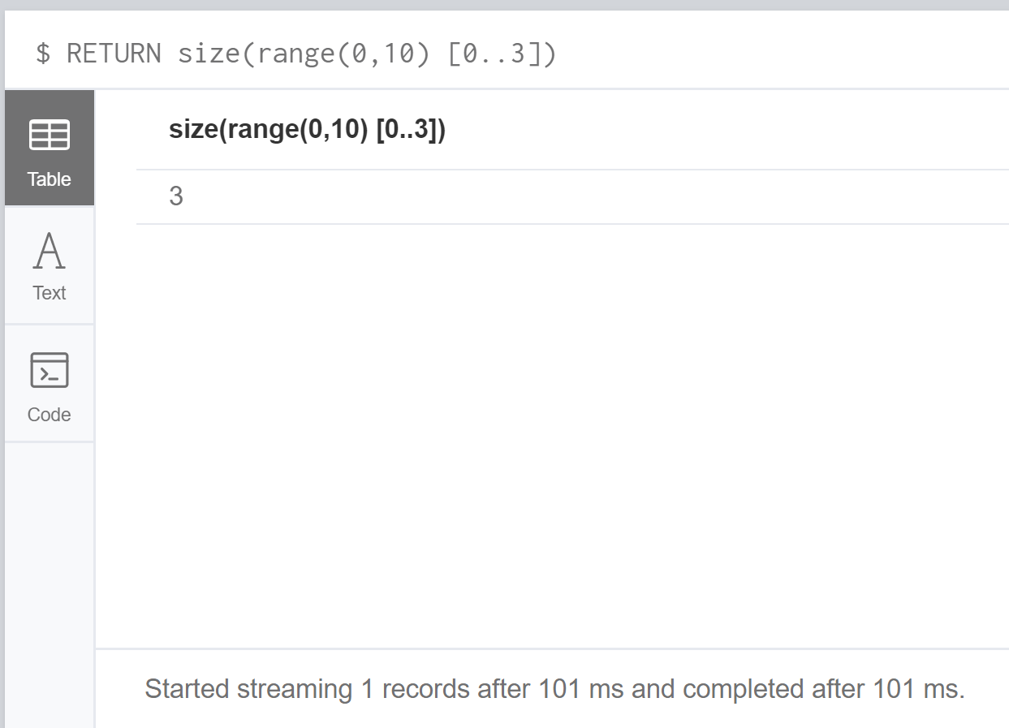

Lists Comprehension:

RETURN [x IN range(0,10) WHERE x % 2 = 0 | x^3] AS result

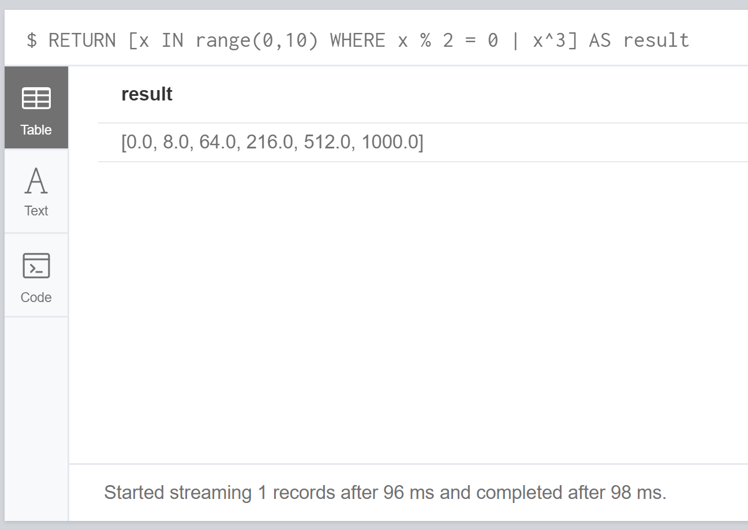

RETURN [x IN range(0,10)| x^3] AS result

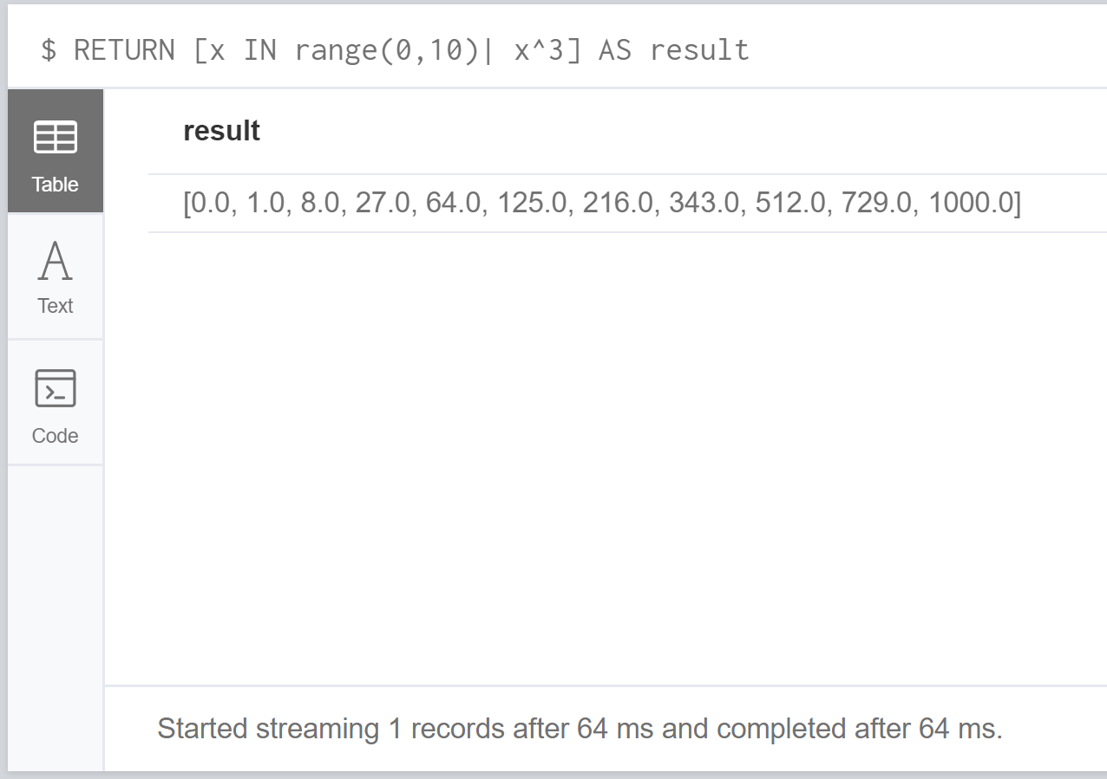

Literal Maps:

RETURN {key: "value", listkey: [{ inner: "map1" }, {inner: "map2" }]} AS result

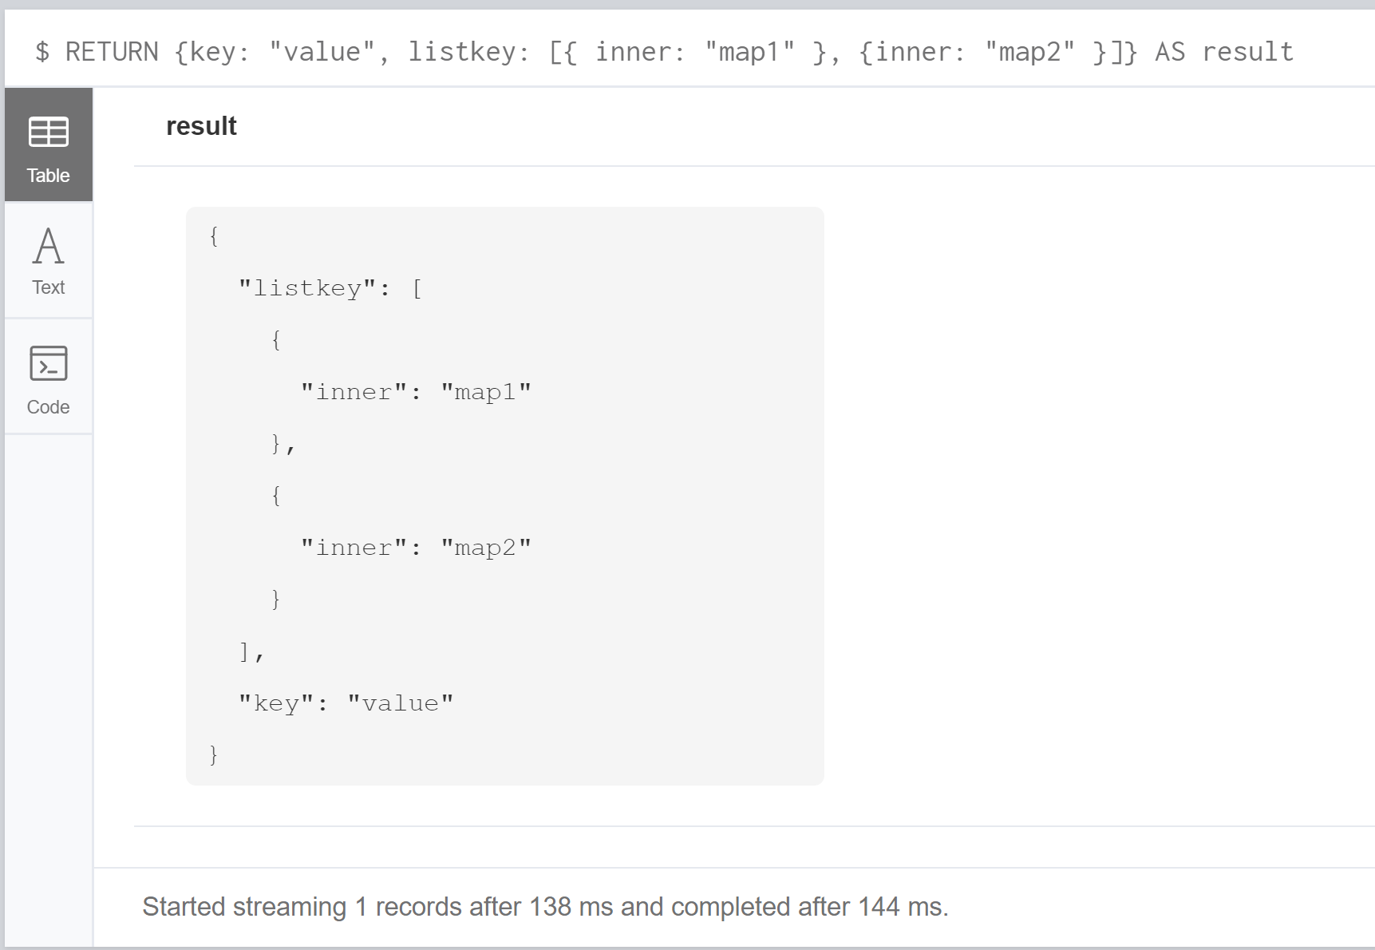

Exercises:

Run the commands on previous slides on LIST and UNION

Combine Two Queries:

MATCH (n:Person)

RETURN n.name AS name

UNION ALL MATCH (n:Letter)

RETURN n.name AS name

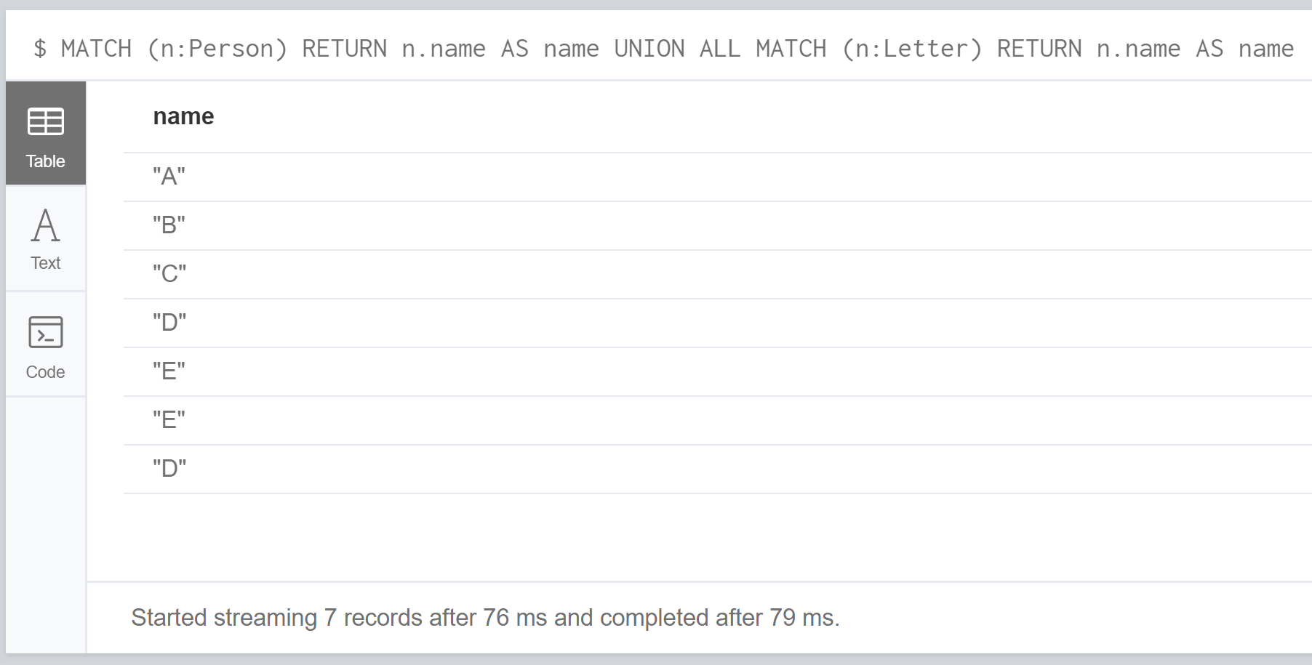

Combine Two Queries And Remove Duplicates:

MATCH (n:Person)

RETURN n.name AS name

UNION

MATCH (n:Letter)

RETURN n.name AS name

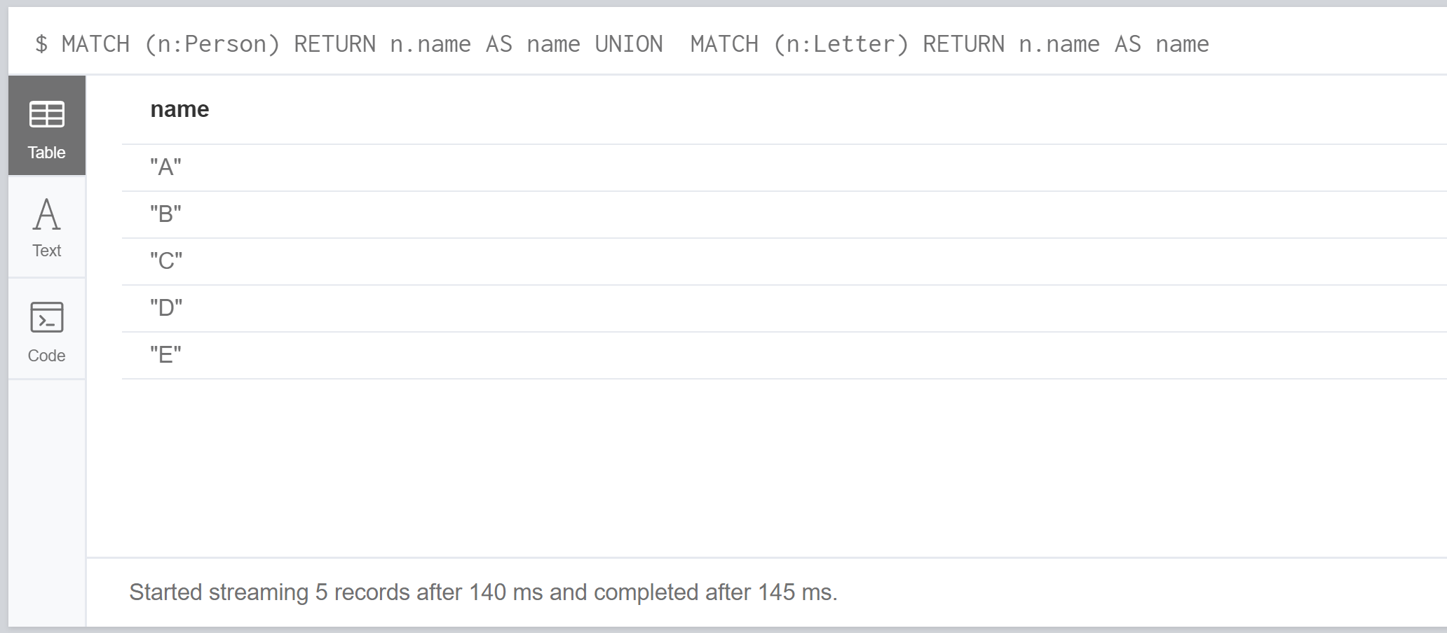

Summary:

This week we looked at using UNION, LIST, SIZE and RANGE. I am comfortable with understanding these functions in terms of actually using them more practice is required to make sure I am using them for the right reasons and I know why I am using them. This is where practice makes perfect comes into play. At this point I am comfortable with Neo4j but I need constant practice in order to keep my ability else I will start forgetting how I should use these features. RANGE is very useful as it can pull find data that is in a certain range which is specified. I feel using these features inside loops will help me create more advanced queries.

# Code:

//Call db.schema

// create nodes

LOAD CSV WITH HEADERS FROM

"file:///EPL_dataset_for_2018_19_assignment.csv" as row

MERGE(c:Club {name:row.`Team 1`})

// create relationship

// split("4-3","-")[0] then use toInteger toInteger(split("4-3","-") [0])

// this allows the score to be seperated from one string into two integers.

LOAD CSV WITH HEADERS FROM "file:///EPL_dataset_for_2018_19_assignment.csv" AS row

MATCH (c1:Club {name: row.`Team 1`}), (c2:Club {name: row.`Team 2`})

CREATE UNIQUE (c1)-[f:FEATURED{

round:toInteger(row.Round),

date: row.Date,

homeTeamFullTimeScore: toInteger(split(row.FT,"-") [0]),

awayTeamFullTimeScore: toInteger(split(row.FT,"-") [1]),

homeTeamHalfTimeScore: toInteger(split(row.HT,"-") [0]),

awayTeamHalfTimeScore: toInteger(split(row.HT,"-") [1])

}]->(c2)

// set the match result in relationship

// see if home team has won and set results

MATCH (c1)-[f]->(c2)

WHERE f.homeTeamFullTimeScore > f.awayTeamFullTimeScore

SET f.winningTeam=c1.name, f.losingTeam=c2.name

// see if away team won

MATCH (c1)-[f]->(c2)

WHERE f.homeTeamFullTimeScore < f.awayTeamFullTimeScore

SET f.winningTeam=c2.name, f.losingTeam=c1.name

// see if the match was drawn

MATCH (c1)-[f]->(c2)

WHERE f.homeTeamFullTimeScore = f.awayTeamFullTimeScore

SET f.matchTied="Draw", f.winningTeam="Draw", f.losingTeam="Draw"

// https://neo4j.com/docs/cypher-manual/current/introduction/query-the-graph/

// find number of matches played

// AS `` allows a table header to be format to read a lot smoother

MATCH (c1)-[f]->(c2)

RETURN count(*) AS `Featured Games`

//https://neo4j.com/docs/cypher-manual/current/clauses/where/

//https://neo4j.com/docs/cypher-manual/current/clauses/return/#return-unique-results

// find number of games for Man utd with match details

MATCH (c1)-[f]->(c2)

WHERE c1.name = 'Manchester United FC' OR c2.name = 'Manchester United FC'

RETURN f.round, f.date, c1.name AS Home, c2.name AS Away, f.homeTeamHalfTimeScore, f.awayTeamHalfTimeScore,

f.homeTeamFullTimeScore, f.awayTeamFullTimeScore, f.winningTeam, f.losingTeam, f.matchTied

ORDER BY f.round

// display all the teams that have played in the EPL

MATCH (c)

RETURN c.name AS `Teams playing in the EPL` ORDER BY c.name

// team with most wins in jan

MATCH (c1)-[f]->(c2)

WHERE f.date CONTAINS 'Jan'

AND NOT f.winningTeam = 'Draw'

RETURN f.winningTeam AS TEAM, COUNT(f.winningTeam) AS Total_Wins

ORDER BY Total_Wins DESC LIMIT 1

// best scoring power

MATCH (c1)-[f1]->(c2), (c2)-[f2]->(c1)

RETURN c1.name AS Team, SUM(f1.homeTeamFullTimeScore) + SUM(f2.awayTeamFullTimeScore) AS Goals_Scored

ORDER BY Goals_Scored DESC LIMIT 5

// 5 teams with worst defending

MATCH (c1)-[f1]->(c2), (c2)-[f2]->(c1)

RETURN c1.name AS Club, SUM(f1.awayTeamFullTimeScore) + SUM(f2.homeTeamFullTimeScore) AS Goals_Conceded

ORDER BY Goals_Conceded DESC LIMIT 5

// 5 teams with best winning records

MATCH (c1)-[f]->(c2)

WHERE NOT f.winningTeam = 'Draw'

RETURN f.winningTeam AS Club, COUNT(f.winningTeam) AS Victorys

ORDER BY Victorys DESC LIMIT 5

// 5 teams with best halftime score

//https://neo4j.com/docs/cypher-manual/current/syntax/expressions/

MATCH (c1)-[f1]->(c2), (c1)<-[f2]-(c2)

RETURN c1.name,

CASE WHEN

MAX(f1.homeTeamHalfTimeScore - f1.awayTeamHalfTimeScore)>= MAX(f2.awayTeamHalfTimeScore - f2.homeTeamHalfTimeScore)

THEN MAX(f1.homeTeamHalfTimeScore - f1.awayTeamHalfTimeScore)

ELSE MAX(f2.awayTeamHalfTimeScore - f2.homeTeamHalfTimeScore)

END AS `Goals ahead at halftime`

ORDER BY `Goals ahead at halftime`

DESC LIMIT 5

// team with the most losses

MATCH (c1)-[f]->(c2)

WHERE NOT f.losingTeam = 'Draw'

RETURN f.losingTeam AS TEAM, COUNT(f.losingTeam) AS Total_Losses

ORDER BY Total_Losses DESC LIMIT 5

// team with most consecutive wins

MATCH (c1)-[f]-(c2)

WITH c1, f.winningTeam AS WinningTeam

ORDER BY f.round

WITH c1, collect(WinningTeam) AS wins

WITH c1, reduce(acc = [], i IN range(0, size(wins) - 1) |

CASE wins[i] = wins[i-1]

WHEN true THEN [j IN range(0, size(acc) - 1) |

CASE j = size(acc) - 1

WHEN true THEN acc[j] + [wins[i]]

ELSE acc[j]

END

]

ELSE acc + [[wins[i]]]

END

) AS Consecutive_Victorys

UNWIND Consecutive_Victorys AS Victorys

WITH c1, Victorys

RETURN c1.name AS Club, max(size(Victorys)) AS `Consecutive Victorys`

ORDER BY `Consecutive Victorys` DESC LIMIT 1

// drop database

MATCH (n) DETACH DELETE n